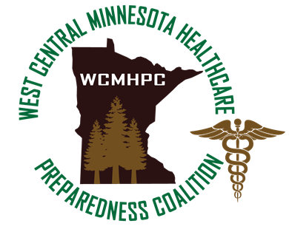
Prepared by: Shawn Stoen
JUNE 2023

Appendix 3.5.1.4 crisis standards of care

Certain situations, such as medical surge, cause shortages of supplies at the local level as well as regional and state levels. This shortage may even extend nationally/globally. Minnesota Department of Health has created the Crisis Standards of Care plan that addresses how major shortages would be handled.

WCMHPC members should plan for limited resources and to implement Crisis Standards of Care.

The Role of the RHPC
As dictated by the event or as requested by the WCMHPC member, the RHPC can be contacted to assist. Dependent upon the situation, the RHPC may activate the HMAC in support of Coalition members. See Chapter 1: Regional Coordination Plan.

Regional resources will be made available to its’ membership. The Appendix 3.5.6 Regional Resource Plan will be used to facilitate this support.

The RHPC will also share information received from the State of Minnesota, Federal Government, and other resources/subject matter experts about options available to healthcare providers when there is a scarce resource situation.

Planning Resources
The Minnesota Department of Health has developed strategies for events that overwhelm the healthcare system. Clinical guidelines to ethically care for patients when a healthcare facility is overwhelmed are available for all regions and facilities to use. During a disaster, healthcare facilities need to uphold certain standards of care.
- Patient Care Strategies for Scarce Resource Situations
A standardized framework to assist Minnesota hospitals, clinics, or primary care settings in determining the best use of specialized equipment and supplies during a public health emergency.
- Pharmaceutical Shortages for MN Hospitals
Frequently Asked Questions
- Pandemic Incident Command Considerations for Health Care Facilities
Part of the state of Minnesota’s efforts to plan for the possibility of an influenza pandemic.
- Crisis Standards of Care: A Systems Framework for Catastrophic Disaster Response
National guidance in establishing and implementing standards of care that should apply in disaster situations, both naturally occurring and man-made, under conditions of scarce resources.

Approvals and Revisions
Purpose | Date
Updated to expand on the role of the coalition/RHPC in a response | 6/12/2023

