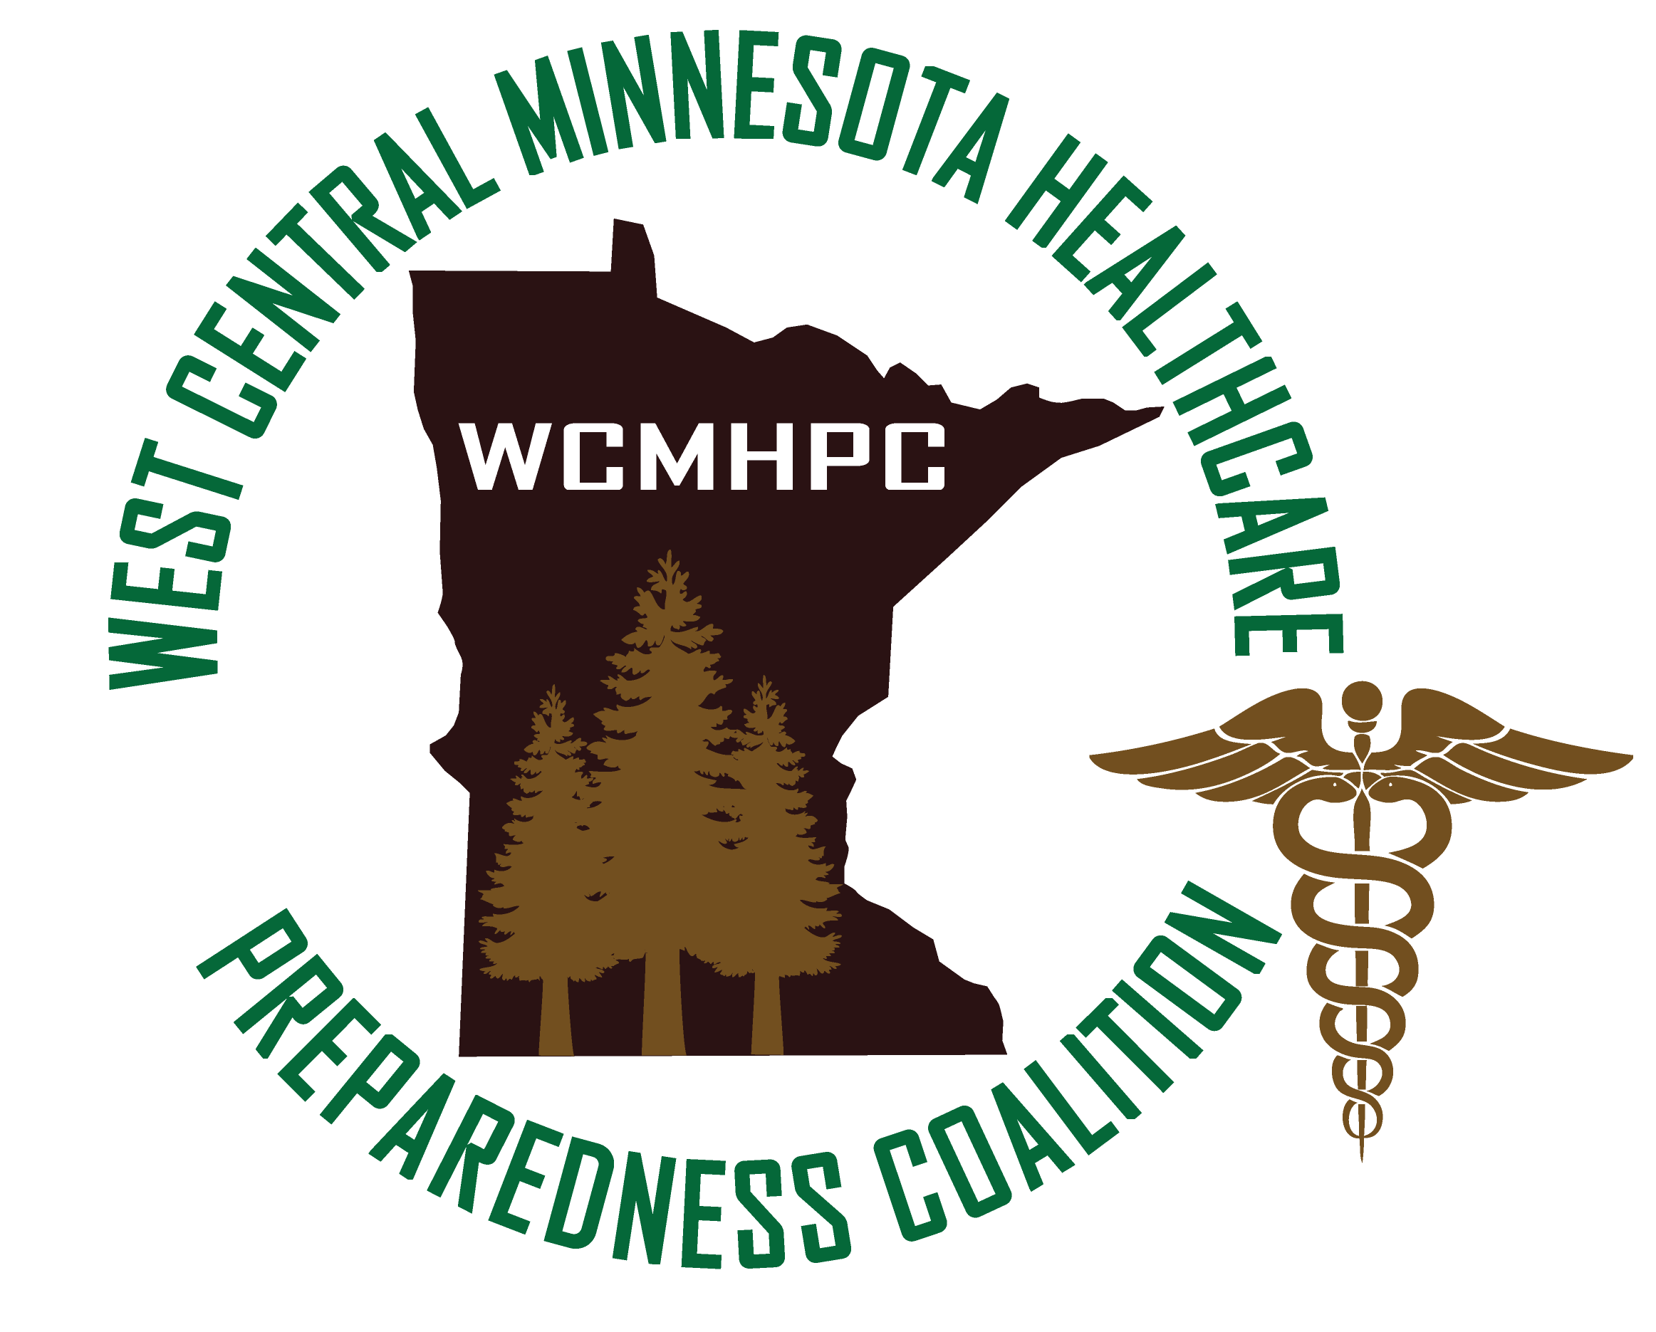
Prepared by: Stoen, Shawn
JUNE 2023

Appendix 3.5.1.2 Regional Pediatric Surge Plan

THIS PAGE IS INTENTIONALY LEFT BLANK

Table of Contents
INTRODUCTION 3
PURPOSE 3
SCOPE 3
OVERVIEW/RISKS 4
ACCESS AND FUNCTIONAL NEEDS 6
CONCEPT OF OPERATIONS 6
ACTIVATION 6
ROLES AND RESPONSIBILITIES 7
Initial Receiving Hospital/Health Care Facility 7
Designated Pediatric Trauma Center 7
Health Care Coalition 7
LOGISTICS 8
Space 8
Staff 8
Supplies 8
SPECIAL CONSIDERATIONS 10
Behavioral Health 10
Decontamination 10
Evacuation 10
Infection Control 10
Security 11
OPERATIONS – MEDICAL CARE 11
Triage and Treatment 11
TRANSPORTATION 11
PATIENT TRACKING AND REUNIFICATION 12
DEACTIVATION AND RECOVERY 12
PLAN MAINTENANCE AND REVIEW 12
RESOURCES 12
Approvals and Revisions 13

INTRODUCTION

PURPOSE
This appendix applies to a mass casualty event with many pediatric patients. It is designed to support the West Central Minnesota Health Care Preparedness Coalitions’ (WCMHPC) Response Plan and Appendix 3.5.1 Medical Surge Coordination by addressing the specific needs of children and the medical care of a pediatric patient. This plan does not replace any existing facility policies or plans; however, it is designed to support the facility level plans by providing pediatric specific resources and information.

SCOPE
The Regional Pediatric Surge Plan is designed to provide the communication processes and the procedure for inter-regional and interstate transfer as related to pediatric patients. This pediatric surge appendix provides a regional framework to support and supplement the MN Statewide Pediatric Surge plan. The Plan is designed to:
1. Support safe pediatric transfer decision making
2. Discuss and identify standardized care guidelines available for facilities
3. Provide tools to ensure regional communication processes are in place
4. Support the tracking of pediatric patients throughout the incident
5. Identify the pediatric tertiary care centers/specialty care centers
6. Assist with the decompression from pediatric tertiary care centers/specialty care centers in order to make additional critical care beds available for acutely ill/injured pediatric patients.

OVERVIEW/RISKS
The total population in the West Central region is approximately 197,164 of which 6.5% are under the age of 5 and 22% are under the age of 18 (See WCMHPC Preparedness Plan, Section 6). In 2021, there were 61 crashes resulting in one fatality and 26 injuries in which a school bus was indirectly involved. (www.dps.mn.gov). In rural West Central Minnesota, many students rely on bus transportation to get to and from school in addition to school events. The West Central Minnesota region has eight (8) hospitals within the region. An event that impacts the region’s pediatric population would have a major impact on the ability of health care services to provide care. With just over 55,000 pediatrics in the region and the limited amount of health care resources, the region’s facilities will be very reliant upon the neighboring health care facilities as well as the pediatric specialty facilities in the state. These resources are between 1.5 and 4 hours away from hospitals within the West Central region.
The table below identifies the number of pediatric specific resources available at each facility:
Name of Facility | # Pediatric Beds | # PICU Beds | # NICU Beds | Pediatricians on staff
Alomere Health | 6 | 0 | 0 | Yes
Lake Region Health | 4 | 0 | 0 | Yes
CHI St Francis, Glacial Ridge Health, Prairie Ridge Health, Sanford Wheaton, and Stevens Community Medical do not have Pediatric beds or Pediatricians on staff.

The West Central region has 10 pediatric beds. This indicates the reliance upon neighboring facilities as well as specialized pediatric facilities to support an event within the region. The region will use the North Dakota Pediatric facilities and St. Cloud Hospital as needed. There are no Pediatric Trauma Centers located within our coalition. The West Central regional assets do not include Pediatric specialized Emergency Medical Services (see page 10 for further discussion about transportation assets during a surge event).

The table below shows available resources in regions surrounding the West Central region:
Name of Facility | Region | # Pediatric Beds | # PICU Beds | # NICU Beds
Sanford Fargo  (701) 417-2000 | North Dakota | 24 | 12 | 40
Essentia Health – Fargo  701-364-8000 | North Dakota | 3 | 0 | 10
St. Cloud Hospital  (320) 251-2700 | Central | 20 | 5 | 30

The following table identifies specialized pediatric centers within the State of Minnesota:
TRAUMA DESIGNATION | HOSPITAL NAME | HCC CONTACT
Level I | Children’s of Minnesota, Minneapolis | Metro Health & Medical Preparedness Coalition  612-873-9911
Level I | Hennepin County Medical Children’s Hospital
Level I | Regions Hospital/Gillette Children’s Specialty Healthcare
Level I | Mayo Clinic Hospital Eugenio Litta Children’s Hospital | Southeast Minnesota Disaster Health Coalition  855-606-5458  507-255-2808
Level I | Essentia Health St. Mary’s Medical Center | Northeast Healthcare Preparedness Coalition  Jo Thompson 218-269-7781  Adam Shadiow 218-428-3610
Level II | North Memorial Health Hospital | Metro Health & Medical Preparedness Coalition  612-873-9911

ACCESS AND FUNCTIONAL NEEDS
The chart below indicates the estimated disabilities amongst the pediatric population in West Central Minnesota.
 | All Disabilities | Hearing difficulty < 17 years | Vision Difficulty < 17 years | Cognitive Difficulty < 18 years | Ambulatory Difficulty <18 years | Self-Care difficulty <18 years
Clay | 429 | 9 | 75 | 434 | 32 | 105
Douglas | 284 | 66 | 57 | 193 | 9 | 31
Grant | 83 | 19 | 24 | 45 | 5 | 4
Otter Tail | 534 | 54 | 43 | 466 | 61 | 117
Pope | 137 | 17 | 25 | 103 | 26 | 30
Stevens | 38 | 6 | 4 | 34 | 2 | 2
Traverse | 40 | 15 | 4 | 26 | 3 | 6
Wilkin | 76 | 19 | 13 | 36 | 9 | 9
Totals | 1621 | 205 | 245 | 1337 | 147 | 304
Data collected from: http://w20.education.state.mn.us/MDEAnalytics/Data.jsp
Information obtained 08/30/2019

Health care facilities and the coalition consider planning for individuals with Access and Functional needs in all plans, including Medical Surge. This population will require special equipment and resources. See Appendix A for a list of resources available for planning and response considerations.

CONCEPT OF OPERATIONS

ACTIVATION
When an incident occurs resulting in pediatric victims, the initial response should follow local
surge plans. Local hospitals and EMS agencies should assess:
- Scope and magnitude of the incident,
- Estimate the influx of patients and the real or potential impact on the local health care system,
- Any special response needs (e.g., infectious disease, hazardous materials, etc.), and
- Internal response plan activation(s).
- Facility normal referral patterns and availability of these resources

The local hospitals will notify the pediatric trauma center and advise them of the situation. If the designated pediatric trauma center activates their internal surge plan, they are responsible to request activation of the Minnesota Pediatric Surge Plan by contacting their HCC as delineated in their regional activation and notification plan(s). The pediatric trauma center will assume the role of the State Coordinating Pediatric Trauma Center (SCPC).
Activation of the statewide Minnesota Pediatric Surge Plan is done as outlined in the Concept of Operations of that plan. See: https://www.health.state.mn.us/communities/ep/surge/pediatric/index.html

ROLES AND RESPONSIBILITIES

Initial Receiving Hospital/Health Care Facility
It is expected that all hospitals providing emergency care will maintain a standardized basic level of preparedness and ability to deal with traumatic injury. Per the Minnesota Pediatric Surge Plan, the State Coordinating Pediatric Trauma Center may provide telephone/telemedicine expertise to assist stabilizing hospitals caring for victims.
The initial receiving facility should:
- Activate their organization’s emergency operations plan.
- Attempt to obtain resources through its normal and contingency methods (such as special agreements with other facilities within its parent organizations)
- Assess the response needs and communicate with the pediatric trauma center for guidance.
- Notify the health care coalition of the situation and identify any specific needs from the coalition.

Designated Pediatric Trauma Center
- Assess the situation and if deemed necessary activate their facilities surge plan
- Provide guidance to the initial facility regarding stabilization of patients
- Notify the HCC of the need to activate the states Pediatric Surge plan

Health Care Coalition
- Activate the Coalition Health Multi-Agency Coordination Center (HMAC) and the Regional Medical Operations Coordination Cell (RMOCC)
- Notify members of the activation and request
- Issue a MNTRAC Alert and/or set up a regional conference call or coordination room
- Create a Patient tracking room within MNTrac
- Initiate a bed availability request statewide
- Monitor MNTRAC periodically
- Assess available healthcare resources
- Connect with MDH DOC or CEPR 24/7
- Maintain situational awareness of healthcare status.
- Assess and coordinate available supplies and resources
- Facilitate deployment of disaster stockpiles.

LOGISTICS

Space
If space is requested from a facility, the Coalition will work with the local emergency manager to assist in locating a site. Each hospital has an alternate care site plan and will be expected to activate that plan if possible.

Staff
The staffing of the HMAC will be determined by the regional healthcare preparedness coordinators at the time of activation. The initial configuration will be based upon known and projected incident parameters and the initial response objectives of the Coalition. The regional healthcare preparedness coordinator, the public health preparedness consultant, the emergency medical services region representative would be the initial staffed positions and would request other non-affected members to assist as needed. A liaison will be assigned to work with the local emergency management Emergency Operations Center to facilitate communication.
If the affected hospital is requesting support with staffing their facilities’ command center the HMAC will utilize the coalition MOU and reach out to fellow, unaffected health care members to fulfill the requested roles.
If the affected hospital is requesting health care providing staff, the HMAC will work with the public health partners in requesting support through MN Responds as well as reach out to coalition membership that is unaffected to assess availability for support.

Supplies
The HMAC can facilitate the resource sharing process by coordinating requests for assistance, identifying potentially available resources needed by a member healthcare organization, and supporting the direct agreement between assisting and supported organizations during response to an emergency or disaster.
The Coalition does not provide a cache of pediatric supplies in the event of a pediatric incident. The Coalition would contact MDH – CEPR for additional resources.
See our Appendix 3.5.5 Resource Request plan.
Individual healthcare organizations are expected to utilize their primary vendor suppliers and other regular means of acquiring resources before requesting assistance through the Coalition. This includes their affiliated organization (enterprise/parent) and mutual aid agreements first.

SPECIAL CONSIDERATIONS
Reference materials available in the Pediatric Surge Toolkit. Within the Toolkit the Pediatric Surge Videos cover special consideration topics as does the Pediatric Primer.

Behavioral Health
The HMAC will support any requests for assistance with behavioral health needs by working with local Health and Human Services and may reach out to the Minnesota Behavioral Health Response team within MN Responds.
Behavioral Health Homepage: https://www.health.state.mn.us/communities/ep/behavioral/index.html
Pediatric Surge Toolkit Handouts: PFA, Disaster Mental Health for Children, Guide for Parents & Caregivers

Decontamination
Special considerations need to be considered when decontaminating a pediatric patient. Facilities are encouraged to access the Pediatric toolkit to obtain guidance on planning for decontamination of a pediatric patient.

Evacuation
Hospitals have developed evacuation plans, including the identification of transportation plans for moving patients from the facility. If several facilities within the region needed to be evacuated, the HMAC would assist in coordination of the incident as requested. Hospitals are also expected to have shelter in place plans within their emergency operations plan. The hospitals are equipped with Med Sleds to assist in the evacuation of non-ambulatory patients. Individual hospitals can activate their mutual aid agreements with other hospitals in the region for personnel, supplies and resources as needed. Any pediatric special equipment will be requested amongst members and then to the local emergency manager to assist in locating the supplies. i.e. car seats.

Infection Control
Children are more likely to become dehydrated from vomiting or diarrhea because they have less body fluid reserve than adults do, and this increases their risk for rapid dehydration. Children also have smaller circulating blood volumes than adults, so without rapid intervention, relatively small amounts of blood loss can become dangerous more quickly. Isolation precautions with a pediatric patient are unique as they are often accompanied by a parent. Health care facilities are encouraged to utilize the resources contained within the Pediatric toolkit to plan for infection control for pediatric patients.

Security
Each hospital should outline their security procedures and differences for pediatric patients. They can use the following sources to help plan for security:
  - Pediatric Primer pg. 12
  - Pediatric Surge Toolkit Reference: Pediatric Safe Area Checklist, Registry, Unaccompanied Minor Registration.

OPERATIONS – MEDICAL CARE

Triage and Treatment
Per the Minnesota Pediatric Surge Plan, EMS will triage patients in the field according to their standard of care. It is the responsibility of all hospitals to perform secondary triage to determine the best setting for a patient to receive definitive care. The State Coordinating Pediatric Trauma Center will maintain the lead on definitive care guidance for patient placement.
MDH-CEPR provides a Quick Reference for Assessment, Stabilization and Transfer of Pediatric Patients online. Additionally, Patient Care Strategies for Scarce Resource Situations is another online resource for providers and includes Pediatric Resource and Pediatric Triage cards.

TRANSPORTATION
The region is limited on pediatric/neonatal specialty transport assets. This region has access to medical transport options which include helicopter and fixed wing resources (Sanford Air Med, Life Link III and North Ambulance), ground ambulance services and a few private businesses (MediVan, Peoples Express, Rainbow Rider) for transporting patients. Sanford Fargo EMS has a transport bus located in Fargo, ND that could be requested directly through Sanford Fargo EMS. Family members may be asked to transport if able. Several long-term care facilities have vans with some wheelchair tie downs that could be used for transport. Local school buses and handicap accessible buses may be requested through local emergency management. The HMAC, along with local emergency management, will assist with procuring the necessary transportation assets if requested.
Ambulance Strike Teams could be requested for transport assistance through local emergency management to the State Emergency Operations Center or the Minnesota State Duty Officer.
Transportation processes in use during a surge incident should adhere to the appropriate regulatory guidance, to include EMTALA and HIPAA, as well as other medical and legal guides to transporting patients and transferring care. Hospitals would use their normal referral processes and locations.

PATIENT TRACKING AND REUNIFICATION
Patient tracking is the responsibility of the affected facility and the personnel managing the transportation assets. Upon notification from the effected health care facility, the HMAC can activate the Regional Patient Tracking plan to support the facility. Affected health care facilities should be coordinating information sharing to families regarding the status of family members that are being transported to another facility. In a large response, the facility should work with local emergency management partners and local public health in identifying the family reunification/notification process.

DEACTIVATION AND RECOVERY
The impacted facility will be requested to create an after-action report summarizing the events that occurred, the processes followed, any lessons learned.
The HCC will support facility recovery by sharing resources such as behavioral health support, resource management, and assistance with completing reimbursement documentation.

PLAN MAINTENANCE AND REVIEW
The Minnesota Pediatric Surge Plan is maintained by MDH-CEPR and is reviewed at minimum annually; or after an exercise or activation, as warranted. The West Central MN Health Care Preparedness Coalition reviews and update plans annually . The Regional Hazard Vulnerability Analysis is also updated annually by the full membership and approved by the Advisory Committee. The Regional Pediatric Surge plan will be available to all members via the coalition website.

RESOURCES
Bridge to Benefits (http://mn.bridgetobenefits.org/Disability_Services2)
Children’s Minnesota (https://www.childrensmn.org/)
PACER Center (https://www.pacer.org/)
Vision Loss Resources (http://visionlossresources.org/programs/dbsm)
Autism Society (https://www.ausm.org/)
Rice Home Medical (https://ricehomemedical.com/#)

Approvals and Revisions
Purpose | Date
Updated to correct grammar, update links and data | Emailed 3/11/2023 and approved by all 4/3/2023
Updated to add RMOCC verbiage and correct links. | 6/6/2023

