Prepared by: shawn stoen
JUNE 2023

Appendix 3.5.1.5 Infectious disease surge annex

THIS PAGE IS INTENTIONALY LEFT BLANK

Contents
1. Introduction 7
1.1 Purpose 7
1.2 Scope 7
1.3 Overview of Healthcare Coalition and Situation 9
Description of Disease 9
Coalition Infectious disease resources 10
1.4 Planning Assumptions 11
2. Concept of Operations 12
2.1 Activation 12
2.2 Activation and Notification Flow 14
2.3 Roles and Responsibilities 15
County Emergency Management Agency 15
EMS Services / Pre-Hospital Providers 15
Frontline Healthcare Facilities 15
Local Public Health Department 16
West Central MN Healthcare Coalition 16
West Central MN HMAC 17
Minnesota Department of Health (MDH) 17
Minnesota Homeland Security and Emergency Management 18
2.4 Operational Mission Areas 18
2.4.1 Surveillance 18
2.4.2 Safety and Infectious Control and Prevention 18
2.4.3 Non-Pharmaceutical Interventions 20
2.4.4 Surge Staffing 20
2.4.5 Supply Chain, Supplies, Personal Protective Equipment (PPE) 21
2.4.6 Support Services 21
2.4.6.1 Laboratory 22
2.4.6.2 Waste Management and Decontamination 22
2.4.7 Patient Care and Management 23
2.4.8 Medical Countermeasures 24
2.4.9 Community-based Testing 24
2.4.10 Patient Transport 25
2.4.10.1 PATIENT Surge 25
2.4.10.2 Patient Tracking 26
2.4.10.3 Patient Transport 27
2.4.11 Mass Fatality 27
2.5 Special Considerations 28
2.5.1 Behavioral Health 28
2.5.2 At-Risk Populations 28
2.5.3 Situational Awareness 29
2.5.4 Communications 29
2.5.5 Jurisdictional – Specific Considerations 30
2.5.6 Training and Exercises 30
2.5.7 Deactivation and Recovery 31
ADDENDUMS 31
Addendum A: References 31
Addendum B – Agent Fact Sheets 33
Approvals and Revisions 1

1. Introduction

In an increasingly internationalized world, the ability for infectious diseases to be transmitted globally is increased. International travel increased the ability of citizens of Minnesota, and more specifically West Central Minnesota, to be easily exposed to infectious diseases such as Coronaviruses, Ebola, and other unknown emerging infectious diseases as well as outbreaks of established diseases such as measles.

An “infectious disease response” is a response to any new, emerging, or severe infectious disease situation that goes above and beyond routine infectious disease investigation, coordination, and response; and likely requires significant multi-agency response.

The West Central MN Healthcare Preparedness Coalition (WCMHPC) Infectious Disease Surge Plan Annex will define roles and responsibilities of regional coalition members and partners to an infectious disease response. This will include coordination of healthcare, local public health agencies, and other regional and State partners. The annex will serve as a template and guide towards response and will be considered a flexible document as infectious diseases evolve and change over time. The annex will be reviewed annually and updated as necessary to ensure readiness to respond and to incorporate any lessons learned in previous response efforts.

1.1 Purpose

The purpose of this plan is to provide a concept of operations for a coordinated regional response related to an infectious disease outbreak. The purpose of the plan is to:

    - Describe the decision-making structure to be used to determine healthcare response actions and priorities and how they will integrate with local public health.
    - Describe procedures to consider for patient placement, movement, and care. The plan is considered a guide, however, will not provide specific patient care treatment guidance/guidelines.
    - Outline the coalitions’ role and procedures for sharing and/or prioritizing scarce resources as well as how those activities will relate to cross-regional and statewide efforts.
    - Discuss the roles and responsibilities for healthcare, public health, local response agencies, emergency management, community, non-governmental, and local, state, federal and tribal partners in an infectious disease response in the region.
    - Review the coalitions process for communications and coordination among public health, healthcare partners, and other local partners during a response.
    - Describe procedures for the coordination of local healthcare planning and response efforts.

1.2 Scope

The Infectious Disease Surge Plan Annex is part of the WCMHPC Response Plan and is applicable for any incident in which an individual or community is impacted by a suspected or confirmed infectious disease that is beyond the scope of a local response. This plan outlines the concept of coordination and operations for incidents wherein the complexity or duration requires regional coordination of information, resources and/or response activities.
This plan will promote the concepts outlined by the National Incident Management System (NIMS) and will commit to establishment of a common set of goals, strategies as well as terminology utilized in other regional plans. This plan may be used as a supplement to local plans and will promote the coordination of a response with the local, regional, and State agencies involved in the response.

1.3 Overview of Healthcare Coalition and Situation

Description of Disease
Diseases are illnesses caused by the presence and actions of one or more pathogenic agents including viruses, bacteria, fungi, protozoa, multicellular parasites, and abnormal proteins called prions. A disease may be classified as “emerging” or “re-emerging”.

According to the National Institute of Allergy and Infectious Diseases, emerging infectious diseases are commonly defined as:
- Outbreaks of previously unknown diseases
- Known diseases that are rapidly increasing in incidence or geographic range in the last 2 decades
- Persistence of infectious diseases that cannot be controlled.
Emerging diseases include HIV infections, SARS, Lyme disease, Escherichia coli O157:H7 (E. coli), hantavirus, dengue fever, West Nile virus, and the Zika virus.
Reemerging diseases are diseases that reappear after they have been on a significant decline. Reemergence may happen because of a breakdown in public health measures for diseases that were once under control. They can also happen when new strains of known disease-causing organisms appear. Human behavior affects reemergence. For example, overuse of antibiotics has led to disease-causing organisms that are resistant to medicines. It has allowed the return of diseases that once were treatable and controllable. Reemerging diseases include malaria, tuberculosis, cholera, pertussis, influenza, pneumococcal disease, and gonorrhea.

The transmission of diseases can occur through a variety of modes including:
- Inhalation of airborne particles
- Inhalation of droplet particles
- Contact with infectious surfaces.

The National Institute of Allergy and Infectious Diseases identifies three categories of pathogens:

Category A pathogens are those organisms/biological agents that pose the highest risk to national security and public health because they:
- Can be easily disseminated or transmitted from person to person.
- Result in high mortality rates and has the potential for major public health impact.
- Might cause public panic and social disruption.
- Require special action for public health preparedness.
- Examples: Anthrax, botulism, plague, and Ebola

Category B pathogens are the second highest priority organisms/biological agents. They
- Are moderately easy to disseminate.
- Result in moderate morbidity rates and low mortality rates.
- Require specific enhancements for diagnostic capacity and enhanced disease surveillance.
- Examples: Ricin, Staphylococcus, Food and waterborne pathogens, and mosquito borne viruses

Category C pathogens are the third highest priority and include emerging pathogens that could be engineered for mass dissemination in the future because of
- Availability
- Ease of production and dissemination
- Potential for high morbidity and mortality rates and major health impact
- Examples: Hantaviruses, tickborne viruses, tuberculosis, influenza, human coronaviruses.

See Addendum A for links to the National Institute of Allergy and Infectious Disease.

Coalition Infectious disease resources

 | Hospital | Address |  | Phone Number
Highly Infectious Disease Treatment facility | Mayo Clinic |  | 200 First St. SW  Rochester, MN 55905 |  | (507)229-3401
Highly Infectious Disease Treatment facility | M Health Fairview University of Minnesota Medical Center – West Bank |  | 2450 Riverside Ave., Minneapolis, MN 55454 |  | (612) 273-3000
Infectious Disease Assessment Facility | Allina Unity Hospital |  | 550 Osborne Rd NE, Fridley, MN 55432 |  | (763) 236-5000
Pediatric Infectious Disease Specialists | Children’s Hospital |  | 345 Smith Ave N, Saint Paul, MN 55102 · |  | (651) 220-6000

out of state support facilities with infectious disease specialties:
 | State | Hospital | Address | Phone Number
Regional Biocontainment Center | Nebraska | Nebraska Medicine | 4350 Dewey Ave. Omaha, NE | (800) 922-0000
 | North Dakota | Sanford Health | 736 Broadway N.  Fargo, North Dakota 58102
 | South Dakota | Sanford Infectious Disease Clinic | 1205 S. Grange Ave.  Suite 401  Sioux Falls, South Dakota 57105

Coalition Frontline hospitals
Trauma Designation | Hospital | Address | County | Phone | Website
Level III | Alomere Health | 111 17th Ave E, Alexandria, MN 56308 | Douglas | (320) 762-1511 | https://alomerehealth.com/
Level III | Lake Region | 2311 W Lincoln Ave, Fergus Falls, MN 56537 | Otter Tail | (218) 739-6800 | https://www.lrhc.org/
Level IV | Prairie Ridge Health | 1411 Highway 79 E, Elbow Lake, MN 56531 | Grant | (218) 685-7300 | https://www.prairiehealth.org/
Level IV | Perham Health | 1000 Coney Street West  Perham, MN 56573 | Otter Tail | (218) 347-4500 | https://www.perhamhealth.org/
Level IV | Glacial Ridge | 10 4th Ave SE, Glenwood, MN 56334 | Pope | (320) 634-4521 | https://glacialridge.org
Level IV | Stevens Community Medical Center | 400 E 1st St, Morris, MN 56267 | Stevens | (320) 589-1313 | https://www.scmcinc.org/
Level IV | Sanford Wheaton Health | 401 12th Street North  Wheaton, MN 56296 | Traverse | (320) 563-8226 | https://www.sanfordhealth.org/locations/sanford-wheaton-medical-center
Level IV | St. Francis Medical Center | 2400 St. Francis Drive  Breckenridge, MN 56520 | Wilkin | (218) 643-3000 | https://www.sfcare.org/

1.4 Planning Assumptions

Planning assumptions for this plan include:

    - This plan is meant to provide an overview of the regional response to an infectious disease outbreak and the coordination with other relevant regional plans and health partners.
    - Infectious disease outbreaks may be anticipated and provide the ability to plan, or there may be no notice and require immediate response.
    - Patients with an infectious disease could present to healthcare organizations in the region through two modes:
      - A patient presents with symptoms with or without a history of exposure and no advance notification to the healthcare facility.
      - A patient being monitored or treated for a disease/exposure and is directed to a healthcare facility for evaluation or treatment in the region.
    - Not all healthcare facilities in the coalition may be able to care for all infectious disease patients.
    - All healthcare facilities must be able to maintain a base level of preparedness to safely screen (in-person or remotely), stabilize, isolate if necessary, and arrange for the transport of a possible infectious disease patient.
    - Resources such as personnel, equipment, and personal protective equipment may be in short supply throughout the region, state, country, or the globe depending on the severity and nature of the infectious disease.
    - The objectives of public health and hospitals may differ in an infectious disease response: public health is primarily concerned with community disease control and healthcare facilities are focused on the clinical care of patients.
    - This plan does not apply to routine disease responses such as tuberculosis, measles, STD, and foodborne illness cases or outbreaks, unless the response requires coordination above and beyond normal operational procedures.
    - Local public health agencies maintain plans for pandemic/avian influenza as well as isolation and quarantine. This plan is meant to complement other local planning efforts.
    - Responses to large scale infectious disease response may require coordination with other regional, state, and federal partners.
    - Local Board of Health and Minnesota Department of Public Health have the authority to change or implement procedures to protect the public’s health, including isolation and quarantine.
    - Healthcare organizations and systems throughout the region will commit their own resources to address internal challenges prior to releasing resources to other healthcare organizations.
    - Pediatric, obstetric, and other specialty care patients, including those that are critically ill, may present to ANY healthcare facility during an infectious disease response.
    - Healthcare organizations will rely on existing contracts with medical suppliers and pharmaceutical vendors to the maximum extent possible.
    - Hospitals and healthcare systems are expected to have their own plans for an infectious disease response. This plan is not designed to replace the facility level planning effort.
    - An infectious disease outbreak can cause a surge of patients – this plan will work along with the Appendix 3.5.1 Medical Surge Coordination as well as Appendix 3.5.1.4 Crisis Standards of Care.

2. Concept of Operations

2.1 Activation
This plan may be activated during any infectious disease scenario that requires coordination between healthcare organizations and coalition partners, when the existing resources and plans are limited and inhibit the ability to adequately respond to the infectious disease.

Potential triggers to activate the Infectious Disease Annex include:

    - Regional coordination required to assist with monitoring, laboratory testing, patient care, patient movement, etc.
    - Multiple counties affected by an infectious disease requiring a coordinated response.
    - Regional coordination required for risk communication, public information, and/or media response.
    - Public health response to a new/novel communicable disease.
    - Multi-agency response to an infectious disease health threat.
    - Notification by a local public health agency/community health board for the need for regional coordination of coalition members.
    - Response to a more routine public health event (e.g., small outbreak) that will benefit from use of ICS to organize the response and provide an opportunity to exercise implementation of ICS.

When the RHPC or a local health authority identifies that the infectious disease outbreak meets the triggers identified above and additional resources may be needed, this plan will be activated at the discretion of the RHPC, or their designee. Regional or local partners, a local Emergency Manager, local public health, or a representative of another health or medical organization may request activation. Coalition staff should consider the likelihood that state resources will be employed, the need or potential need for specialized technical assistance, and the status or activation forecast of the State Emergency Operations Center when determining whether or when to activate the HMAC and the plan.
HMAC activation is likely, and activation protocol may be initiated.
RHPC will coordinate with HMAC representatives to relay responsibilities, provide collected background data from assessments, and aid with priority tasks.

Activation of the HMAC and implementation of the Infectious Disease Surge Plan will be coordinated with both state and local partners. Members should consider that infectious disease events might create unforeseen recovery challenges for both state and local agencies, some of which may not be clearly recognized during the response. As a minimum, consideration should be given to:
- Disease and illness forecasts or verifiable trends
- Expected timing of and challenges associated with deactivation or demobilization of state-owned or controlled resources or teams; and
- Possible recovery needs that may require facilitation, coordination or technical assistance that was provided by the coalition during the response phase.

Refer to the Coalition Response plan for further information regarding HMAC activation during a response.

The Coalition uses a four-level system to describe different levels of emergency response activation. This system will be used in an infectious disease emergency. The table below depicts the activation and readiness levels as they apply in an infectious disease emergency.

Level | Definition | Description/Activities
IV | Routine Operations: No confirmed human cases having infectious disease potential identified in Minnesota | Infectious diseases or pandemic events pose a minimal immediate risk to the region.  - The region continues to conduct normal business and monitors threats.  - Local Public Health Departments track infectious diseases and influenza like illnesses that are present among those seeking treatment.  - This is the default level of readiness and activation for the coalition with the emphasis on prevention and preparedness activities.  - The RHPC will monitor the situation and communicate with MDH to assure integration with the State infectious disease CONOPS.  - The RHPC will coordinate with other state and regional entities, local jurisdictions, and private sector/not-for-profit partners to identify resources, undocumented capabilities, and previously unrecognized limitations.
III | Enhanced Operations: Sporadic confirmed, isolated, travel-related human case of infectious disease or suspected infectious disease detected in Minnesota | Infectious diseases or pandemic events pose an increased risk to the region.  - Conducting coordination meetings or conference calls with local partners. Increased health monitoring and education activities.  - RHPC will review their assigned responsibilities and tasks in this plan and communicate with state, regional, and local partners as necessary.
II | Increased Readiness Operations: Single confirmed, non-travel related human case of infectious disease or suspected infectious disease detected in Minnesota | Infectious diseases or pandemic events pose a significant risk to the region. The coalition partners have most if not all of the resources required to immediately respond to the event although increased coordination among regional partners and outside agencies may occur. Local operations and activities may be impacted or canceled due to absenteeism or to prevent the spread of disease.  - Implementation of social distancing guidelines, modification of operations that may include shift work or teleworking.  - RHPC will begin identifying initial priority tasks. During a period of Increased Readiness, the RHPC may designate a frequency for such assessment.
I | Escalated Operations: Multiple confirmed non-travel-related human cases of infectious disease or suspected infectious disease within a defined geographic area in Minnesota  Emergency Response Operations: Multiple confirmed non-travel-related human cases of infectious disease or suspected infectious disease detected in Minnesota: | Infectious diseases or pandemic events pose a major risk to the region. The coalition partners may not have all of the resources required to respond to the event and significant coordination among coalition partners and outside agencies is required. Local operations will be impacted or canceled due to absenteeism or to prevent the spread of disease.  - Cancellation of face-to-face meetings and other activities.  - Distribution of Personal Protective Equipment from the coalition cache or other acquired sources.  - RHPC will begin preparing to activate the HMAC.  - RHPC will continue to assess priority tasks (those that may be already underway or will be within the first operational period of the HMAC) and will begin to assess any unique and immediate regional issues (such as many public gatherings, temporary unavailability of substantial resources, etc.) that may impact the completion of priority tasks.  - RHPC will establish and maintain contact with key partners and resources and may provide liaisons or SMEs to support regional efforts.

2.2 Activation and Notification Flow
Refer to the WCMHPC Response Plan – Section 2.3 for indepth description of the coalition activation and notification process.

Following notification, the RHPC and HMAC will identify the appropriate partners to notify. Partners may include:
    - Neighboring local public health agencies
    - Local healthcare organizations/providers
    - Local EMS
    - Local emergency management
    - Central Minnesota Healthcare Coalition
    - Minnesota Healthcare Coalition Collaborative members
    - Cross border healthcare partners and public health
    - Minnesota Department of Public Health (preparedness and communicable disease)
    - CDC/Assistant Secretary for Preparedness and Response (ASPR)
    - Other health partners as necessary

2.3 Roles and Responsibilities

County Emergency Management Agency

    - Provide knowledge, assessment data, requests, and other needs during incident.
    - Lead local agency for incident coordination including activation and coordination of jurisdictional EOC as needed.
    - Serve as point of contact for local resource requests and request resources that exceed local capabilities from the State.
    - Request State declaration of emergency if needed.
    - Assist with dissemination of public information via designated Public Information Officer
    - Assist with volunteer and donations management.
    - Assist with distribution of supplies from the coalition or other partners.
    - Coordinate or facilitate meetings inclusive of county healthcare, public health and other agencies as needed.

EMS Services / Pre-Hospital Providers

    - Provide knowledge, assessment data, requests, and other needs during an incident.
    - Lead local agency for first response, treatment, and patient transport.
    - Interface with local hospitals and EOC to share information/status.
    - Maintain appropriate staff in county EOC to receive and monitor notifications.
    - Monitor the MNTrac system for any alerts related to diversions and patient movement.

Frontline Healthcare Facilities

    - Provide initial treatment and stabilization of any victim/patient transferred or presenting to their facility.
    - Follow normal organizational referral protocols and transport criteria with respect to infectious disease patients.
    - Identify the need for additional staff, supplies, pharmaceuticals, and specialized equipment.
    - Ensure that individuals with access and function needs and patients with limited language proficiencies have access to appropriate medical care and support services.
    - Determine the appropriate distribution of patients-injured, infected, and psychologically impacted.
    - Notify the jurisdictional EOC and the coalition when a surge of patients threatens to overwhelm their facility.
    - Initiate internal emergency operations plans and call staff back to work, as needed.
    - Continue to provide triage for patients, even when at capacity, but may limit treatment to the stabilization of critically ill or injured patients and may transfer stable patients to other
facilities’
    - Analyze the facilities capabilities to accept and treat patients over a protracted period.
    - Track their own disaster/incident-related expenditures and coordinate with local, state, and federal organizations for reimbursement activities, if applicable.
    - Monitor for and acknowledge all alerts, notifications, and communications during an incident and provide information as requested to local, regional, and state partners.
    - Update MNTrac bed availability as requested by coalition or state agencies.
    - When in situations of scarce resources follow guidelines from the State or Federal agencies
    - Consider activation of continuity of operation plans.
    - If the Regional Medical Operations Coordination Center (RMOCC) is activated – participate in all huddles and provide appropriate representation such as a medical provider/liaison and admissions specialists to support level loading/patient movement efforts.
    - Participate in Regional meetings and respond appropriately to requests made from the coalition and/or the State during the response.

Local Public Health Department

    - Establish and monitor epidemiological surveillance systems.
    - Investigate unusual occurrences of diseases, bioterrorist agents, chemical agents, and radiation to identify possible public health threats in the community.
    - Contain disease outbreaks by implementing control measures such as community outreach and education, provision of medical countermeasures, isolation, social distancing, and/or quarantine.
    - Provide staffing support to other impacted local public health departments, as needed.
    - Follow local policies and direction on tracking disaster/incident related expenditures.
    - Maintain appropriate users in county EOC to receive and monitor notifications.

West Central MN Healthcare Coalition

- The coalition RHPC is the point of contact for the region in support of local response needs.
    - Supports a regional health response – consider activating the RMOCC.
    - Activate the Infectious Disease Plan when requested.
    - Support information sharing and coordination of activities between coalition members.
    - Support resource coordination between facilities in the region.
- Coordinate regional medical response and recovery preparedness, including planning, training, and exercises.
- Work with local and regional partners to align infectious disease plans and procedures and identify potential capability and resource shortfalls.
- Synthesize data (case reports, medical resource availability, etc.) at a regional level to improve preparedness and situational awareness.
- Develop regional coordination systems and maintaining these systems – consider activation of the RMOCC.
- Facilitate routine use of the regional coordination systems developed through routine operations and emergency preparedness exercises.
- Develop and maintain a current inventory of resources related to an infectious disease incident response and a means of obtaining them.
- Provide situational and operational status reports in response to an infectious disease incident.
- Work with cross regional partners in the Minnesota Healthcare Coalition Collaborative.
- Participate in State response meetings and advocate for the needs of the healthcare facilities and other members of the regional coalition.

West Central MN HMAC
- Communicate with regional and local stakeholders within their discipline area to sense for concerns or areas where support may be needed through emails, conference calls, or other appropriate methods.
- Assess expected medical response and treatment activities to identify potential areas where assistance may be needed.
- Provide information and safety protocols specific to infectious diseases.
- Coordinate with the state to develop or refine PPE guidance in a format that can be rapidly distributed and easily understood by partner organizations.
- Ensure that information is shared with entities that they represent.
- Coordination of movement of resources – work with local Emergency Management to support the logistics of movement of resources within the region.
- Coordinate or support the employment of mutual aid assets.
- Facilitate the integration of state and federal response teams as allocated to the region.
- Coordinate the collection of data from facilities and other entities.
- Collect data from needs assessments conducted by LHDs, healthcare facilities and other providers.
- Collect data from local EOCs, if appropriate, to identify priority Critical Infrastructure/Key Resources (CI/KR), as well as other local and regional infrastructure of high value/importance and assess potential impacts.
- Consider availability of public health tools and resources, as well as situation-specific efficiency and accessibility of facilities and other infrastructure.
- Supporting behavioral health needs within the region, upon request.
- Coordinate with appropriate agencies for the purpose of including disaster behavioral health assistance as part of an infectious disease incident response.
- Coordinate all medical surge issues with the facilities.
  - Coordinate surge protocols for triage, transport, treatment (See Section C in All Hazards Plan)
- Support decompression of critical hospital beds.
- Coordinate with hospitals/facilities to identify safe and reasonable methods to clear beds.
- Considerations for at-risk individuals and those with medical needs during infectious disease incident-related surge.
- Coordinate logistics and tracking of assets.
- Facilitate consultations with appropriate subject matter experts or medical specialists regarding patient care guidance.
- Coordinate patient transportation issues with EMS Teams (Transport Officer) through West Central EMS.
- Monitor medical and medical transport systems.
- Collaborate with appropriate entities regarding patient movement and placement/destination determinations.
- Support identification and deployment of additional or specialized resources as needed.
- Coordinate the need for large-scale patient movement - moving many patients from the impact area.
- Manage key information to support situational awareness and to improve decision making within the coalition and by LHDs, healthcare providers, and other partners.

Minnesota Department of Health (MDH)

    - Lead state agency for health-related issues. Works closely with Minnesota Homeland Security for incident coordination and consider activation of the State Emergency Operations Center
    - Request State Disaster or Public Health Emergency Declarations and governor’s emergency orders as required to support response.
    - Request CMS 1135 waivers as required during response to allow patient billing when usual conditions cannot be met.
    - Request specific emergency orders/actions by the Governor’s office if needed.
    - Provide health related guidance and recommendations for clinicians, local and tribal public health and community members.
    - Represent the needs of rural healthcare communities when working with State decision makers.

Minnesota Homeland Security and Emergency Management

    - Lead state agency for incident coordination
    - Serve as state point of contact for resource requests.
    - Request State declaration of emergency if needed.

2.4 Operational Mission Areas

2.4.1 Surveillance
Given an infectious disease incident, epidemiologists will conduct investigations on cases and identify contacts. Multiple disease surveillance systems will be used to detect potential cases, and specialized epidemiological studies may be initiated to increase understanding. Persons with a certain travel history, exposures, and/or symptoms, may need to be monitored. Risk, impact, and needs assessments also may be conducted. Depending on the incident, various pharmaceutical or non-pharmaceutical disease control interventions may be recommended—including mass vaccinations, isolation, quarantine, social distancing, or vector control operations.
Surveillance of communicable diseases is completed at the local level with the assistance of the Minnesota Electronic Disease Surveillance System (MEDSS). MEDSS enables local public health, hospitals, laboratories, and Infelicitous Disease Epidemiology Prevention and Control (IDEPC) to collaborate electronically as they perform disease reporting and surveillance activities across the state. MEDSS is widely used by hospitals, laboratories, and public health agencies statewide. In special circumstances of a widespread issue, assistance with contact tracing may be made available from the Minnesota Department of Public Health.

The Coalition uses MNTRAC as a reporting tool for hospitals to provide data on bed availability. Depending upon the needs of the response, the coalition will support those State and Federal partners in obtaining data as needed.

2.4.2 Safety and Infectious Control and Prevention
Public health infection control and prevention programs along with infectious preventionists at facilities have plans in place. The RHPC has provided a network for coordination of planning with these groups.

Controlling exposures to occupational hazards is the fundamental method of protecting workers. Traditionally, a hierarchy of controls has been used as a means of determining how to implement feasible and effective control solutions.

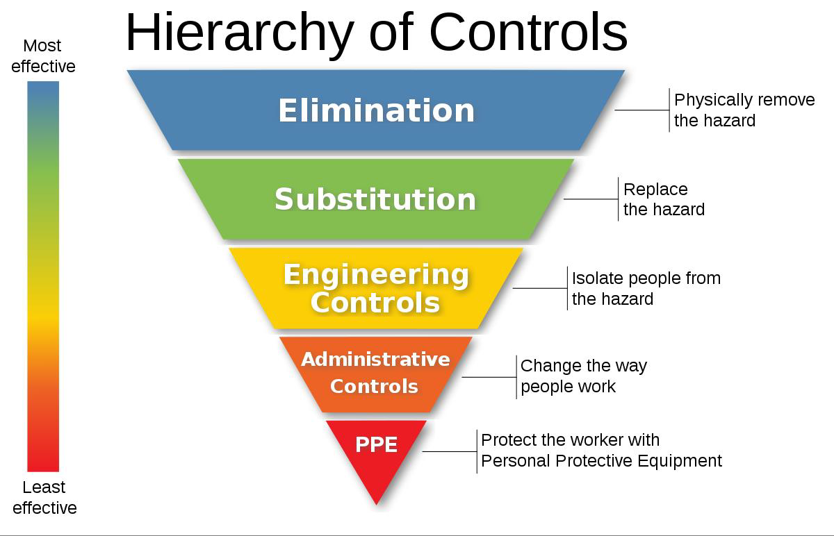

Source: https://www.cdc.gov/niosh/topics/hierarchy/default.html

Standard precautions include a group of infection prevention practices that apply to all patients, regardless of suspected or confirmed infection status, in any setting in which healthcare is delivered. Standard precautions include:

- Hand hygiene
- PPE use
- Safe injection practices
- Safe handling/cleaning of equipment and environmental surfaces
- Respiratory hygiene and cough etiquette
Administrative controls:
- Workplace safety programs
- Vaccination of healthcare personnel
- Infection control and prevention protocols
- Plans, procedures, algorithms, checklists

The Coalition has supported long term care facilities that needed assistance with Respiratory Protection Plan development and implementation. The coalition has trained facility staff to conduct fit testing utilizing the Qualitative fit testing kits. Facilities were provided fit testing kits, respiratory plan templates and forms. The coalition will continue to provide guidance and as funding allows may be able distribute additional fit testing kits. Facilities are required to obtain their own PPE and maintain the kits for facility use as necessary. In addition to fit testing kit distribution, the coalition has provided skilled nursing facilities with one Powered Air Purifying Respirator (PAPR). These facilities are required to maintain the PAPR in working order. A small cache of PAPR’s will be maintained by the coalition for additional needs.

The coalition provides the opportunity for healthcare and emergency medical services to receive annual first receiver training.

2.4.3 Non-Pharmaceutical Interventions

Non-Pharmaceutical Interventions (NPI’s) will be the principal means of disease control until adequate supplies of vaccines and/or antiviral medications are available. NPI’s are extremely important for infection control and are known to decrease the transmission of communicable diseases. The NPI’s recommended for all community members when dealing with a pandemic or disease outbreak, include:

- Staying home when sick
- Covering coughs and sneezes
- Frequent and appropriate hand washing
- Routine cleaning of frequently touched surfaces

A Governor’s Proclamation may create limitations for mass gatherings or closures.

The coalition share guidance developed by the CDC and MDH on an ongoing basis throughout the outbreak. These may include PPE actions, isolation and quarantine directions, and visitor restrictions.

See the reference section for CDC NPI links.

2.4.4 Surge Staffing

Staffing shortages may be a result of patient surge, staff turnover, staff illness, or illness/exposure in a family household requiring quarantine. In a small-scale response, the coalition may be able to arrange staff sharing support amongst the healthcare providers within the region. Facilities are encouraged to have relationships with staffing agencies as reliance upon other healthcare entities to share staff during a pandemic is unreasonable. Refer to the Appendix 3.5.6 Regional Resource Plan for more details regarding staff sharing.

Staffing shortage issues are not limited to healthcare providers, back up plans need to consider support services such as dietary, housekeeping and maintenance. The HMAC partners may also be able to support staffing assistance requests for those non-healthcare providers.

A variety of different staffing alternatives may be used in situations where standard staffing is not available. During the COVID-19 response, the Minnesota Department of Health and RHPC’s worked together to develop tools and resources to support Long Term Care in the response – several tools included resources for staffing support. These documents can be found on the MDH website. Healthcare facilities including hospitals, long term care providers, home health, clinics etc. should consider:

- Protocols for revision of staff work hours
- Cross-training staff
- Callback of off-duty personnel
- Use of non-clinical staff
- Local Medical Reserve Corps
- Untraditional patient care providers (e.g. family members, nonprofessional personnel such as city employees)
- Surge plans for home care agencies and clinics
- Contracts with staffing agencies
- Consider unique incentives to maintain existing personnel and reduce turn over.
- Tiered Staffing / Team Nursing

During the COVID-19 pandemic the Society of Critical Care Medicine (SCCM) recommended the utilization of a tiered staffing model for hospitals to expand the existing capacity of patient care areas specifically Intensive Care Units. The strategy utilizes lessons learned in emergency management responses and fire safety about span of control. Tiered staffing allows one experienced critical care physician to supervise four ICU teams.
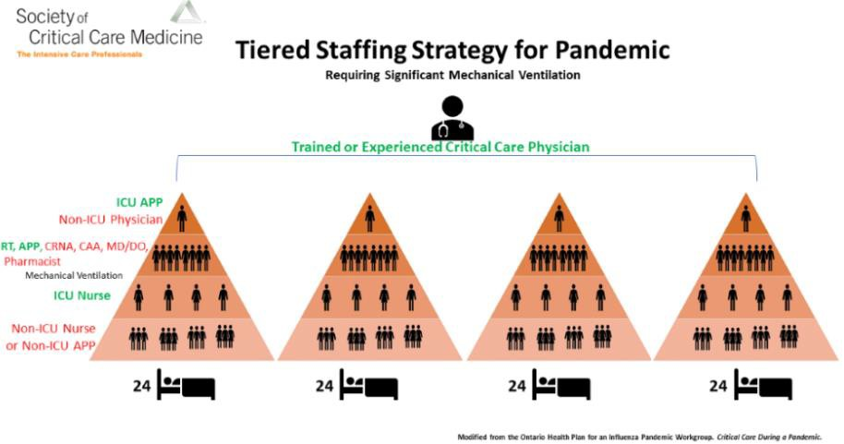

2.4.5 Supply Chain, Supplies, Personal Protective Equipment (PPE)
The Coalition maintains a small cache of items that may be available for redistribution during times of scarcity. Facilities can contact the coalition coordinator and request assistance from other facilities or the coalition. If the supply or resource is located and available, arrangements will be made to move the resource. The receiving facility is responsible for the reimbursement, if applicable.
Refer to the Coalition Response Plan - Appendix 3.5.6 Coalition Resource Plan.

The requesting site must exhaust all means to procure the resource on their own. The requestor may be required to show proof that the item/resource is not available. This support is not to be used due to increased costs of resources. All healthcare partners are strongly encouraged to make arrangements with their suppliers and support services in advance of an emergency. Facilities should consider including a clause to increase par levels during emergent situations.

2.4.6 Support Services
Support services may include any healthcare or non-healthcare staff or material resources required to support the care of infectious disease patients. This may include dialysis providers, blood banks/blood product providers, laboratory services, infection prevention/control, waste and material management, food and dietary services, and environmental services. Support service providers will work with local healthcare to prepare and respond by assisting healthcare organizations in the care of infectious disease patients. All healthcare partners are strongly encouraged to make arrangements with their suppliers and support services in advance of an emergency.

2.4.6.1 Laboratory

The Minnesota Infectious Disease Laboratory is Minnesota’s environmental and public health laboratory, serving all 87 counties by testing and tracking infectious diseases and illnesses. Clinical laboratories serving Minnesota are required by state statute to submit specific microbial isolates, allowing MDH laboratory to provide surveillance, reference and diagnostic testing services that are generally not otherwise available in the state. In addition, the Infectious Disease Laboratory is prepared to respond to emergencies and outbreaks that threaten the public's health. Not all patients and diseases qualify to be tested at the Minnesota Infectious Disease Laboratory.

Testing may also be completed at the hospital laboratories and reference laboratories.

Local Public Health may also support testing efforts within the counties. MDH can provide testing teams for regions, however the support received may be limited. Healthcare facilities including hospitals and clinics will be expected to provide testing support to fill in the gaps when able.

Refer to Addendum A for the appropriate links for Minnesota Department of Health.

2.4.6.2 Waste Management and Decontamination

Healthcare organizations will work through their normal vendors and channels to ensure all waste produced in the screening and care of infectious disease patients will be handled and disposed of appropriately.

Refer to the Coalitions Response Plan – Appendix 3.5.7 Handling of Solid Waste Contaminated with Infectious Waste

Infectious Disease Category | Pathogen | Requires Category A waste management for all medical waste | Generalized laboratory risk from raw specimen | Risk of transmission to healthcare workers providing direct  care | Other need for robust institutional response
Category 1 | Ebola, Marburg, Lassa, Crimean-Congo, Smallpox Note: low prevalence only – if high prevalence then these  pathogens might be Category 2 | Yes | Yes | Yes | Yes
Category 2 | MERS-CoV, SARS-CoV,  Avian Influenza, Measles | No | Yes | Yes | Yes
Category 3 | Pneumonic Plague, Cutaneous Anthrax, Antibiotic Resistant  Infections | No | No | Yes | Yes
Category 4 | Botulism, Tularemia, Glanders, Melioidosis | No | No | No | Yes
Adapted from, Tosh Pritish, MD (Mayo Clinic). A Preparedness/Response Model & Computer Simulation Modeling for High Consequence Infectious Disease. National Healthcare Coalition Preparedness Conference. December 2016.

2.4.7 Patient Care and Management
Refer to Coalition Response Plan Appendix 3.5.2 Regional Patient Tracking Plan

The coalition will work with the Coalition Medical advisor to share information about clinical and operational protocols based upon guidance from the World Health Organization (WHO) and the CDC. The coalition will also work closely with the Minnesota Department of Health and will share any guidance provided from the Infectious Disease Epidemiology, Prevention and Control (IDEPC) division.

Hospitals are encouraged to have arrangements with telemedicine providers to ensure consistent access to specialists and to ensure continuity of care for the community. This is especially important when bed availability statewide becomes limited, and facilities are forced to care for patients that they would normally transfer out.

The West Central region consists of two level III hospitals and six level IV hospitals. The partnership with the larger systems is essential. Facilities work closely with Sanford Health Fargo and Essentia Health Fargo which are Level I and Level II respectively as well as CentraCare Health St. Cloud Hospital which is a Level II hospital.

To ensure awareness of infectious disease outbreaks globally the coalition will provide an annual epidemiology update by inviting the Regional Epidemiologist to present to the group.

The coalition will maintain an up-to-date Annex 1 West Central Regional Health Care Assets and Essential Services. This tool identifies the resources and specialties available within the region.

During situations where there is a scarcity of bed availability and the region, the coalition will work with cross regional partners and State partners to identify bed availability. All coalition hospitals are required to report daily bed availability in the MNTrac platform.

The Statewide Healthcare Coordination Center (SHCC) was developed during the COVID-19 response. The SHCC brought the eight healthcare coalitions together with State, associations, and other response partners to work collaboratively in a response. This included utilizing the MNTrac platform to gather data and the development of a coordinated option for patient placement. The option to reactivate the SHCC during future responses will be beneficial to all.

The State of MN developed and maintained an updated Crisis Standards of Care framework and the Patient Care Strategies for Scarce Resource situations. Hospitals are encouraged to utilize these resources to support their response to any infectious disease outbreak or situations that create a scarcity of resources. See Addendum A to links for the tools.
During a response to an infectious disease event, hospitals will need to take measures to ensure that their facility does become a spreader of disease. Hospitals may choose to limit visitors within the hospital. Some possible restrictions include:

- Visitations with patients are limited to one support person.
- Patients on end-of-life support are limited to two support persons.
- Visitors are to be age 16 or older.
- Visitors are to be free of any signs of illness and/or exposure to infectious diseases.
- Adhere to strict physical distancing guidelines and hygiene protocols.
- Visitors may need to wear PPE.
- Stay in their respective patient’s room, as appropriate, unless using the laboratory or utilizing food services.
- Closure of common areas (e.g., waiting rooms, cafeteria)

2.4.8 Medical Countermeasures

During the COVID-19 response, the coalition developed a hub and spoke plan for the redistribution of vaccine between hospitals, clinics, local public health, and pharmacies. This plan can be adapted for use in other responses requiring redistribution of product/resources. The coalition also partnered with local emergency management to assist in redistribution of personal protective equipment and other supporting resources.

Public Health has the primary responsibility in Point of Dispensing (POD) and Medical Countermeasures (MCM) planning. These agencies may act independently or in conjunction with each other, intra-jurisdictional service area counties, and inter- service area wide counties situation dependent. Within these counties, primary and secondary receiving/distribution sites are pre-designated. The coalition will support as needed and requested.

One of the regional hospitals maintains the CHEMPACK for the region. The coalition works with MDH and the facility to ensure that the CHEMPACK and its’ contents are maintained per the federal guidelines.

See Addendum A for links to more information about the Chempack and Medical Countermeasures

2.4.9 Community-based Testing
Community-based testing relies on a partnership between local public health and healthcare. During times where there is a patient surge and hospitals are unable to provide routine testing the reliance will be on public health to support the needs of the community. Healthcare facilities may need to limit or reduce elective services to ensure the capacity to maintain community testing.
Lessons learned during the COVID-19 response showed the WC region that we need to be creative when looking for community-based testing options. The State of MN typically did not have the resources to assist beyond the large metropolitan borders. As assets became available limited testing support was created in Moorhead, MN. By targeting the larger communities (Moorhead) and communities with larger educational institutions such as the University of Minnesota in Morris, MN as sites for larger community-based testing sites will provide more output.
Recognizing that there may be a need to support facilities in obtaining specimens for Covid 19 testing, the health care coalition along with its’ partner agencies, local public health and regional emergency medical services have developed a plan to assist in this response.
Goal:
Through collaboration, the goal of this plan is to support facilities by providing tools and resources to ensure that specimens can be obtained for testing in a timely manner.
Roles:
Facility Response:
- Obtain specimen collection kits and ensure that all residents and staff are tested according to the State of Minnesota guidelines.
- If the facility is unable to collect the specimens, they are to reach out to their system and vendors for support.
- Contract with lab services.
- Contract with health care agencies.
Local Response:
- Assess the availability of local public health to assist with testing at the facility level.
- Consider activation of MN Responds.
- Assess the availability of local emergency management to assist with testing at the facility level.
- Assess the availability of local first responders to assist with testing at the facility level.
Regional Coalition Response: (If local response is not available)
  - Utilize the regional Memorandum of Understanding to reach out to hospitals within the region to request staffing support for specimen collection.
  - Create a team of individuals from surrounding counties that could assist in the process to include reaching out to neighboring local public health and local first responders for assistance.
  - Reach out to neighboring health care coalition leadership to assist in filling any regional gaps.
  - Provide just-in-time training to all personnel to ensure they understand their roles, thereby maximizing efficiency of operations and reducing workplace safety risks. It is essential that workers receive training in the donning, doffing, usage, and disposal of the PPE they will wear prior to participating in operations.
  - It is essential that individuals collecting the specimens be trained in the technique to ensure that the correct collection technique is utilized. Provide just-in-time training to all personnel to ensure they have the tools and techniques to provide the service.
      - NETEC training video for Covid-19 testing: https://www.youtube.com/watch?v=osl9W-O0O5g
Compensation:
The requesting facility/entity will be required to reimburse any agency that provides on-site specimen collection support. The sending facility/agency will invoice the requesting facility and reimbursement is requested within 30 days of receipt of the invoice.

2.4.10 Patient Transport

2.4.10.1 PATIENT Surge

During a patient surge situation, emergency medical services (EMS) may be forced to transport patients longer distances for higher levels of care. They may also need to transport patients from higher acuity facilities to lower acuity facilities to increase capacity of the higher-level facilities. The process of level loading involves not only moving patients from lower to higher level care centers but can involve moving patients from facilities that are full to those that have capacity.

During the COVID-19 response the coalition reviewed normal transfer patterns and identified alternative ways to utilize the EMS resources to maximize capacity.

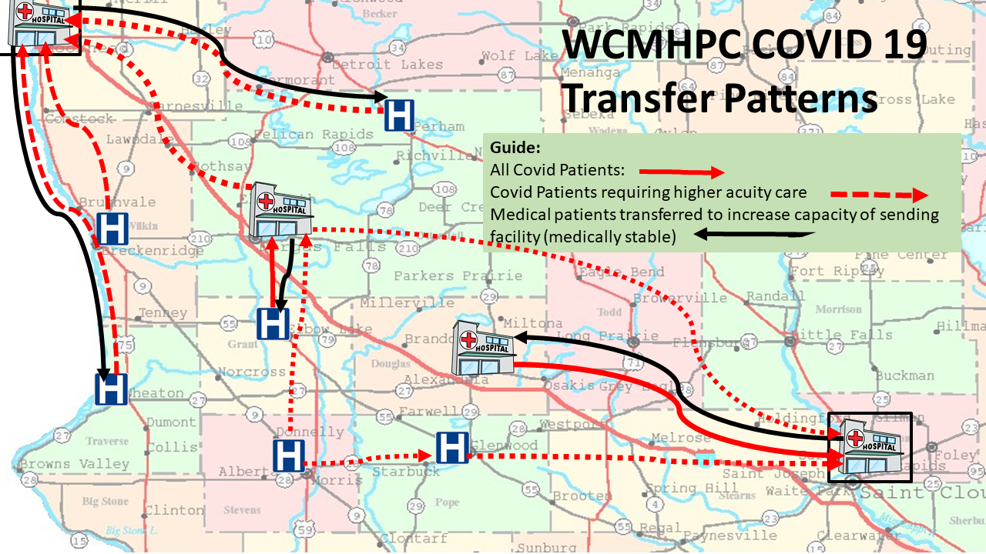

The above map identifies the standard transfer patterns as well as the options made available during the COVID-19 response. This map can be adapted for any scenario.

During COVID-19 the healthcare coalitions created a Patient Movement Decompression Guidebook as well as a directory of all the hospitals to support the decision-making process for patient transport:

The decisions about which patients are being transferred and where they are being transferred to is done at the facility level. The coordination between facilities will be supported by the coalition by requesting that facilities update their staffed bed availability in the MNTrac platform. The RMOCC process can be activated to support level-loading decision making amongst the hospitals within the region and possibly with neighboring regions.

2.4.10.2 Patient Tracking

During some instances it may be necessary to track the locations of patients and the specific movement of patients from facility to facility. The region developed a Patient Tracking plan to support patient movement related primarily to evacuations or mass casualty however this plan can be used to coordinate inter-agency patient movement if necessary. It is the hospitals’ responsibility to track patients and to maintain records about such transfers – including recording the receipt of a transferred patient at another facility.
Refer to the Regional Response Plan – Appendix 3.5.2 Regional Patient Tracking Plan

2.4.10.3 Patient Transport

Most Emergency Medical Services (EMS) have the capability of handling Category B and C infectious disease patients and the situation should be handled on a case-by-case basis.

Sick individuals may self-present to a medical facility or require transportation. Should a patient present at a hospital with an infectious disease, the patient may need to be transported to a designated assessment hospital, and possibly a specialized treatment facility (such as an approved Ebola Treatment Facility, in the case of Ebola virus disease). Surge strategies may need to be implemented if the number or complexity of patients is great. If an individual is determined to be a case, contaminated material may need to be removed from locations visited by the person, and further environmental decontamination may be required. Pets/service animals also may need to be cared for and monitored for symptoms.
The State of Minnesota identified seven EMS services for Category A infectious diseases.
See the All-Hazards Response and Recovery Plan STATE OF MINNESOTA CONCEPT OF OPERATIONS: EBOLA VIRUS DISEASE CHAPTER OF THE HEALTH CARE SURGE ANNEX (Link in Addendum A)

Ebola or Other High Consequence Infectious Disease Ready Ambulance Services:
Agency | EMS Region(s) of Operation96 | Contact Name | Email | Station Address
Allina Health EMS | Metro, Central, South Central, Southwest | Cory Kissling | cory.kissling@allina.com | 167 Grand Ave  Saint Paul, MN 55102
Altru Ambulance Service | Northwest | Eric Toutenhoofd | etoutenhoofd@altru.org | 1200 South Columbia Rd  PO Box 6002  Grand Forks, ND 58206
Sanford EMS | West Central, Northwest | Rick Cameron | rick.cameron@sanfordhealth.org | 2215 18th St S  Fargo, ND 58103
Gold Cross EMS | Northeast, Central, Southeast | Mike Sveen | sveen.michael@mayo.edu | 501 6th Ave NW  Rochester, MN 55901
HealthEast EMS | Metro | Nick Lesch | njlesch@healtheast.org | 799 Reaney Ave  Saint Paul, MN 55106
North Memorial Ambulance | Metro, Central, Southeast, South Central, Southwest | Kevin Novotny | Kevin.Novotny@northmemorial.com | 4501 68th Ave N  Brooklyn Center, MN 55429
CentraCare EMS | Southwest/Central | Brad Hanson | bradly.hanson@centracare.com | 301 SW Becker Ave  Willmar, MN 56201

Source: https://www.health.state.mn.us/communities/ep/plans/allhazardsebola.pdf

2.4.11 Mass Fatality
Counties should follow their local guidelines with coalition support.
Refer to the Regional Response Plan - Appendix 3.5.1.3 WCMHPC Mass Fatality Planning

At any time, the counties can request assistance from The Minnesota Office of the State Medical Examiner. The State Funeral Directors Association may provide needed supplies, equipment, vehicles, and personnel as well. If called upon, the State Funeral Directors Association staff is there to assist the Medical Examiner only; they do not work under any local response agency.

The emergency manager and public health may establish family assistance centers around the event and have developed plans for those centers.

2.5 Special Considerations

2.5.1 Behavioral Health

During an infectious disease outbreak a range of mental health and chemical abuse (behavioral health), and stress management problems may surface. Social isolation, infection control measures, and mandated activities increase the feeling of loss of control. The healthcare response during an infectious disease outbreak can include working long hours, dealing with issues that are beyond their normal day to day practice, and suffer from isolation from support networks. During the COVID-19 response it was recognized that there was a need to develop tools and resources to support the healthcare worker. The WellnessMN.org website was created to ensure that healthcare and responders to COVID-19 had access to these tools. All employers, all leaders, and all staff are encouraged to access this information.

The State of MN developed a Regional Behavioral Health Coordinator position during the COVID-10 response. Regional Behavioral Health Coordinators are disaster behavioral health subject matter experts who engage in outreach and educational activities within each of the public health regions across the state to facilitate the resiliency and recovery of survivors and responders from disasters, terrorism, and public health emergencies.

Behavioral health services are limited during the best of times. Access to inpatient behavioral health beds is difficult. Lake Region Health has 17 inpatient behavioral beds, and these beds are always at 90% occupancy. Hospitals are often forced to board behavioral health patients waiting for in-patient services.

There are two 16 bed inpatient Community Behavioral Health Hospitals in the WC region. One in Fergus Falls and the other in Alexandria. Access to these facilities is through referral by social services.

2.5.2 At-Risk Populations
As a rural healthcare coalition our community at a whole is considered at-risk. There is an overall lack of services due to geography and availability of limited resources. One example being the number of EMS agencies serving a large geographical area often leads to long wait times, long transportation times and limited resources for higher acuity needs.

All coalition planning involves ensuring that all people have equal access to the appropriate care. Considerations are given to those individuals who require resources such as those with language barriers, mobility issues, homelessness, communities of color and the LGBTIQ+ population. Many healthcare facilities and local public health agencies within the coalition have staff available that may be able to assist with translating or have recommendations for language services. Service Area Coordinators can assist healthcare organizations in finding additional language services.

All coalition members are asked to include Access and Functional needs in their planning efforts.

Refer to Addendum A for ASPR Tracie link regarding Access and Functional Needs

2.5.3 Situational Awareness

Essential elements of information (EEI) is any critical information required by coalition members to ensure that they are able to respond to any event. This allows membership to make informed decisions. The EEI are specific to a particular event or thing. The EEI are written out in advance of an event so that when the event occurs this information is obtained.

To ensure situational readiness during a response to an infectious disease – the following EEI are identified for the healthcare organizations and response partners:

Healthcare Organizations | Critical Partners
• Facility operating status | • School-related data
• Facility structural integrity | • Road closures
• Status of evacuations/shelter-in- place operations | • Critical infrastructure status (e.g., electrical, sewer, water)
• Status of critical medical services (e.g., trauma, critical care) | • EOC status
• Critical service/infrastructure status (e.g., electric, water, sanitation, HVAC) | • Local declarations
• Bed or patient status/patient tracking | • Public information
• Equipment, supplies, medications, vaccine status or needs | • Evacuation/shelter-in-place operations
• Staffing status
• Emergency Medical Service (EMS) status
• Epidemiological, surveillance or lab data (e.g., test results, case counts, deaths)
• POD/mass vaccination sites data (e.g., throughput, open/set-up status, etc.)
• Access and Functional Needs sheltering status

Refer to the Regional Response Plan – Appendix 3.4.2 Essential Elements of Information

2.5.4 Communications

EEI and data sharing amongst coalition members and response partners is critical for a successful response to an infectious disease situation. The gathering of information will be sporadic throughout the response and the information will change frequently as more information is learned.

Regional situational awareness will utilize the processes outlined in Appendix 3.5.5 Regional Communications plan.

The coalitions’ primary role in a response is information sharing. The Coalition will receive, collect, organize, interpret, and assess information on the infectious disease incident and its actual and potential impact on the region. Sources of information may include local, state, federal, and international public health agencies, medical providers, response partners, and subject matter experts.

The frequency of the situation report will be event driven.

During an infectious disease incident, the Coalition supports MDH efforts to disseminate public health, disease prevention, and behavioral health information to the partners.

Coalition members are responsible for reporting issues that may impact local or regional healthcare delivery.
If the local/county partners are aware of impacts to healthcare organizations, they should also notify the regional coordinator or designee. It is understood that healthcare organizations may or may not elect to notify the coalition and/or that notification may be delayed, depending on the situation.

Response Data and/or EEI may be gathered by the coalition and reported up to the State as requested.

During an infectious disease response data may be requested from local healthcare to support initiatives and response needs by the State. The State of Minnesota may utilize the MNTrac platform or RedCap surveys to obtain information for healthcare. It is essential that healthcare members respond appropriately to these data requests. The coalition will support the state by providing guidance on reporting the data as requested.

2.5.5 Jurisdictional – Specific Considerations
The WC region follows the I-94 corridor and borders with North Dakota. Moorhead, MN is a micropolitan community located in Clay County. This community is unique as they do not have a hospital within their boundaries. The closest hospital is across the border in Fargo, North Dakota. This requires close communications between the region, Clay County PH, and our healthcare partners and public health in North Dakota. Moorhead has a large population of homelessness that will have a direct impact in an infectious disease response. Often times the city of Moorhead have had to fend for themselves and during an infectious disease outbreak they need to the support of not just their own county but of the region as a whole. Cross border collaboration is essential.

2.5.6 Training and Exercises
Facilities should regularly test their plans and communication methods with the staff to ensure the staff knows what to do in a real-world incident. Exercise templates and training tools can be found at: https://www.health.state.mn.us/diseases/hcid/

Several infectious disease trainings can be found at:

    - https://www.train.org/
    - https://www.cdc.gov
    - https://www.netec.org/
    - https://www.who.int/

The coalition also completes a training and exercise workshop annually outlining the goals for the next three years. These will include a regional communications exercise twice per year, first receiver training and a coalition surge exercise annually.

2.5.7 Deactivation and Recovery
As in any response, demobilization and recovery planning should begin immediately. When an infectious disease outbreak is involved, the process may be long term and will require accurate record keeping. As the local healthcare facilities, local public health, local emergency management monitor the coordination and the response they will determine when the response concludes. Consideration will need to include regional and state decision making processes as well.

ADDENDUMS

Addendum A: References
ASPR Tracie
Access and Functional Needs
Access and Functional Needs | ASPR TRACIE (hhs.gov)
Center for Disease Control and Prevention (CDC):
Nonpharmaceutical interventions:
https://www.cdc.gov/nonpharmaceutical-interventions/index.html

Minnesota Department of Health

All-Hazards Response and Recovery Plan STATE OF MINNESOTA CONCEPT OF OPERATIONS: EBOLA VIRUS DISEASE CHAPTER OF THE HEALTH CARE SURGE ANNEX
State of Minnesota Concept of Operations: Ebola Virus Disease

MDH Lab
https://www.health.state.mn.us/about/org/phl/topics/index.html

Crisis Standards of Care Plan
Crisis Standards of Care - Minnesota Dept. of Health (state.mn.us)

Patient Care Strategies for Scarce Resource Situations
Patient Care Strategies for Scarce Resource Situations (state.mn.us)

SNS Chempack Project
SNS Chempack Project - Minnesota Dept. of Health (state.mn.us)

Medical Countermeasures
Medical Countermeasures - Minnesota Dept. of Health (state.mn.us)

Regional Behavioral Health
https://www.health.state.mn.us/communities/ep/behavioral/rbhc.html

National Institute of Allergy and Infectious Diseases:
NIAID Emerging Infectious Diseases/ Pathogens | NIH: National Institute of Allergy and Infectious Diseases

Society of Critical Care Medicine:
https://sccm.org/getattachment/Blog/March-2020/United-States-Resource-Availability-for- COVID-19/United-States-Resource-Availability-for-COVID-19.pdf?lang=en-US

National Emerging Special Pathogens Training and Education Center

PPE (COVID-19) Use and Conservation · PPE (COVID-19) Use and Conservation · NETEC Resource Library (netecweb.org)

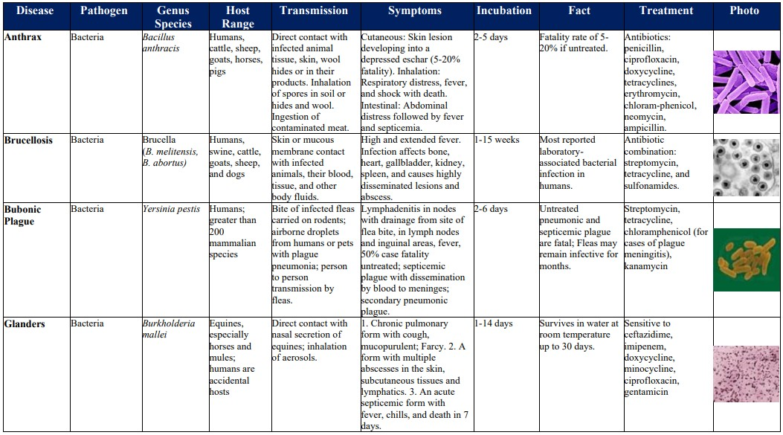
Addendum B – Agent Fact Sheets

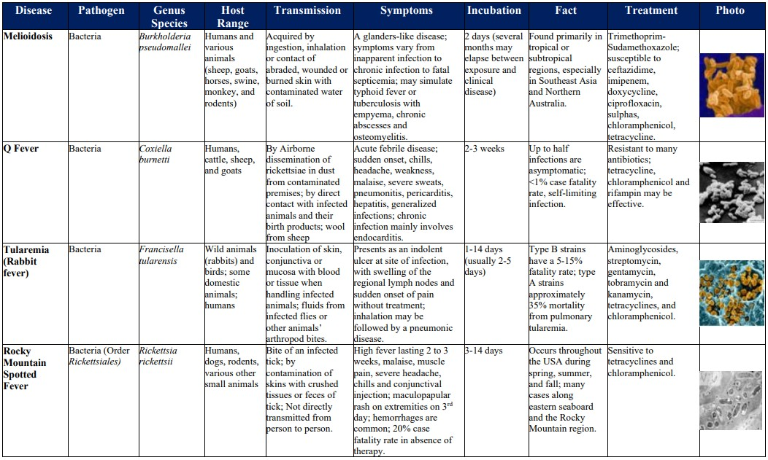

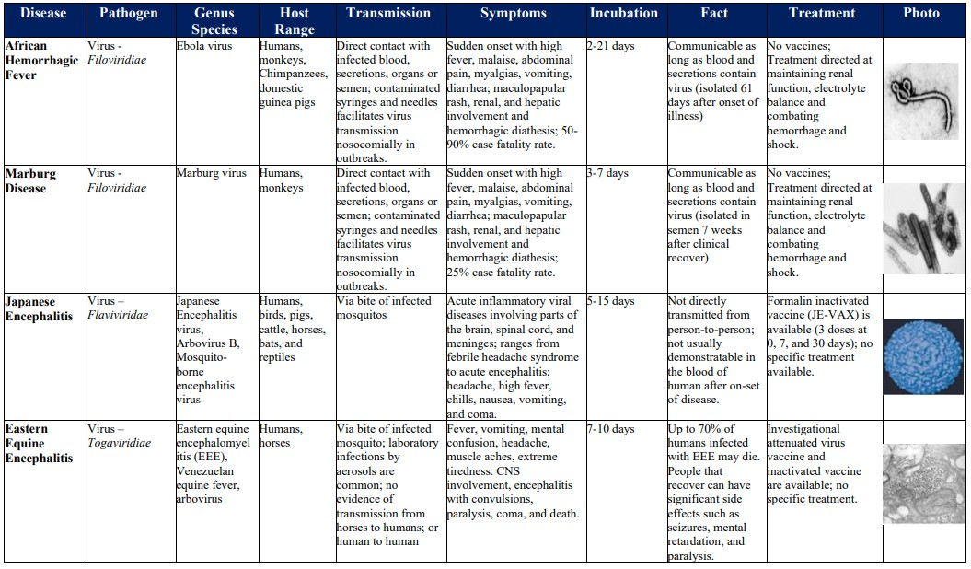

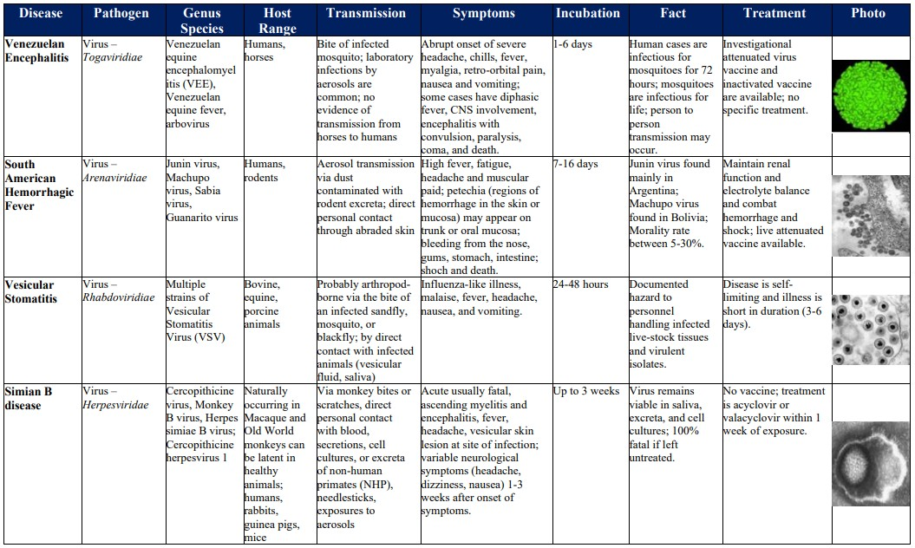

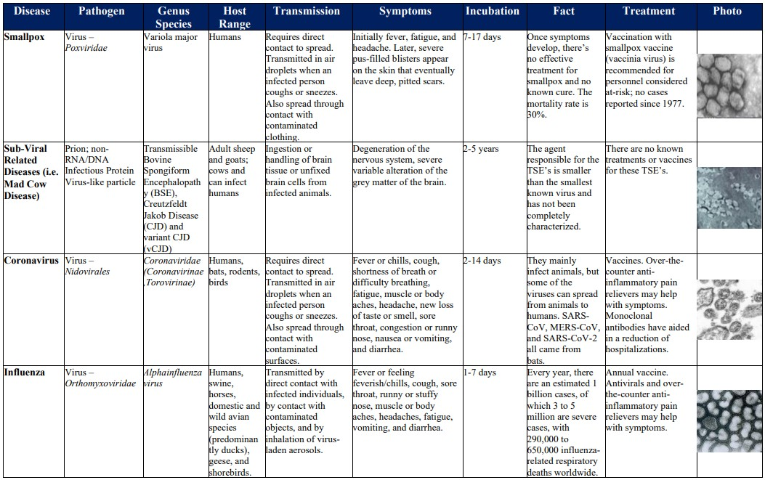
Table completed with information from https://www.osha.gov/alliances/products, https://www.cdc.gov/, https://www.niaid.nih.gov and
https://www.who.int/emergencies/diseases/en/

Approvals and Revisions
Purpose | Date
Updated to correct grammatical errors, include the RMOCC process, update EMS agency point of contacts | Approved June 14, 2023

