Date: April 2023
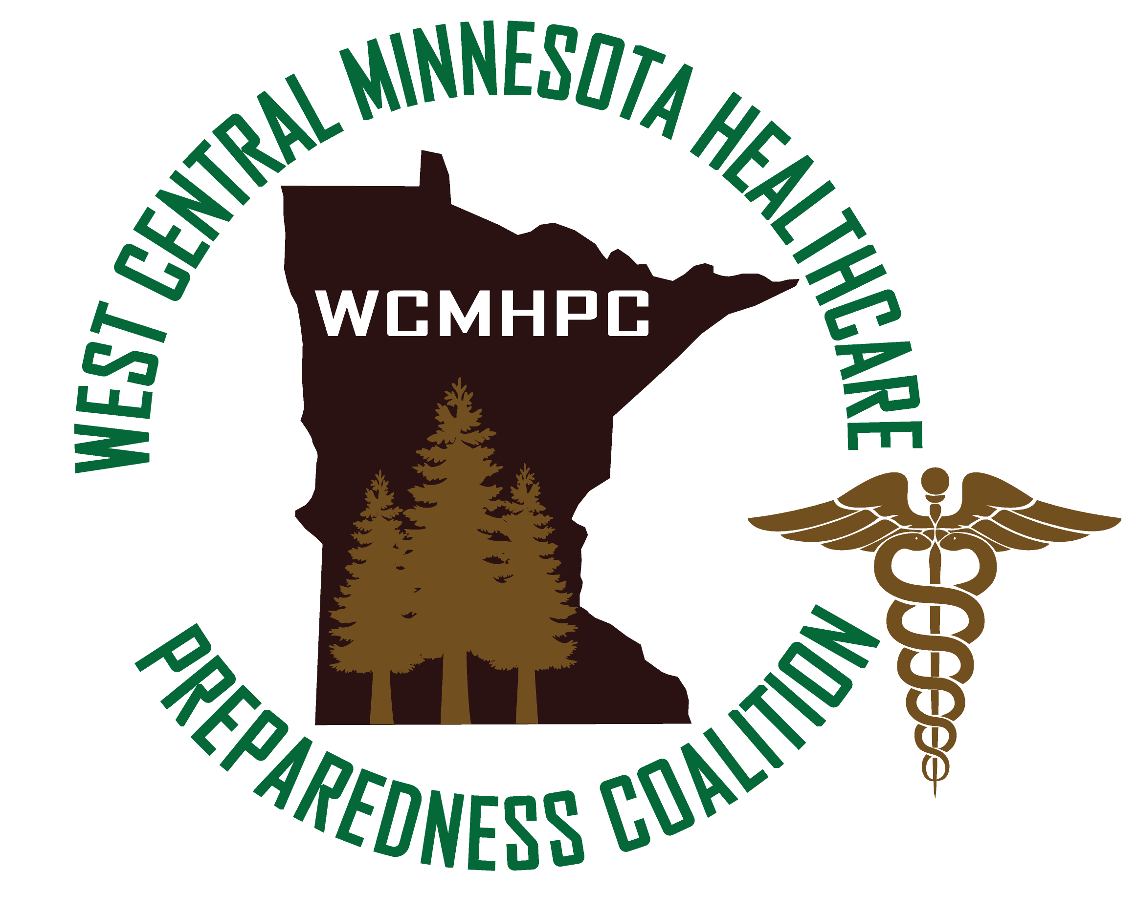

Appendix 5.7 Access and functional needs plan

Appendix 5.7 Access and functional needs plan

Purpose
The purpose of this document is to outline the role of the West Central Minnesota Healthcare Preparedness Coalition (WCMHPC) in response to an event that includes Access and Functional Needs (AFN) populations. In healthcare it is essential that Health Equity is also considered when decisions are made. This Appendix also provides guidance to the WCMHPC members and partners for their planning purposes.

Definitions
  - At-Risk individuals: people with access and functional needs that may interfere with their ability to access or receive medical care before, during, or after a disaster or emergency. Irrespective of specific diagnosis, status, or label, the term “access and functional needs” is a broad set of common, crosscutting, access, and function-based needs.
    - Access-based needs require ensuring that resources are accessible to all individuals, such as social services, accommodations, information, transportation, medications to maintain health, and so on.
    - Function-based needs refer to restrictions or limitations an individual may have that requires assistance before, during, and/or after a disaster or public health emergency.
    - Included in this group are people who are physically or mentally disabled (e.g. blind, deaf, hard of hearing, have learning disabilities, mental illness or mobility limitations), people with limited English language skills, geographically or culturally isolated people, homeless people, senior citizens, and children
  - Health Equity: The Center for Disease Control and Prevention (CDC) defines Health Equity as the state in which everyone has a fair and just opportunity to attain their highest level of health. Achieving this requires focused and ongoing societal efforts to address historical and contemporary injustices; overcome economic, social, and other obstacles to health and healthcare; and eliminate preventable health disparities.
  - Special Medical Needs: a person with medical special needs includes someone who:
    - would need assistance during evacuation and sheltering because of physical or mental disabilities
    - requires the level of care and resources beyond the basic first aid level of care that is available in the shelters for the general populations

Role of the WCMHPC in Planning for At-Risk Individuals, Functional Needs, and Special Medical Needs
- Local Emergency Management and Public Health are primarily responsible for Mass Sheltering plans, which include At-Risk Individuals, Access and Functional Needs, and Special Medical Needs. Healthcare facilities may be asked to assist with certain medical needs that may not be available in a shelter environment.
- Mass Sheltering Operations will occur in accordance with local Emergency Operations Plans (EOPs). Refer to local EOPs for reference.
- The WCMHPC will assist in providing information and resources in the pre-planning, response, and recovery as needed in order to help lessen the impact especially during response and recovery.
- In all planning, preparedness, training and education events held by the WCMHPC, the coalition will reinforce the definition of health equity and encourage that all coalition members consider health equity in their day-to-day operations as well as during response events.

WCMHPC Access and Functional Needs Planning Considerations

Planning Considerations
    - Planning at a healthcare level may include working with entities within the healthcare agency who interact with people who have a healthcare need that extends outside the agency. Examples may include those who are on or need oxygen, dialysis, infusions, or other medical device, medication, or assistance routinely causing them to interact with a healthcare entity.
    - This planning could take the form of asking individual sections within a healthcare organization to discuss with patients how to manage during a crisis if access to a healthcare agency may be in jeopardy.
    - The planning could also cause the specific section within a healthcare organization to do planning in order to pre-identify patients considered at risk, if access to healthcare or services are in jeopardy. This planning could take the form of prioritizing patients that need more immediate access than others. Working with other local disaster personnel could assure persons whom are considered more in need are accounted for in a timelier manner during crisis settings.
    - Healthcare agencies should be prepared to accept patients during crisis that would otherwise be consider outpatients due to a lack of items such as oxygen, electricity, and other medical items needed to deliver medications or functions that were curtailed at home due to the crisis variables.
    - Medical surge should also be accounted for during crisis events not only for those directly injured, but also for patients who have exacerbations of medical conditions or who are in need of medical supplies, medicines, or device otherwise not planned on but created by the crisis event.
    - Increases in staffing, supplies, and entropy are all impacts during crisis and disaster settings.

Resources
During a disaster, it has been observed that certain at-risk individuals, specifically those with access and functional needs, have required additional response assistance before, during, and after an incident. These additional considerations for at-risk individuals with access and functional needs are vital towards inclusive planning for the whole community, and have been mandated for inclusion in federal, state, territorial, tribal, and local public health emergency plans by the Public Health Service (PHS) Act. Such plans must also meet applicable requirements of the Americans with Disabilities Act (ADA).
The CDC guidance will introduce and connect you to available resources and inclusive strategies for integrating the access and functional needs of at-risk individuals into emergency preparedness, response, and recovery planning at all jurisdictional levels.
http://www.phe.gov/Preparedness/planning/abc/Pages/afn-guidance.aspx
The Minnesota Department of Health, Center for Health Equity was created to improve health equity statewide. Coalition members are strongly encouraged to participate in Health Equity training and programs. Health Equity - MN Dept. of Health (state.mn.us)

Approvals and Revisions
Purpose | Date
Updated to correct grammar and include language regarding health equity. | Emailed 3/11/2023 and approved by all 4/3/2023

