Date: January 2023

Appendix 5.6 continuity of operations

Contents
Introduction 2
COALITION CONTINUITY OF OPERATIONS 2
Order of succession 3
Continuity of Systems 3
1. Outlook: 3
2. Essential Files: 3
3. Website 4
4. Communication sources 4
5. Coalition Office 4
HEALTHCARE CONTINUITY - ESSENTIAL FUNCTIONS 5
Access to Healthcare Workforce: 5
Community/Facility Critical Infrastructure: 6
Health Care Supply Chain: 6
Access to Transportation: 7
Information Technology/Communications: 7
Administrative/Financial: 7
ORGANIZATION LEVEL CONTINUITY PLANNING RESOURCES 8
1. Community Level Continuity Planning Resources for Pandemics 8
2. Fiscal Considerations 8
3. Medicare Claims Submission 9
4. Accelerated/Advanced Payment from Medicare 10
5. Federal Regulation Waivers 10
6. Insurance Strategies 11
7. Pandemic Disaster Assistance Policy Influenza 13
8. Federal Recovery Support Functions 13
9. Supporting Reference Documents 15
DEFINITIONS 15

Introduction
The primary purpose of the continuity of operations plan (COOP) is to enable the coalition to recover from a disaster as soon as possible so that it can continue its mission. In times of disaster, that mission might additionally include support and assistance to the various healthcare agencies, other public safety organizations and their personnel, and the public, to help them recover from disaster. The exact form of assistance may vary depending on the disaster, but this plan identifies the essential steps the Coalition will take to support the healthcare community and others who will depend on that support.

COALITION CONTINUITY OF OPERATIONS
The WCMHPC has a partnership with the Central Health Care coalition and St Cloud Hospital. St. Cloud Hospital acts as the fiscal agent for the WCMHPC coalition. The following table shows the organizational structure related to emergency preparedness and the WCMHPC and CMHPC collaborative:
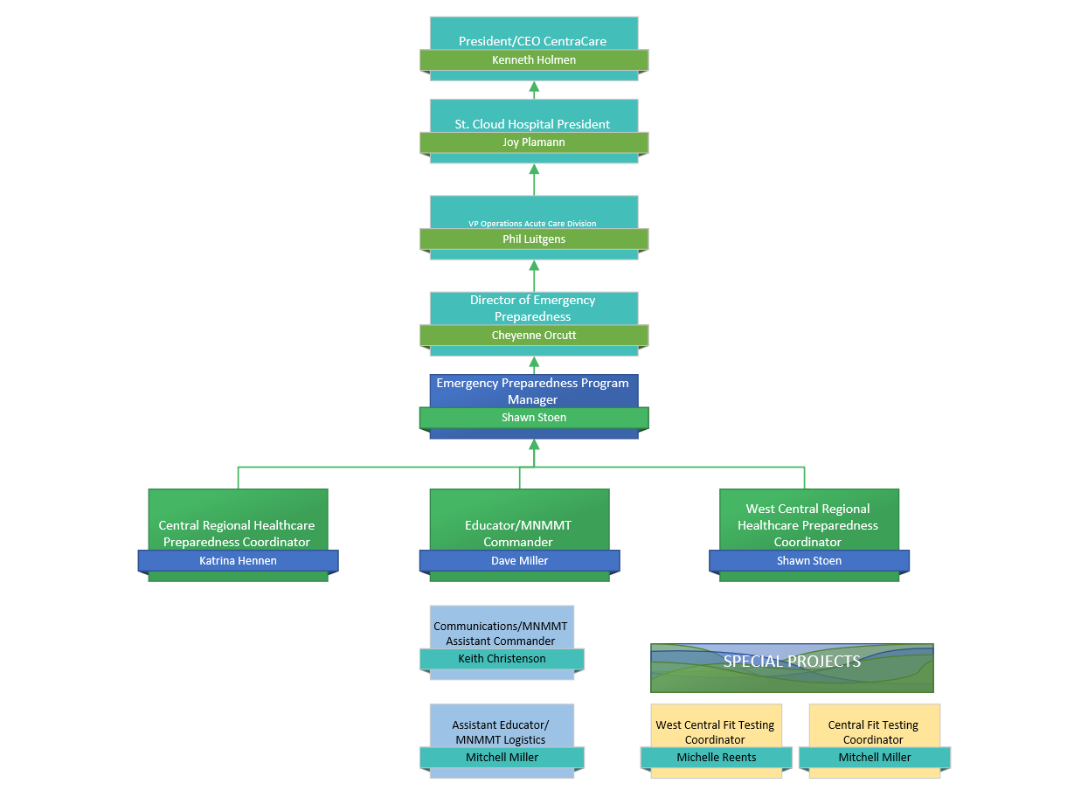
If at any time, the West Central Regional Healthcare Preparedness Coordinator (RHPC) is unavailable to perform their duties, coalition members are to contact the HPP Program Manager and/or the Director of Emergency Preparedness for assistance and guidance. During planned absences, the WC RHPC will notify coalition members in advance any changes to coalition contacts. If any members have any concerns about the operations of the coalition, they can reach out to the Director of Emergency Preparedness at CentraCare or the Minnesota Department of Health Office of Emergency Preparedness and Response.

Order of succession
During or after a disaster or any other event that can impact the operations of the coalition, in the long-term absence or inability of the Regional Healthcare Preparedness Coordinator (RHPC) to perform executive functions, the following are authorized to act on behalf of the RHPC in the order of succession listed until his/her return or until the a replacement is named:
- West Central Public Health Preparedness Consultant (PHPC) and/or
- Program Manager
- Central RHPC or North West RHPC
- Central and West Central Exercise and Training Coordinator
- Delegate from the Hospital Advisory team membership

Continuity of Systems

Outlook:
- The WC RHPC will ensure that all contact lists are shared and accessible to the succession list via SharePoint.
- The WC RHPC will share his/her calendar with the Central Region RHPC and the Exercise and Training Coordinator.
- The WC RHPC will enable the Central Region RHPC to have access to the WC emails.
- The WC Coalition will use a standardized email (cwchealthcarecoalitions@centracare.com) that is not tied to one specific individual to allow access by the succession list at any time.

Essential Files:
  - The Coalition require all work-related electronic files to be saved on the St. Cloud Hospital/CentraCare Health System network server. Which is accessible to the Central RHPC and Exercise and Training Coordinator. Backup files may be restored by IT support as needed.
  - Coalition files are also maintained on the Coalition SharePoint site and website.
  - Laptops should be configured to automatically save to a default network file location.
  - 24/7 IT support is available by calling the St. Cloud Hospital at (320) 251-2700 and request extension 54540.
  - Laptops are required to be password protected and those passwords shall be changed frequently.
  - All RHPC’s have a mobile hotspot device to ensure connectivity to the internet if facility-based internet is not available.

Website
  - The WC and Central RHPC as well as the Training and Exercise Coordinator and Central Administrative assistant have administrative access to the coalition website.
  - The website is maintained on the Meta13 server. Emergency contact with Meta13 can be made by calling (320) 230-1223.
  - Website account information can be found on the Bioterrorism shared drive under the folder titled Website.

Communication sources
- Refer to the Regional Response Plan Communications Plan
- Bi-annual radio tests will ensure proficient use of the 800 MHz radios amongst coalition partners.
- Bi-annual communications exercises will ensure that all members understand the forms of redundant communications in place.
- In the absence of the MNTrac Command Center, the coalition will utilize the chat room in the coalition website for non-patient related information sharing.

Coalition Office
- The main office for the coalition is located at:
  - 1555 Northway, St. Cloud, Minnesota
- The alternate office location is:
  - 9840 State Highway 114 SW, Alexandria, Minnesota
- Minimal office requirements:
  - Electricity/water/sewer
  - Access to internet – either directly or indirectly
  - Copier/Scanner
  - Communications – Telephone, Cellular, and 800 MHz
- Coalition staff will practice safe workplace practices by being aware of weather conditions and other situations which could impact the safety in their workplace.
- All smoke detectors and carbon monoxide detectors are to be in working order.
- Coalition staff are to follow safe zone recommendations – i.e. shelter in place and evacuation zones

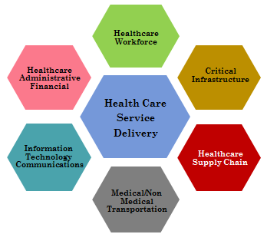
HEALTHCARE CONTINUITY - ESSENTIAL FUNCTIONS

The following functions are considered essential to ensure the coalition can successfully commit to their mission:
- Healthcare Workforce
- Critical Infrastructure
- Supply Chain Integrity
- Transportation
- Information Technology/Communications
- Administrative/financial support
All members of the coalition are encouraged to develop their continuity of operations plan to ensure that these essential functions are always accessible. The health care coalition will support their membership in providing these essential functions.
During or after a disaster, or any event that has the potential to disrupt the ability of the coalition to fulfill its’ mission the coalition will:
- Collect situational assessment data from coalition members on their ability to provide patient care.
- Aggregate individual facility data to generate coalition health care service delivery situational report.
- Disseminate health care service delivery data to local and state authorities.
- Assist local health care coalition partners in obtaining/securing resources, as available.
- Assist coalition partners in returning to full operational status.

Access to Healthcare Workforce:
Defined: Access to healthcare workforce is the ability to deploy a credentialed health workforce to provide patient care to support healthcare service delivery in all environments.
The coalition shall support its’ partners by:
- Conducting a health workforce shortage assessment within coalition boundaries, In collaboration with local partners
- Coordinating with health care organizations to maximize medical & non-medical personnel support. This may include activating the Regional Memorandum of Understanding.
- Working with local public health in identifying resources to support the local need – including Minnesota Responds.
- Disseminating reports of regional staffing shortages to local emergency management/emergency operations center and Minnesota Department of Health, if applicable.

Community/Facility Critical Infrastructure:
Defined: To be fully operational critical community/facility infrastructure including power, water, and sanitation, etc., is necessary to support patient care environments.
The coalition shall support its’ partners by:
- Determining local/region-wide disruption of critical infrastructure that affects the health care system.
- Aggregating reports of critical infrastructure disruption.
- Disseminating reports to Coalition partners, as appropriate.

Health Care Supply Chain:
Defined: Supply Chain integrity is full access to the healthcare supplies including medical & non-medical supplies, pharmaceuticals, blood products, industrial fuels and medical gases, food etc.

The coalition shall support its’ partners by:
- Monitoring region-wide disruption of health care supply chain.
- Determining the specific medical and non-medical supply needs of health care partners.
- Facilitating disaster medical resource support for health care organizations with local emergency management agency/emergency operations center and Minnesota Department of Health, as applicable.
- Assisting with coordinating private sector vendors on distribution and resumption of normal supply delivery.
- Disseminating health care supply chain disruption situation reports to local emergency management agency/emergency operations center Minnesota Department of Health, as applicable.
- Activating the coalition memorandum of understanding and coordinating the sharing of resources amongst coalition members and if necessary, accessing the limited coalition cache. See the Regional Response Plan - Resource Request plan.

Access to Transportation:
Defined: A fully functional medical and non-medical transportation system that can meet the operational needs of the healthcare sector during the response and continuity phases of an event.

The coalition shall support its’ partners by:
- Collecting medical transportation needs of health care organizations during response and continuity operations.
- Working with the West Central EMS representative or alternate, coordinate with EMS agencies to close gaps in medical transportation needs.
- Advocate for coalition partners’ medical transportation assistance.

Information Technology/Communications:
Defined: Fully functional information technology and communications infrastructure that supports high availability of the healthcare sector’s data management and information sharing capability.
The coalition shall support its’ partners by:
- Determining the extent of disruption of communication/information technology capabilities within coalition boundaries.
- Activate redundant communication capabilities if necessary – to include monitoring the regional 800 MHz talk group, opening up a Command Center in MNTrac, utilizing the chat room in the coalition website.
- Work with local Emergency Management to identify alternative sources of communications such as HAM radio and Cellular support services.
- Coordinate with state health authorities to disseminate critical response and continuity operations information.

Administrative/Financial:
Defined: Fully operational administrative and financial capability including maintaining & updating patient records, adapting to disaster recovery program requirements, payroll continuity, supply chain financing, claims submission, losses covered by insurance and legal issues.
The coalition shall support its’ partners by:
- Collecting disaster response data to be used in after action reports.
- Informing coalition partners about any available disaster assistance from federal, state, and local authorities.
- Providing incident command support either by utilizing the regional memorandum of understanding and sharing staff and subject matter experts to support the facility operations center.

ORGANIZATION LEVEL CONTINUITY PLANNING RESOURCES
The following standards provide organizations frameworks for establishing a process and standards-based continuity and recovery program. The standards are applicable to any type of organization.

- ASIS SPC.1-2009 Organizational Resilience: Security, Preparedness, and Continuity Management Systems-Requirements with Guidance for Use

- ISO 22301: Societal security –Business continuity management systems --- Requirements

- NFPA 1600: Standard on Disaster/Emergency Management and Business Continuity Programs

Community Level Continuity Planning Resources for Pandemics
The following resources provide communities frameworks for understanding essential services during an event that will affect the community’s ability to maintain healthcare system services and for establishing pandemic continuity plans for the healthcare system.
- http://www.flu.gov/planning-preparedness/community/index.html

- https://www.ready.gov/pandemic

Fiscal Considerations
Disaster Declaration the Robert T. Stafford Disaster Relief and Emergency Assistance Act
At the request of the Governor of an affected State, or a Chief Executive of an affected Indian Tribe, the President may declare a major disaster or emergency if an event is beyond the combined response capabilities of the State, Tribal, and jurisdictional governments. Among other things, this declaration allows Federal assistance to be mobilized and directed in support of State, Tribal, and jurisdictional response efforts. Under the Stafford Act (42 USC Chapter 68), the President can also declare an emergency without a Gubernatorial request if primary responsibility for response rests with the Federal Government because the emergency involves a subject area for which the United States exercises exclusive responsibility and authority.
In addition, in the absence of a specific request, the President may provide accelerated Federal assistance and Federal support where necessary to save lives, prevent human suffering, or mitigate severe damage, and notify the State of that activity.
FEMA administers disaster relief funding allowed under the Stafford Act. Reimbursement eligibility rules apply for certain aspects of emergency medical care including:
- Treatment and monitoring of disaster victims requiring medical care.
- Vaccinations for disaster victims, emergency workers and medical staff.
- Only private nonprofit healthcare facilities may directly apply for FEMA assistance grants.
- For-Profit entities may be indirectly eligible through established mutual aid agreements, emergency operations plan, or memorandums of understanding with other nonprofit entities.
- FEMA’s role as “payer of last resort” requires individuals, as well as entities like hospitals and other medical facilities, to exhaust all other forms of insurance and reimbursement before seeking assistance FEMA
- Access to the FEMA forms: https://www.fema.gov/forms

Medicare Claims Submission
Healthcare organizations may experience operational circumstances that may impede their ability to meet many of the Medicare requirements, including conditions of participation, certification, and proper claims submission procedures. Activities that will assist healthcare organizations in meeting federal and state requirements include developing and implementing processes to:
- Monitor and report staffing issues that may affect claims submission
- Alert local, state, and federal authorities on medical surge conditions that may overwhelm the healthcare system and create a backlog of claims submissions for both Medicaid/Medicare and private payer submissions. The WCMHPC HMAC will work with the MDH to assist in this process.
- Monitor and document volunteer and out-of-state personnel who are working with the healthcare organization and assess if they will affect the organization’s ability to be reimbursed by Medicare.
- Monitor the impact of any declaration emergency/disaster or implementation of Crisis Standards of Care as it relates to claims submission and reimbursement.
- Monitor and report issues relating to the healthcare organization’s ability to maintain records, submit electronic claims and process checks to pay employees, contractors, and vendors.
- Sign up for CMS updates via the CMS website. https://www.cms.gov/

Accelerated/Advanced Payment from Medicare
The Medicare accelerated payment provisions allows Part A healthcare providers to receive payment for services after the services have been provided but before the healthcare provider submits a claim to CMS.
Three situations that may justify accelerated payment are:
- A delay in payment from the Fiscal Intermediary (FI) for covered services rendered to beneficiaries whereby the delay had caused financial difficulties for the healthcare provider,
- Highly exceptional situations where a healthcare provider has incurred a temporary delay in its bill processing beyond the healthcare providers normal billing cycle, or
- Highly exceptional situations where CHS deems an accelerated payment is appropriate.

Federal Regulation Waivers
Section 1135 Waiver
The Social Security Act authorizes Medicare, Medicaid, the Children’s Health Insurance Program (CHIP), and social services programs of the Department. It authorizes the Secretary, among other things, to temporarily modify or waive certain Medicare, Medicaid, CHIP, and HIPAA requirements when the Secretary has declared a public health emergency and the President has declared an emergency or a major disaster under the Stafford Act or a national emergency under the National Emergencies Act.
The 1135 waiver authority applies only to Federal requirements and does not apply to State requirements for licensure or conditions of participation.
Sanctions may be waived under Section 1135 for the following requirements:
- Conditions of Participation
- Licensure Requirements
- EMTALA
- Physician Self-referrals
- HIPAA Regulations
- Out-of-network payments
Examples of requirements waived/modified under section 1135 waivers:
- Hospitals- recordkeeping requirements, certification for organ transplants
- Inpatient beds- modifications to expand the number of beds
- Critical Access Hospitals- waiver of classification requirements for critical access hospitals, inpatient rehabilitation facilities, long term care facilities, psychiatric units
- EMTALA - waiving EMTALA sanctions for transferring patients to other facilities for assessment, if the original facility is in the area where a public health emergency has been declared. (other provisions of EMTALA remain in full effect)
- HIPAA - waiving certain HIPAA privacy requirements so that healthcare providers can talk to family members (other provisions of HIPAA remain in full effect)
Waivers for EMTALA (for public health emergencies that do not involve a pandemic disease) and HIPAA requirements are limited to a 72-hour period beginning upon implementation of a hospital disaster protocol. Waiver of EMTALA requirements for emergencies that involve a pandemic disease last until the termination of the pandemic-related public health emergency.
Section 1115 Medicaid Waivers
Section 1115 the HHS Secretary to conduct demonstration projects that further the goals of Medicaid, Medicare, and CHIP. This waiver has been used to ease some of the statutory requirements during a disaster for persons eligible for Medicaid, Medicare, and CHIP. Additional 1115 Waiver Information
Social Security Act, Section 1812(f) Medicaid Waivers
The Act authorizes the Secretary to provide for skilled nursing facility (SNF) coverage in the absence of a qualifying hospital stay, as long as this action does not increase overall program payments and does not alter the SNF benefit’s “acute care nature” (that is, its orientation toward relatively short-term and intensive care).

Insurance Strategies
Insurance is one strategy for healthcare organizations to transfer risk and better assure organizational sustainability and continuity of operations. Healthcare organizations should maintain relevant insurance products to protect against losses from a disaster. Options might include:
- Accounts Receivable Insurance – protects healthcare organizations against their inability to collect their accounts receivable because of the loss of supporting records that have been destroyed by a covered cost cause of loss. This type of insurance also covers “the extra collection expenses that are incurred because of such loss or damage and other reasonable expenses incurred to re-establish records of accounts receivable after loss or damage.
- Business Interruption Insurance - compensates the healthcare organization for lost income if the HCO has to vacate the premises due to disaster related damage that is covered under its property insurance policy. Policies typically cover profits the HCO would have earned based on financial records, had the disaster not occurred. The policy will cover operating expenses that are continuous through the disaster event.
- Civil Authority Insurance – is an extension of business interruption coverage, compensates an healthcare organization for lost income and additional expenses arising out of suspension of the insured’s operations necessitated by an order of civil authority (“closure order”) which prevents access to the insured’s property.
- Contingent or Dependent Business Interruption Insurance – protects the earnings of the insured following physical loss or damage to the property of the insured’s suppliers or customers, as opposed to its own property. Dependent property is frequently defined as “property operated by others upon whom you depend to:
- Deliver materials or services to you or to others for your account (not including utilities).
- Accept your products or services.
- Manufacture products for delivery to your customers under contact for sale.
- Attracts customers to your business.
- Cyber Insurance - An insurance product used to protect businesses and individual users from Internet-based risks, and more generally from risks relating to information technology infrastructure and activities.
- Ingress/Egress Insurance - similar to CAI coverage except that closure order from a civil authority is not necessary. To trigger coverage, many ingress/egress polices require, because of the damage to the property, that the property be completely inaccessible.
- Pandemic Disease Business Interruption Insurance - compensates the healthcare organization for lost income if the HCO has to vacate the premises due to disaster related damage that is covered under its property insurance policy. Policies typically cover profits the HCO would have earned based on financial records, had the disaster not occurred. The policy will cover operating expenses that are continuous through the disaster event. (Available from William Gallagher Associates)

Pandemic Disaster Assistance Policy
In March, 2020, as a result of the COVID-19 Pandemic funding opportunities were made available through both State and Federal governments to support activities during the response. In March 2007, FEMA issued a new Disaster Assistance Policy (DAP) that establishes the types of “emergency protective measures that are eligible under the Public Assistance Program during a Federal response to an outbreak of human influenza pandemic in the U.S. and its territories.” The Pandemic DAP may cover additional reimbursement costs related to the management, control, and reduction of immediate threats to public health and safety. Specific health and social service expenditures that may be reimbursable include:
- Purchase and distribution of food, water, ice, medicine, and other consumable supplies.
- The movement of supplies and personnel.
- Emergency medical care in a shelter or temporary medical facility.
Temporary medical facilities when existing facilities are overloaded.
- Sheltering for safe refuge of patients when existing facilities are overloaded.
- Communicating health and safety information to the public.
- Storage and internment of unidentified human remains.
- Mass mortuary services.
Payment for care at Hospital Alternate Care Sites:
http://www.cms.gov/About-CMS/Agency-Information/H1N1/downloads/AlternativeCareSiteFactSheet.pdf

Federal Recovery Support Functions
Overview
The Recovery Support Functions were created within the National Disaster Recovery Framework (NDRF) to bring together the core recovery capabilities of Federal departments and agencies and other supporting organizations- including those not active in emergency response-to focus on community recovery needs.

The Recovery Support Functions (RSF’s) comprise the NDRF coordinating structure for key functional areas of assistance. Their purpose is to support local governments by facilitating problem solving, improving access to resources and by fostering coordination among State and Federal Agencies, nongovernmental partners, and stakeholders.

The objective of RSFs is to facilitate the identification, coordination, and delivery of Federal assistance needed to supplement recovery resources and efforts by local, State and Tribal governments, as well as private and nonprofit sectors. The RSFs also encourages and complements investments and contributions by the business community, individuals, and voluntary, faith-based and community organizations. These RSF activities assist communities with accelerating the process of recovery, redevelopment, and revitalization.

Health & Social Services Recovery Support Function

The Health and Social Services RSF mission is for the Federal Government to assist locally led recovery efforts in the restoration of the public health, health care and social services networks to promote the resilience, health and well-being of affected individuals and communities. When the Health & Social Services RSF is activated, both primary agencies and supporting organizations are expected to be responsive to the function related communication and coordination needs.

Activation is generally considered when one or more of the following factors apply:

- When the President declares a major disaster under the Robert T. Stafford Disaster Relief and Emergency Assistance Act and Federal assistance is requested by the appropriate state authorities to assist with their health and social services recovery efforts.
- When there is a Public Health Emergency declaration by the HHS Secretary.
- When there is an activation of ESF #6 (Mass Care) and /or ESF #8 (Health & Medical).
- When a jurisdiction is designated for both FEMA Public Assistance and Individual Assistance.
- When recovery activities involve more than one H&SS RSF primary agency.

Outcomes for the Health and Social Services Recovery Support Function include:

- Restore the capacity and resilience of essential health and social services to meet ongoing and emerging post-disaster community needs.
- Encourage mental/behavioral health systems to meet the mental/behavioral health needs of affected individuals, response and recovery workers, and the community.
- Promote self-sufficiency and continuity of the health and well-being of affected individuals; particularly the needs of children, seniors, people living with disabilities whose members may have additional functional needs, people from diverse origins, people with limited English proficiency, and underserved populations.
- Assist in the continuity of essential health and social services, including schools.
- Reconnect displaced populations with essential health and social services.
- Protect the health of the population and response and recovery from the long-term effects of a post-disaster environment.
- Promote clear communications and public health messaging to provide accurate, appropriate, and accessible information; ensure information is developed and disseminated in multiple mediums, multi-lingual formats, and alternate formats, is age-appropriate and user-friendly and is accessible to underserved populations.

Supporting Reference Documents
EMTALA Medical Treatment and Labor Act (EMTALA) Requirements and Options for Hospitals in a Disaster: http://www.cms.gov/Medicare/Provider-Enrollment-and-Certification/SurveyCertificationGenInfo/downloads/SCLetter09_52.pdf

FEMA Reimbursement Quick Guide for Acute Care Hospitals: http://www.semndhc.org/wp-content/uploads/2014/01/FEMA-ACH_ReimbursementGuide.pdf

Information on requesting a Section 1135 waiver: http://www.cms.gov/About-CMS/Agency-Information/H1N1/downloads/requestingawaiver101.pdf

The CMS template for the Section 1115 disaster waiver program noted the following
“Standard Features” regarding healthcare provider reimbursement issues: http://www.medicaid.gov/Medicaid-CHIP-Program-Information/By-Topics/Waivers/1115/Section-1115-Demonstrations.html

Medicare Financial Management Manual Chapter 3 Page 64 Section 150 Accelerated Payments http://www.cms.gov/Regulations-and-Guidance/Guidance/Manuals/downloads/fin106c03.pdf

FEMA Human Influenza Pandemic Disaster Assistance Policy (DAP) can be downloaded here:
http://www.fema.gov/pdf/government/grant/pa/9523_17.pdf

DEFINITIONS
After Action Report (AAR): A summary document of the strengths and opportunities for improvement of an exercise or significant incident delineating specific improvement actions and responsibilities.
After Action Review: A formal and documented debriefing of response actions that occurred during an emergency exercise or a significant incident. A facilitator in a sequential fashion to capture the strengths and areas for improvement from the involved departments/agencies/organizations coordinates the discussions. The comments from the review are incorporated into the After Action Report (AAR).
Clinical & Business Continuity: The ability of a healthcare organization to provide clinical services and support for its customers and to maintain its viability before, during, and after an incident.
Continuity of Operations: Ensuring Primary Mission Critical Functions continue to be performed during an emergency or disaster incident.
Disaster: A type of incident that, due to its complexity, scope, or duration, threatens a Work Area or the organization’s capabilities and requires assistance beyond what is routinely and readily available to sustain patient care, safety, or security functions. A disaster requires activation of an organizational coordination center or community emergency operations center to coordinate response or recovery activities.
Emergency: An unexpected or sudden incident that significantly disrupts a department/organization’s ability to perform its primary mission but is manageable with routinely and readily available resources. An emergency does not require activation of an organizational coordination center/operations center or community emergency operations center to coordinate response and recovery activities.
Essential Supporting Activities (ESA): Enablers/actions that make it possible for the healthcare sector to perform its essential services. ESA might be essential or deferrable.
Foundational Dependencies: A system of critical non-medical elements that are considered essential infrastructure.
Mission Critical Function: Any process necessary for the department to achieve its primary purpose (e.g., registration, billing); Service Level (e.g., Department, Division); Defined through Business Impact Assessment (BIA) Note: A non-essential service will have mission critical functions.

Approvals and Revisions
Purpose | Date
Updated to correct grammar and organization chart. | Emailed 3/11/2023 and approved by all 4/3/2023

