Mission Statement  The WCMHPC is a multi-disciplinary partnership of healthcare and supporting and responding agencies; that collaborate to coordinate preparedness, response and recovery activities as it pertains to routine and emergent events that could impact the region.  - Partnering to Plan, Prepare and Respond.  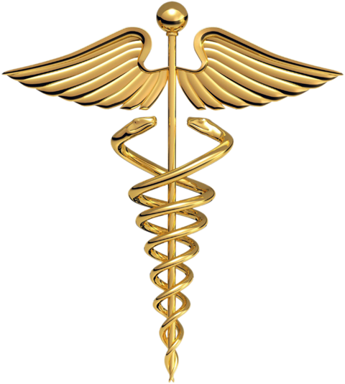 |  |  | 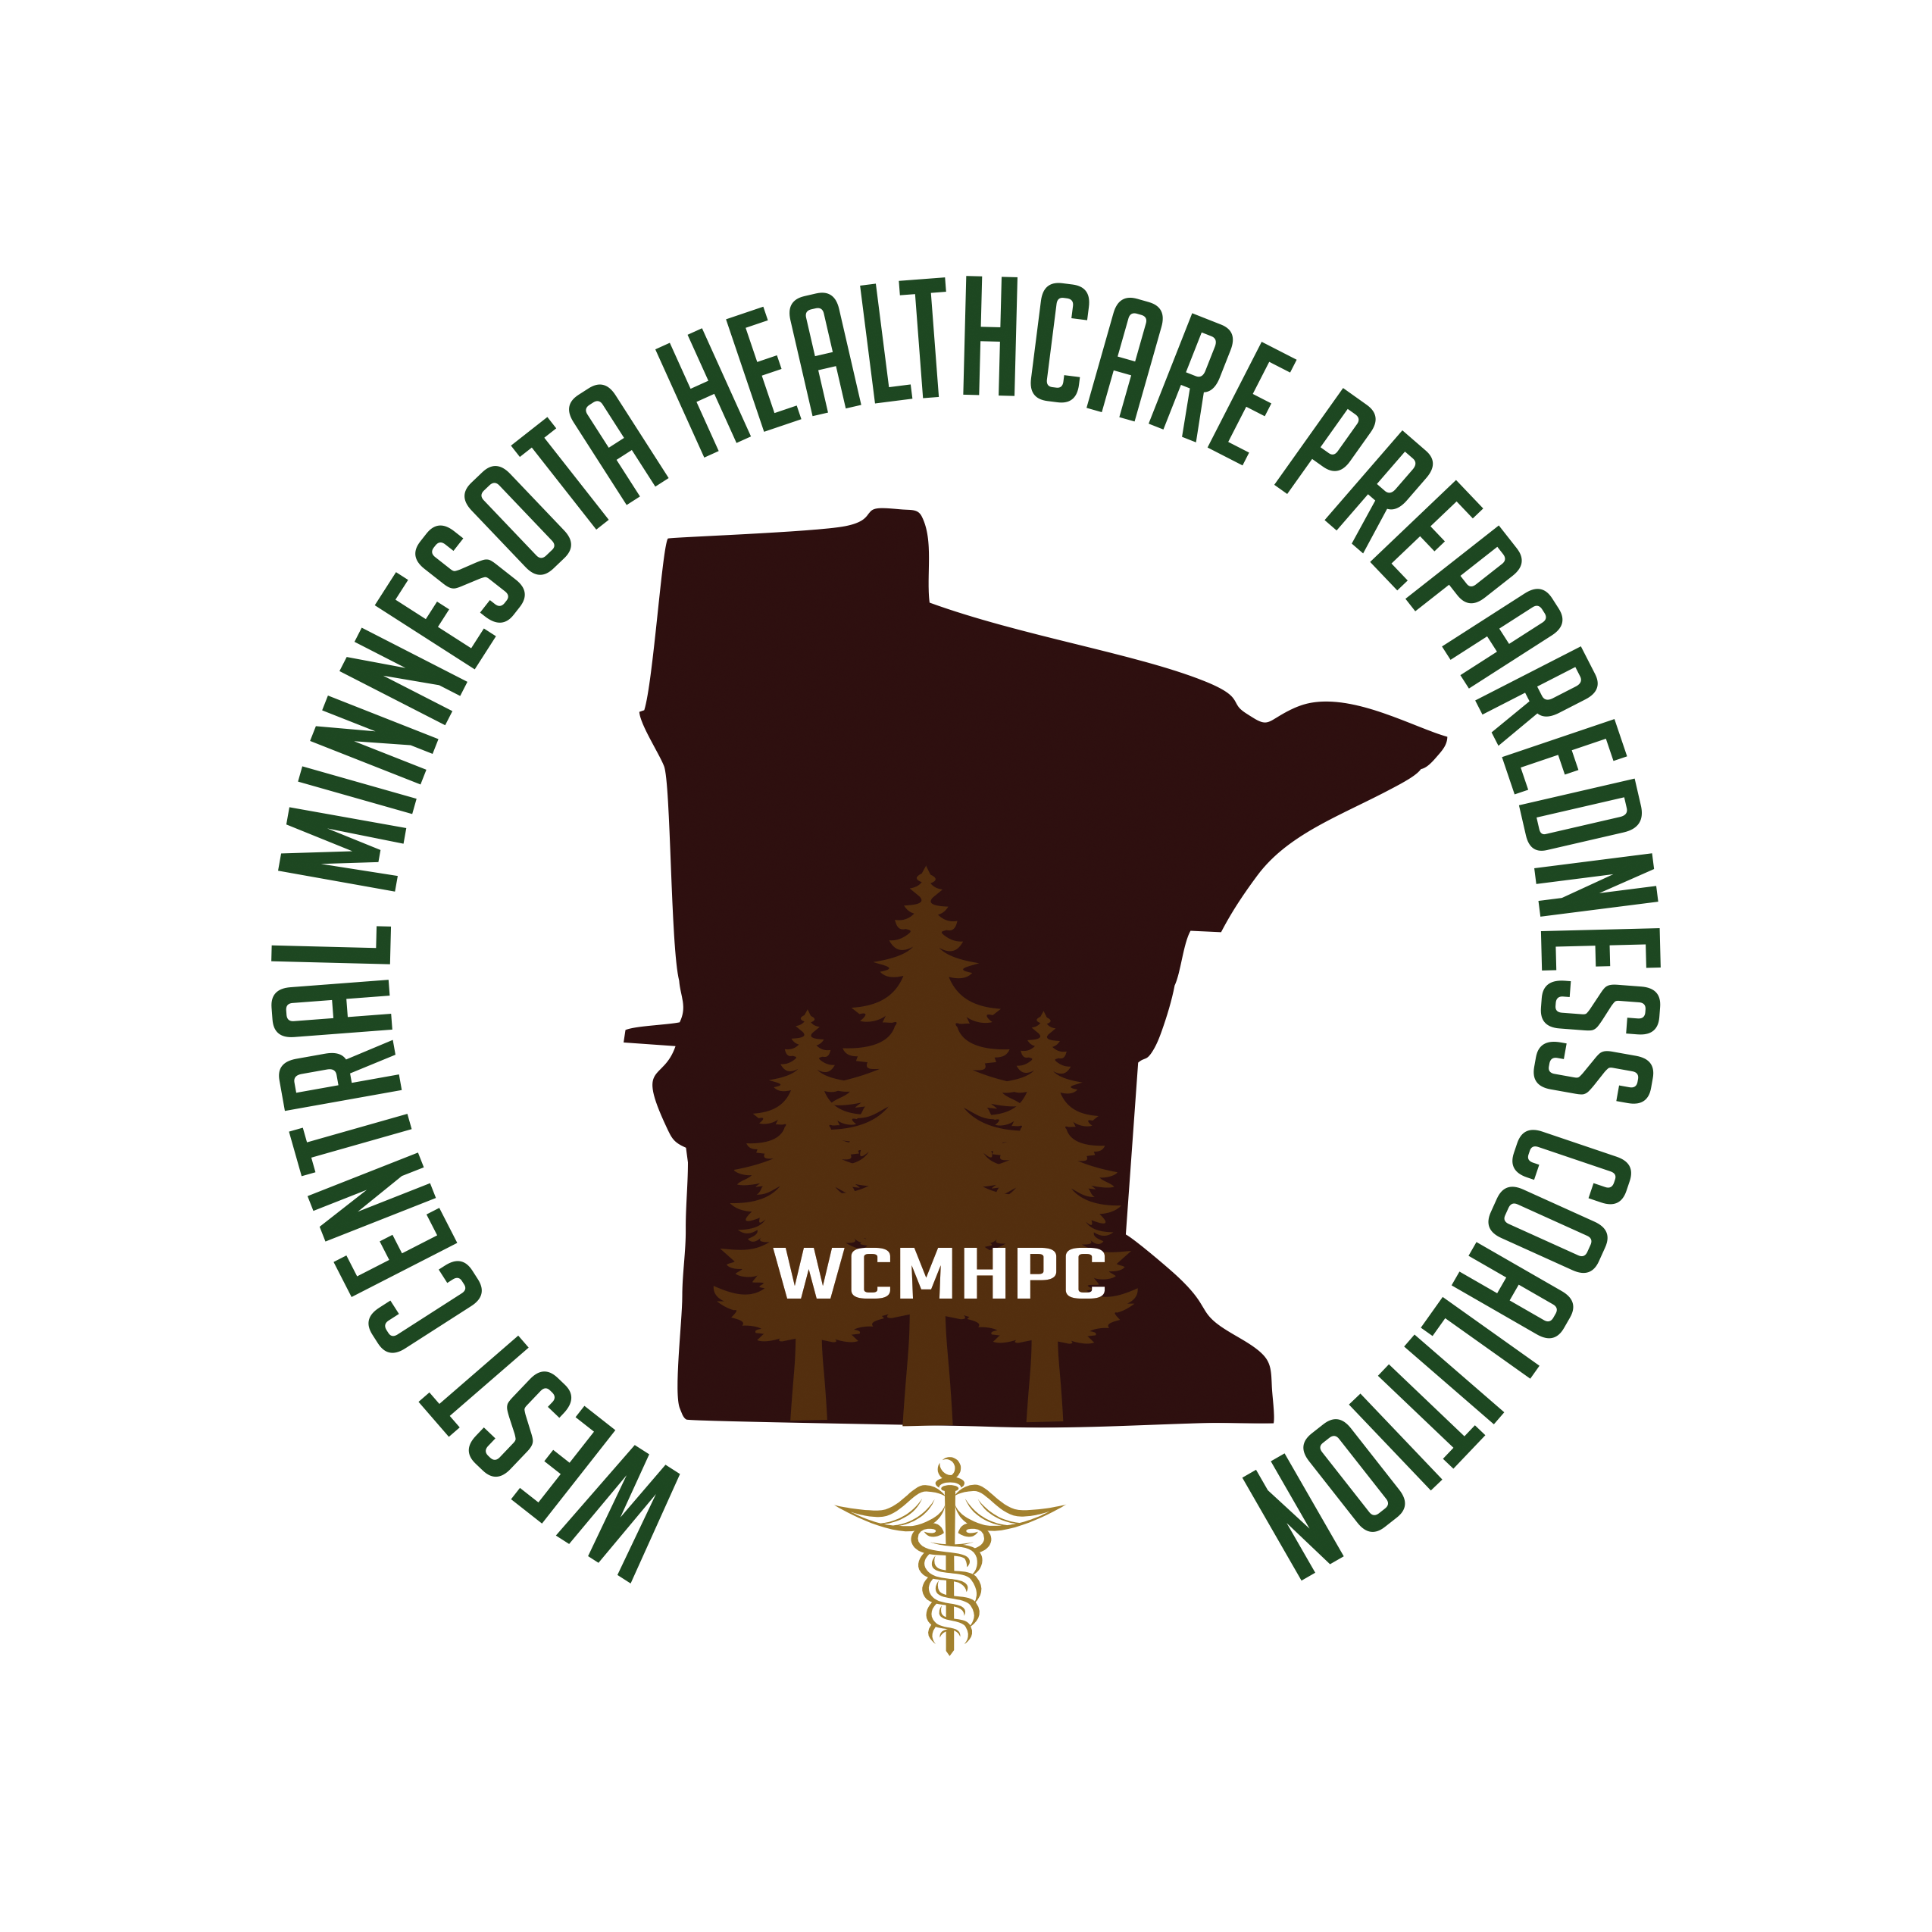  West Central Minnesota Healthcare Preparedness Coalition  (WCMHPC)  The West Central Minnesota Healthcare Preparedness Program is a coalition made up of members from Clinics, Hospitals, and Long-Term-Care facilities, Emergency Management, Emergency Medical Services, Local Public Health Departments, and many other agencies/organizations. Working collaboratively the partners plan, prepare, and respond to the needs of victims of natural or man-made disasters, bio-terrorism, and other health emergencies. Together we have and always will, provide care to the citizens of the West Central Region as well as the State of Minnesota with the quality and expertise that is second to none!

Purpose:  - Assist health care agencies in the pre-disaster planning efforts, and be a resource for emergency preparedness planning and response in health care.  - Promote preparedness in the health care community through standardized practices and integration with other response partners.  - Foster communication, information and resource sharing between local, regional, and state entities during emergency planning and response.  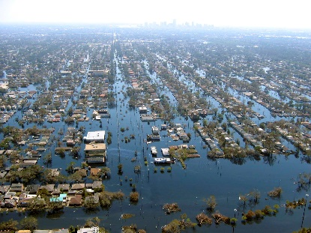  - Enhance the health care community’s ability to effectively respond to an incident through exercises and training. | Coalition Resources:  - Access to a cache of supplies that are deployable during a disaster  - Contacts and relationships with other health care entities in the county, region and state  - MNTrac – an online database that supports real time bed tracking as well as a command center chat room to be used during a disaster  - Access to the Coalition Exercise kit (guides/vests)  - Access 24/7 to disaster and emergency preparedness specialists: 320-240-3115  Fee Based Services include but are not limited to:  - Plan/documentation support  - Facility Based Exercise planning  - Hazard Vulnerability Analysis review  - Decon/First Receiver training  - Fit testing – train the trainer  - Facility based Incident Command training  (contact coalition staff to discuss fee based items) | 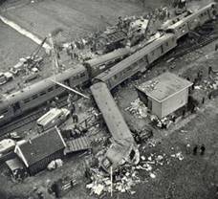  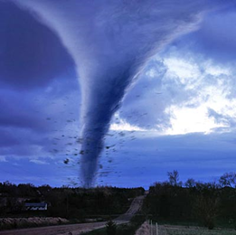  Supported by the United States, Assistant Secretary of Preparedness and Response Health Care Preparedness Grant.  Contact Us  West Central MN Healthcare Preparedness Coalition  Shawn Stoen  Regional Healthcare Preparedness Coordinator  Shawn.stoen@centracare.com  320-760-3513  www.cwchealthcarecoalitions.org

