April 2023
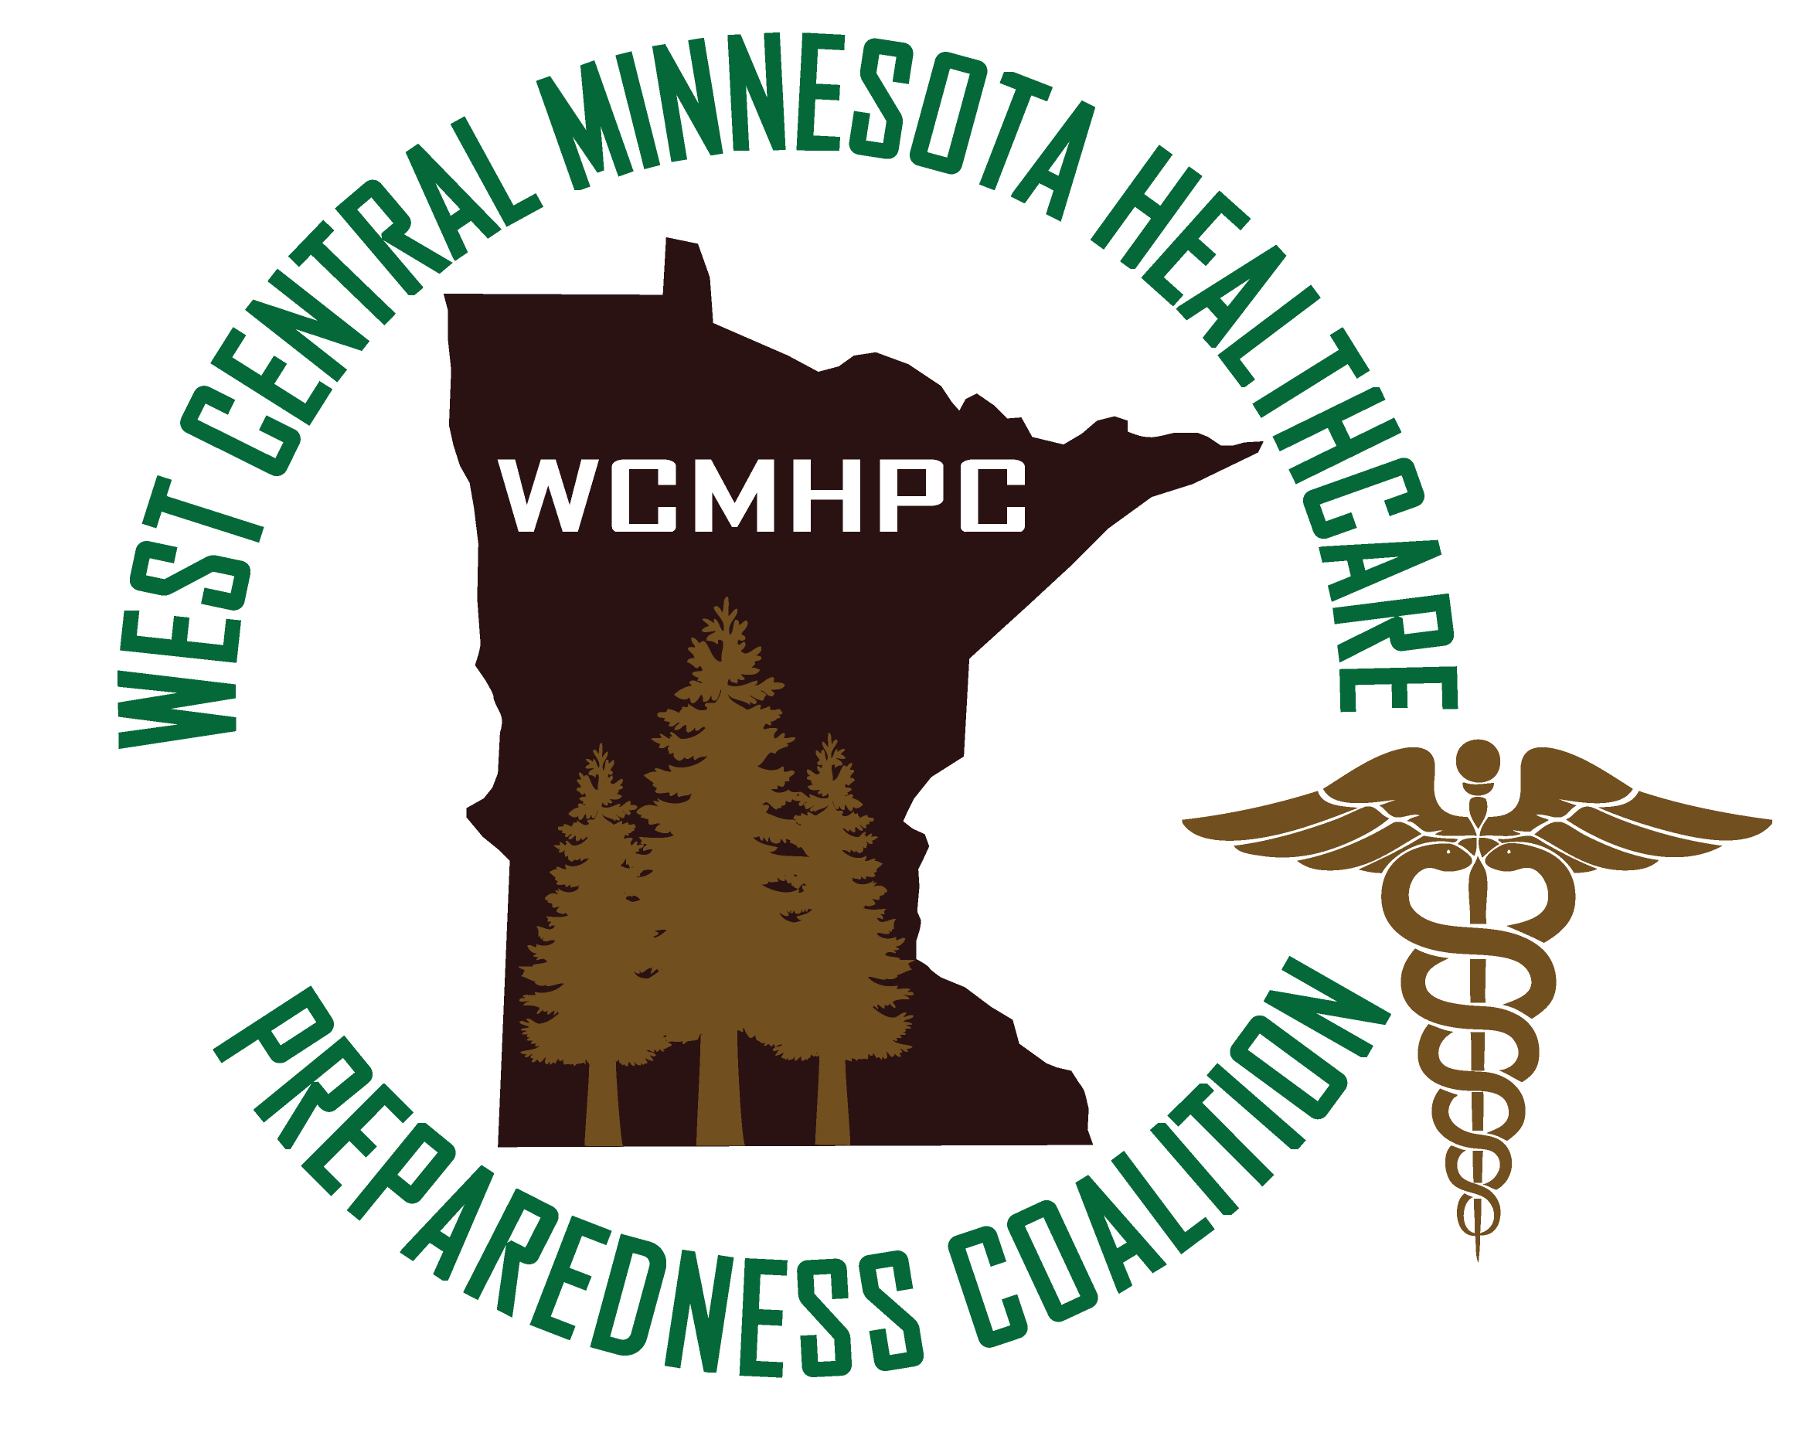

Appendix 5.4 map and demographics

Contents
Regional Geography/Housing information 3
West Central Population Information 5
West Central Health Care demographics 7
West Central Educational Facilities per County 9
Health Care Preparedness Program Regional Map – Minnesota 14

Regional Characteristics: The West Central Region is primarily an agriculture and lakes/tourist area. During the summer, the population increases four times in Otter Tail County and three times in Douglas County. The Red River on the western boundary and has frequent flooding in the spring and has the unique characteristic of flowing north due to the Continental Divide.

Boundaries:
Other states: North Dakota, very small portion of South Dakota
Other regions: Northwest, Central, Southwest

Size: 6763 square miles

Regional Geography/Housing information
 | Clay County | Douglas County | Grant County | Otter Tail County | Pope County | Stevens County | Traverse County | Wilkin County
Population per Square Mile (2020) | 62.5 | 61.2 | 11.1 | 30.5 | 16.9 | 17.2 | 5.9 | 8.7
Land area in square miles (2020) | 1045.18 | 636.94 | 547.80 | 1971.63 | 669.54 | 563.58 | 573.87 | 751.04
Housing Units (2021) | 27,183 | 22,094 | 3,152 | 36,641 | 6,405 | 4,211 | 1,879 | 2,978
Owner Occupied (2017-2021) | 66.9% | 74.4% | 79.1% | 79.9% | 81.1% | 68.1% | 79.4% | 78.3%
Median Value (2017-2021) | $215,100 | $250,400 | $146,600 | $209,100 | $195,900 | $160,800 | $92,700 | $154,000
Households (2017-2021) | 24,998 | 17,030 | 2,512 | 24,838 | 4,892 | 3,794 | 1,424 | 2,680
Persons per household (2017-2021) | 2.46 | 2.24 | 2.37 | 2.36 | 2.25 | 2.48 | 2.3 | 2.38
Households with a computer (2017-2021) | 92.8% | 92.9% | 91.7% | 90.5% | 89.8% | 93.2% | 85.4% | 84.4%
Households with internet (2017-2021) | 86.2% | 83.6% | 82.9% | 82.2% | 82.1% | 87% | 76.9% | 76.6%
Median household income (2017-2021) | $67,984 | $69,069 | $60,781 | $63,587 | $67,040 | $65,750 | $56,667 | $57,907
Persons in poverty (2021 SAIPE) | 12.9% | 9.2% | 10% | 9.5% | 8.6% | 11.9% | 12.6% | 10%

West Central Population Information
 | Clay County |  | Douglas County |  | Grant County |  | Otter Tail County |  | Pope County |  | Stevens County | Traverse County | Wilkin County
Population (2022) |  | 65,665 |  | 39,305 |  | 6,161 |  | 60,222 |  | 11,418 | 9,704 | 3,275 | 6,350
Persons under 5 (2022) |  | 6.8% |  | 5.7% |  | 5.3% |  | 5.4% |  | 5.4% | 6.3% | 5.8% | 5.3%
Persons under 18 (2022) |  | 25.1% |  | 21.7% |  | 23% |  | 21.9% |  | 21.7% | 22.1% | 21% | 22.5%
Persons 65 and over (2022) |  | 13.7% |  | 23.3% |  | 23.7% |  | 24.8% |  | 24.7% | 17.4% | 26.3% | 20%
RACE: (Source 2021 Vintage Pop Estimates Program)
White |  | 88.9% |  | 96.8% |  | 96.1% |  | 95.3% |  | 97% | 91.8% | 89.6% | 95%
Black/African American |  | 5.1% |  | .8% |  | .8% |  | 1.6% |  | .5% | 1.4% | .9% | .5%
American Indian |  | 1.9% |  | .5% |  | .8% |  | .9% |  | .5% | 2.1% | 6.7% | 2%
Asian |  | 1.4% |  | .6% |  | .4% |  | .6% |  | .7% | 2% | .6% | .6%
Islander |  | .1% |  |  |  | .1% |  | .1% |  |  | .1% | .1%
Hispanic |  | 5% |  | 2% |  | 2.4% |  | 3.8% |  | 2% | 8.5% | 5.1% | 3.9%
Veterans |  | 2,626 |  | 2,666 |  | 369 |  | 4,028 |  | 905 | 285 | 258 | 282
Foreign born |  | 4.8% |  | 1.3% |  | 1.3% |  | 2.9% |  | 1.4% | 5.7% | 1.3% | 1%
With a disability – under age 65 years (2017-2021) |  | 7.6% |  | 6.9% |  | 9.7% |  | 8.6% |  | 7.6% | 8.3% | 10.9% | 10.8%
Persons without health insurance – under age 65 (2020 Small Area Health Insurance Estimates) |  | 6.1% |  | 5.2% |  | 6.9% |  | 7.3% |  | 5.9% | 6.8% | 6.9% | 4.9%
High school graduate or higher (25 + years) (2017-2021) |  | 94.9% |  | 95.3% |  | 92.8% |  | 92.6% |  | 94.6% | 93.5% | 93.4% | 94.1%
Bachelors degree or higher (25 + years) (2017-2021) |  | 36% |  | 26.9% |  | 18.5% |  | 26.8% |  | 22.2% | 28.3% | 14.9% | 22.4%

Referenced from: Data collected from the United States Census Bureau (www.quickfacts.census.gov) information updated April 2023

West Central Health Care demographics
 | Clay County | Douglas County | Grant County | Otter Tail County | Pope County | Stevens County | Traverse County | Wilkin County
Level 1 Trauma Center | 0 | 0 | 0 | 0 | 0 | 0 | 0 | 0
Level 2 Trauma Center | 0 | 0 | 0 | 0 | 0 | 0 | 0 | 0
Level 3 Trauma Center | 0 | 1 | 0 | 1 | 0 | 0 | 0 | 0
Critical Access Hospital | 0 | 0 | 1 | 1 | 1 | 1 | 1 | 1
Dialysis Unit | 1 | 1 | 0 | 1 | 0 | 1 | 0 | 0
Behavioral Health Unit | 0 | 1 | 0 | 1 | 0 | 0 | 0 | 0
Behavioral Health Clinic | 6 | 1 | 0 | 1 | 0 | 1 | 0 | 0
Specialty Clinics | 2 | 6 | 0 | 2 | 0 | 0 | 0 | 0
Long Term Care/Skilled Nursing facilities | 4 | 5 | 1 | 7 | 3 | 2 | 2 | 1
Assisted Living | 15 | 19 | 4 | 30 | 8 | 5 | 2 | 2
Hospice/Home Health agencies | 10 | 10 | 2 | 17 | 6 | 3 | 1 | 3
Medical clinics | 6 | 3 | 3 | 7 | 3 | 3 | 2 | 2
Ambulance Services (total services)
# BLS
#ALS
Paid service
Volunteer service
Referenced from: Data collected from the Minnesota Department of Health Provider Directory Search information updated 8/30/2019

West Central Educational Facilities per County
Educational Organization | Grades | City | County
Barnesville Elementary | KG-5 | Barnesville | Clay
Barnesville Secondary | 6-12 | Barnesville | Clay
Hawley Elementary | EC-6 | Hawley | Clay
Spring Prairie Elementary | KG-6 | Hawley | Clay
Hawley Secondary | 7-12 | Hawley | Clay
Probstfield Center For Education | EC | Moorhead | Clay
Dorothy Dodds Elementary School | KG-4 | Moorhead | Clay
Robert Asp Elementary | KG-4 | Moorhead | Clay
Ellen Hopkins Elementary | KG-4 | Moorhead | Clay
S.G.Reinertsen Elementary | KG-4 | Moorhead | Clay
Horizon Middle School | 5-8 | Moorhead | Clay
Moorhead High School | 9-12 | Moorhead | Clay
West Central Academy-S | 4-12 | Moorhead | Clay
West Central Academy-N | 3-12 | Moorhead | Clay
Red River Area Learning Center | 5-12 | Moorhead | Clay
Moorhead Alternative Program | KG-8 | Moorhead | Clay
Red River ALC - Barnesville 146 | 7-12 | Moorhead | Clay
RRALC: DGF Targeted Services 2164 | KG-8 | Moorhead | Clay
Clay County Outreach Center | 7-12 | Moorhead | Clay
Concordia College |  | Moorhead | Clay
Minnesota State University |  | Moorhead | Clay
Dilworth Elementary | EC+KG-4 | Dilworth | Clay
Glyndon-Felton Elementary | EC+KG-5 | Glyndon | Clay
Dilworth-Glyndon-Felton Middle Sch | 6-8 | Dilworth | Clay
Dilworth-Glyndon-Felton Senior High | 9-12 | Glyndon | Clay
Lake Agassiz Education Cooperative | EC | Hawley | Clay
Intensive Interagency Program | 7-12 | Hawley | Clay
Glacial Ridge Transitional Skills Program | 7-12 | Hawley | Clay
Lakes Country Youth Educ Svcs | 9-12 | Moorhead | Clay
Lakes Country Academy - MHD | KG-12 | Moorhead | Clay
Carlos Elementary | PK-5 | Carlos | Douglas
Garfield Elementary | KG-5 | Garfield | Douglas
Lincoln Elementary | KG-5 | Alexandria | Douglas
Miltona Elementary | KG-5 | Miltona | Douglas
Woodland Elementary School | KG-5 | Alexandria | Douglas
Voyager Elementary | KG-5 | Alexandria | Douglas
Early Education Center | EC-PK | Alexandria | Douglas
Discovery Middle School | 6-8 | Alexandria | Douglas
Alexandria Area High School | 9-12 | Alexandria | Douglas
Osakis Elementary | EC-6 | Osakis | Douglas
Osakis Secondary | 7-12 | Osakis | Douglas
West Central Area S. El. | KG-4 | Kensington | Douglas
Brandon Elementary | EC+KG-3 | Brandon | Douglas
Evansville Elementary | 4-5 | Evansville | Douglas
Brandon-Evansville Middle School | 6-8 | Evansville | Douglas
Brandon-Evansville High School | 9-12 | Brandon | Douglas
RUNESTONE REGIONAL LEARNING CENTER | 7-12 | Alexandria | Douglas
Osakis Targeted Services | KG-8 | Osakis | Douglas
Runestone Targeted Services | KG-8 | Alexandria | Douglas
SOAR | 6-8 | Alexandria | Douglas
Lakes Country Academy - ALEX | KG-12 | Alexandria | Douglas
Alexandria Technical College |  | Alexandria | Douglas
Ashby Elementary | EC-6 | Ashby | Grant
Ashby Secondary | 7-12 | Ashby | Grant
Herman Elementary | EC-6 | Herman | Grant
Herman Secondary | 7-12 | Herman | Grant
West Central Area N. El. | EC+KG-4 | Elbow Lake | Grant
WEST CENTRAL AREA SECONDARY | 9-12 | Barrett | Grant
WCA Middle School | 5-8 | Barrett | Grant
Battle Lake Elementary | KG-6 | Battle Lake | Otter Tail
Battle Lake Secondary | 7-12 | Battle Lake | Otter Tail
Adams Elementary | 1-2 | Fergus Falls | Otter Tail
Cleveland Elementary | 2-4 | Fergus Falls | Otter Tail
McKinley Elementary | EC-1 | Fergus Falls | Otter Tail
Fergus Falls Targeted Services Prog | 1-6 | Fergus Falls | Otter Tail
iQ Academy Minnesota | KG-12 | Fergus Falls | Otter Tail
Fergus Falls Area Learning Center | 9-12 | Fergus Falls | Otter Tail
Kennedy Middle School | 5-8 | Fergus Falls | Otter Tail
Kennedy High School | 9-12 | Fergus Falls | Otter Tail
Henning Elementary | EC-6 | Henning | Otter Tail
Henning Secondary | 7-12 | Henning | Otter Tail
Parkers Prairie Elementary | EC-6 | Parkers Prairie | Otter Tail
Parkers Prairie Secondary | 7-12 | Parkers Prairie | Otter Tail
Viking Elementary School | EC-6 | Pelican Rapids | Otter Tail
Pelican Rapids Secondary | 7-12 | Pelican Rapids | Otter Tail
Pelican Rapids Alt Learning Center | 9-12 | Pelican Rapids | Otter Tail
Pelican Rapids Alt Center Mid-Level | 7-8 | Pelican Rapids | Otter Tail
Pelican Rapids ALC K-6 Targeted Svc | KG-6 | Pelican Rapids | Otter Tail
Pelican Rapids Sch Yr Target Svc K-6 | KG-6 | Pelican Rapids | Otter Tail
Pelican Rapids ALC 7-8 Targeted Svc | 7-8 | Pelican Rapids | Otter Tail
Heart of The Lake Elementary | KG-4 | Perham | Otter Tail
Prairie Wind Middle | 5-8 | Perham | Otter Tail
Perham Senior High | 9-12 | Perham | Otter Tail
Perham Area Learning Center | 9-12 | Perham | Otter Tail
Perham Area Targeted Services | 9-12 | Perham | Otter Tail
Underwood Elementary | EC-4 | Underwood | Otter Tail
Underwood Secondary | 5-12 | Underwood | Otter Tail
Underwood ALP | 9-12 | Underwood | Otter Tail
New York Mills Elementary | EC-6 | New York Mills | Otter Tail
New York Mills Secondary | 7-12 | New York Mills | Otter Tail
Fergus Falls Area Sp. Ed. Coop. |  | Fergus Falls | Otter Tail
Fergus Falls Early Childhood Sp Ed | EC+KG-4 | Fergus Falls | Otter Tail
Fergus Falls EC/Elementary Sp Ed | EC+KG-4 | Fergus Falls | Otter Tail
Fergus Falls Elementary Sp Ed 5-8 | 5-8 | Fergus Falls | Otter Tail
White Pine Academy | 5-12 | Wadena | Otter Tail
Elm Tree Academy | 2-12 | Wadena | Otter Tail
Leaf River Academy | KG-12 | Wadena | Otter Tail
Parkers Prairie Targeted Services | KG-8 | Parkers Prairie | Otter Tail
Lakes Country Academy - FF | KG-12 | Fergus Falls | Otter Tail
Minnesota State Community and Technical College |  | Fergus Falls | Otter Tail
Minnewaska Secondary | 7-12 | Glenwood | Pope
Minnewaska Area Junior High | 7-8 | Glenwood | Pope
Minnewaska Area Intermediate School | 4-6 | Glenwood | Pope
Minnewaska Area Elementary | KG-3 | Glenwood | Pope
Minnewaska Area WIN Academy | KG-12 | Starbuck | Pope
Minnewaska Secondary Alternative PG | 9-12 | Glenwood | Pope
Minnewaska Early Childhood Sp.Ed. | EC-PK | Glenwood | Pope
Glacial Hills Elementary | PK-6 | Starbuck | Pope
Middle Level Learning Center | 7-8 | Alexandria | Pope
Minnewaska Targeted Services | 1-6 | Glenwood | Pope
Hancock Elementary | EC-6 | Hancock | Stevens
Hancock Sec. | 7-12 | Hancock | Stevens
Chokio-Alberta Secondary | 7-12 | Chokio | Stevens
Chokio-Alberta Elementary | KG-6 | Chokio | Stevens
Morris Area Secondary | 7-12 | Morris | Stevens
Morris Area Elementary | EC+KG-6 | Morris | Stevens
Midwest Special Education Coop. | EC | Morris | Stevens
University of Minnesota |  | Morris | Stevens
Browns Valley Elementary | PK-4 | Browns Valley | Traverse
Browns Valley Middle | 5-8 | Browns Valley | Traverse
Pearson Elementary | PK-5 | Wheaton | Traverse
Wheaton Secondary | 6-12 | Wheaton | Traverse
Breckenridge Elementary | EC-6 | Breckenridge | Wilkin
Breckenridge Middle | 7-8 | Breckenridge | Wilkin
Breckenridge Senior High | 9-12 | Breckenridge | Wilkin
Breckenridge Area Learning Program | 7-12 | Breckenridge | Wilkin
Rothsay Elementary | EC+KG-6 | Rothsay | Wilkin
Rothsay Secondary | 7-12 | Rothsay | Wilkin
Campbell-Tintah Elementary | EC-6 | Campbell | Wilkin
Campbell-Tintah Secondary | 7-12 | Campbell | Wilkin

Health Care Preparedness Program Regional Map – Minnesota
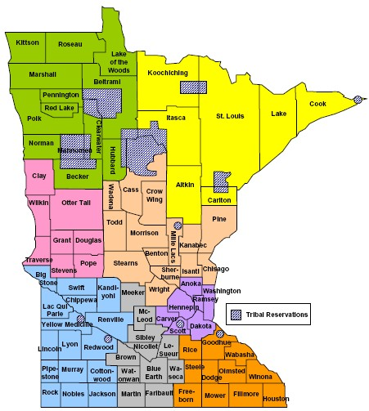

West Central

Approvals and Revisions
Purpose | Date
Updated to include updated census data. | Emailed 3/11/2023 and approved by all 4/3/2023

