Date: April 2023
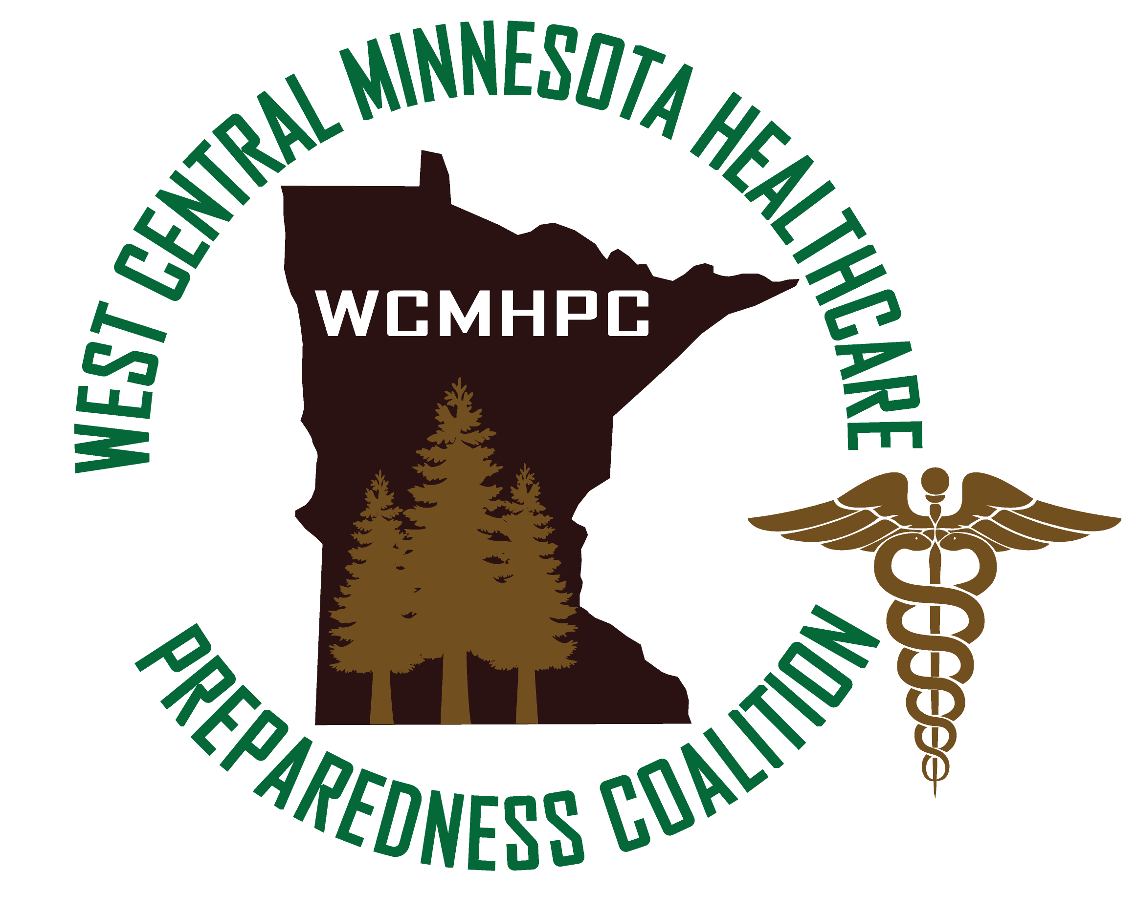

Appendix 5.2.1 memorandum of understanding

THIS PAGE LEFT INTENTIONALLY BLANK
Table of Contents

Purpose 3
General Principles of Understanding 4
1. Participating Agencies: 4
2. Agency Representatives Responsibilities: 4
3. Implementation of Mutual Aid MOU: 4
4. Activation of the Mutual Aid MOU: 4
5. Types of Requests: 5
Medical Supplies/Pharmaceuticals 5
Loaned equipment 5
Staff 5
Transfer/Evacuation of Health Care Customer 6
6. Communication of request 8
Function of the WCMHPC Health Care Multi Agency Coordination Center (HMACC) 8
Terms and Conditions of the Mutual Aid MOU 8
Approvals and Revisions 9

Purpose
The purpose of the Memorandum of Understanding (MOU) is to address the need to support each other during times of crisis or disaster. This could include, but not limited to the loan of medical personnel, pharmaceuticals, supplies, and equipment. This may also include assisting with evacuations or surge events be it sending or receiving patients / residents / tenants. This is an agreement among the West Central Minnesota Health Care Preparedness Coalition (WCMHPC) members, for providing mutual aid, as stipulated in this agreement, at the time of a medical crisis / disaster, when able.
For purposes of this agreement, a crisis / disaster is defined as an overwhelming incident or situation that exceeds the effective capability of the impacted health care facility(s) which, without assistance and support from outside sources, may result in patient/resident/tenant and or staff harm. An incident such as this will often involve local emergency management and local public health. The crisis/disaster may be an “external” or an “internal” event for health care facilities and assumes that each affected facility’s emergency management plans have been fully implemented.
This document addresses the relationships between and among health care facilities and is intended to augment, not replace, each facility's disaster plan. The agreement also provides the framework for health care facilities to work with local emergency management, local public health, emergency medical services and other health care coalition / health care entities during planning and response. Health care coalition partners include, but are not limited to, hospitals, long term care, home health, hospice, clinics, and dialysis.
This document supplements the rules and procedures governing interaction with other organizations during a disaster (e.g., law enforcement agencies, local emergency medical services, local public health, fire departments, American Red Cross, etc.). It is recognized that during an emergency, all requests for assistance must go through the local emergency management agency or local public health. The coalition will help coordinate requests through coalition partners and will communicate the same to the local emergency operations center, if activated.

General Principles of Understanding

1. Participating Agencies:
- All health care facilities and coalition members, who sign the bylaws, agree to and acknowledge MOU.

2. Agency Representatives Responsibilities:
- Coordinate the MOU initiatives with the individual organization emergency management plans.
- It is recommended that facilities that sign the MOU participate in WCMHPC training and exercises.

3. Implementation of Mutual Aid MOU:
- During an emergency, only the authorized administrator (or designee), or health care facility command center has the authority to request assistance from the WCMHPC.
- Communications between facilities formally requesting and volunteering assistance should occur among the senior administrators (or designee) or facility/agency command centers.
- The health care facility or public health will communicate with local emergency management and other partners when determined necessary by local guidelines or when the situation could have community implications.

4. Activation of the Mutual Aid MOU:
- The impacted facility/agency command center is responsible for informing the WCMHPC Regional Coordinator of the situation and defining any needs that cannot be accommodated by the heath care facility itself.
- Activation of the MOU indicates that the impacted facility/agency has reached out to local emergency management and partners for assistance and such assistance is not available or is limited.
- The senior administrator or designee is responsible for requesting personnel, pharmaceuticals, supplies, equipment, or authorizing the evacuation of patients.
- The senior administrator or designee will coordinate both internally, and with the donor/receiving facility/agency, all the logistics involved in implementing assistance under this MOU.

5. Types of Requests:

Medical Supplies/Pharmaceuticals
- All requests for medical supplies and pharmaceuticals will specify:
  - Amount of material needed
  - Size/dosage of material needed
  - When the materials are needed
  - Arrangements for exchange of such supplies
  - Reimbursement or restocking of materials
- The requesting facility will use the requisition forms/paperwork of the agency supplying the materials.
- The recipient facility will reimburse the donor facility for all the donor facility's costs determined by the donor facility’s regular rate.
- It is recommended that reimbursement will be made within 90 days following receipt of invoice or otherwise negotiated facility to facility. This can include replacing items or reimbursing for cost of items.

Loaned equipment
- All requests for loaned equipment will specify:
  - Amount/quantify of equipment being requested
  - An estimate of how quickly the requested equipment is needed
  - Estimated length of time the equipment will be needed
  - Identify how the equipment will be picked up and returned
  - Identify where the equipment will be used.
- If any equipment is damaged the receiving facility will agree to repair or replace the equipment within 30 days or as otherwise agreed to.
- Documentation should detail the items involved in the transaction, condition of the material prior to the loan (if applicable), and the party responsible for the material.
- The donor facility is responsible for ensuring that the equipment provided is safe to use and operational.
- The recipient facility is responsible for using the equipment provided in accordance with manufacture’s guidelines.
- If parts or all of the equipment loaned are consumable or one-time use, the recipient facility will reimburse for actual cost or replace – as agreed upon by both parties.

Staff
- All requests for staffing will specify:
  - The type and number of requested personnel
  - An estimate of how quickly the request is needed
  - The location where they are to report
  - An estimate of how long the personnel will be needed
- The recipient facility will have supervisory direction over the donor facility’s staff.
- The recipient facility will assume all legal responsibility for the personnel from the donor facility during the time the personnel are at the recipient facility.
- The recipient facility will reimburse the donor facility for the salaries of the donated personnel at the donated personnel's rate, as established by the donor facility, unless other arrangements are made between the facilities.
- The donor facility is responsible for appropriate credentialing of personnel.
- The recipient facility is responsible for verifying the credentials of personnel being received.
- The senior administrator (or designee) and/or medical director, in conjunction with the directors of the affected services, will decide as to whether medical staff and other personnel from another facility will be required at the impacted facility to assist in patient care activities.

Limitations on Loaned and Volunteer Staff instructions
- Personnel offered by donor facility should be limited to staff that are fully accredited or credentialed in the donor institution.
- The recipient facility's senior administrator or designee (the health care facility or public health agency command center) identifies where and to whom the donated personnel are to report to.
- Professional staff of the recipient facility will provide supervision to the donated personnel.
- The supervisor or designee will provide direction regarding point of entry, parking, length of shift, clothing requirements, and other pertinent information to functional perform in the assigned job.
- The supervisor or designee will provide donated staff a briefing and orientation as pertinent to the position.
- The recipient facility will provide all personal protective equipment (PPE) necessary to perform the duties as assigned, unless otherwise negotiated between facilities that PPE will come with. If the receiving facility is requiring PPE that requires fit testing, the recipient facility will fit test the personal.

Transfer/Evacuation of Health Care Customer
- The evacuating facility will include the following information:
  - The number of patients needed to be transferred.
  - The general nature of their illness or condition
  - Any type of specialized services required, e.g., ICU bed, burn bed, trauma care, etc.
- Patient-accepting facility assumes the legal and fiscal responsibility for transferred patients upon arrival into the patient-accepting facility.
- In the event of the evacuation of patients, the medical director of the patient-transferring facility will also notify their local emergency manager and any other local response entities necessary (i.e. Emergency medical services (EMS), fire department, law enforcement). Documentation
- The patient-transferring facility is responsible for providing the patient-receiving facility with the patient's medical records necessary to ensure continuity of care, insurance information and other patient information necessary for the care of the transferred patient.
- The patient-transferring facility is responsible for tracking the destination of all patients transferred out.
- The patient transferring facility is responsible for notifying the West Central Minnesota Health Care Multi Agency Coordination Center (HMACC) (if open) of patient destination and numbers and type of patients transferred.
- The patient transferring facility should provide a situational update to the West Central Minnesota Health Care Coalition representative.
- The receiving facility should notify the sending facility that the health care customer has arrived – to ensure confirmation.

Transportation of patients
- The type of transport will be determined by factors such as patient condition, transportation availability, weather, or other mitigating circumstances.

Receiving facility
- Agrees to identify where to off load the patients.
- The transferred patient shall be admitted/accepted, pursuant to the policies and procedures of the receiving facility and situation.
- If admitted, the receiving facility will accept all responsibility to provide medical care for the patients.
- If accepted, the receiving facility will provide either full medical care or support as agreed to between the facilities involved.

Financial and Legal Liability
- Upon admission, the patient-receiving facility is responsible for liability claims originating from the time the patient is admitted, to the patient accepting facility.
- Reimbursement for care will be determined by the policies/procedures pursuant to the situation.

Notification
- The patient-transferring facility is responsible for notifying both the patient's family/ guardian and the patient's attending/personal physician.
- The patient-receiving facility may assist in notifying the patient's family and personal physician.

6. Communication of request
- The request for the transfer of personnel, pharmaceuticals, supplies, or equipment can initially be made verbally, however, must be followed up with written documentation.
- Signatures of both parties must be maintained by both the donating and receiving facility.

Function of the WCMHPC Health Care Multi Agency Coordination Center (HMACC)
The WCMHPC HMACC provides the coordination and logistical support for West Central Coalition Health Care Facilities unable to coordinate amongst themselves, and to integrate with local emergency management, local public health departments, law enforcement, fire departments, emergency medical services, Minnesota Department of Health, and HSEM during the disaster event. Members of the HMACC include the Regional EMS Director, Public Health Preparedness Consultant, and Regional HSEM representative. Additional support personnel can be requested to ensure that response needs are addressed and may include specialty individuals such as epidemiology.

Terms and Conditions of the Mutual Aid MOU
This agreement is made between members of the coalition. This understanding does not extend beyond the coalition boundaries identified in the coalition bylaws except for the Partnership4Health Community Health board – which extends into Becker County. Health care facilities are aware that they are encouraged to obtain a formalized memorandum of understanding with organizations outside of the coalition with which they may need to interact with during emergent events.
This agreement will be reviewed annually.
See Appendix 5.2.2. Membership Signature Form

Approvals and Revisions
Purpose | Date
Updated to correct grammar. | Emailed 3/11/2023 and approved by all 4/3/2023

