Date: 1 April 2023
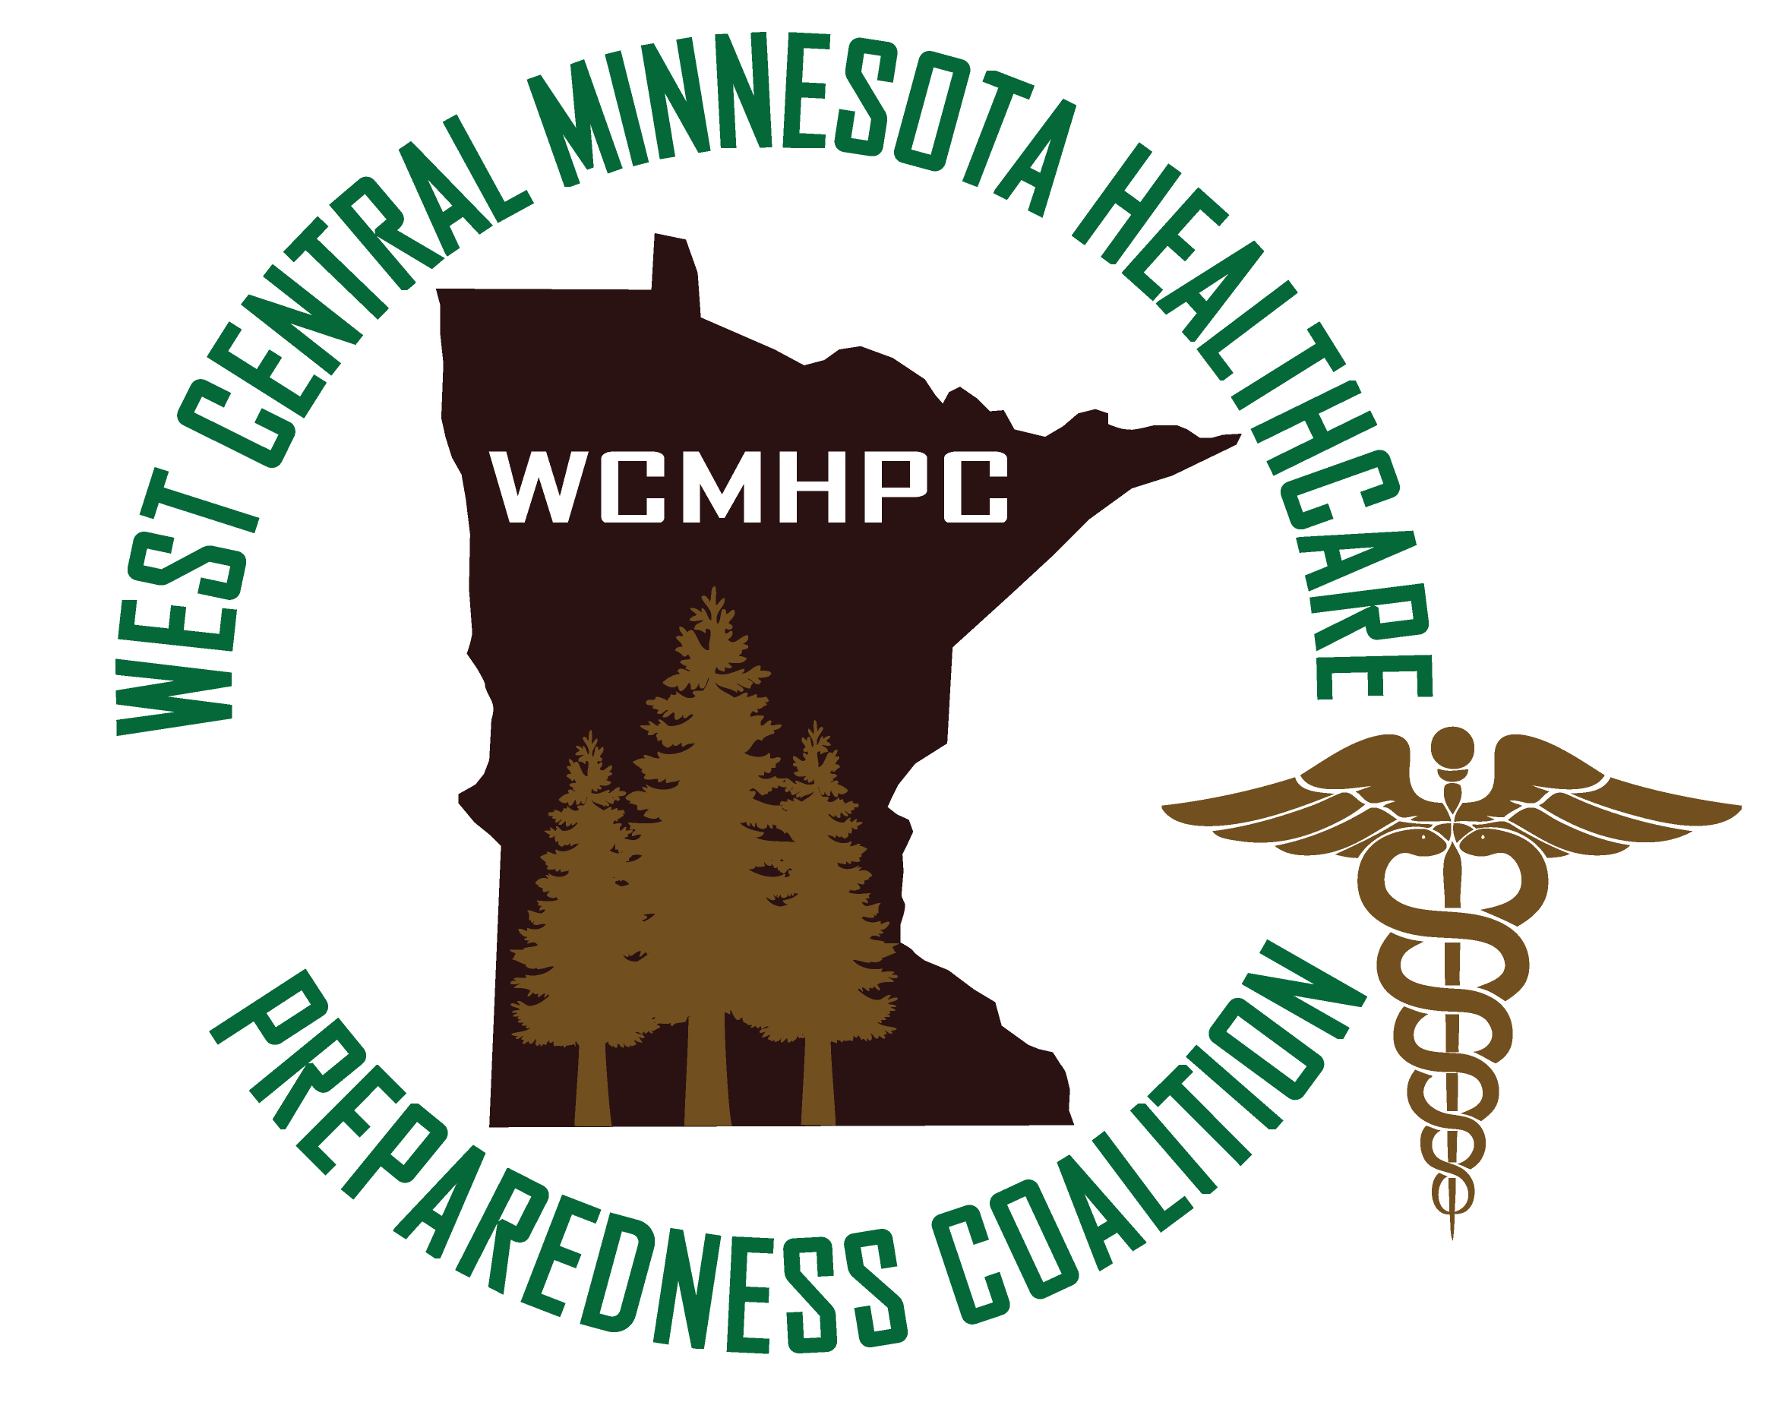

Appendix 5.2 bylaws

Appendix 5.2 bylaws

Article I – Name
West Central (WC) Minnesota Health Care Preparedness Coalition

Article II – Mission
The WC Health Care coalition is a multi-disciplinary partnership of Health care and supporting and responding agencies; that collaborate to coordinate preparedness, response, and recovery activities as it pertains to routine and emergent events that could impact the region.

Article III - Purpose
- Provide oversight and guidance for planning, implementation of strategies, guidance of financial resources and the execution of respective roles and responsibilities of the West Central Minnesota Health Care Preparedness Coalition. The West Central geographic boundaries are outlined in the Regional Preparedness Plan.
- During times of disaster that may have regional implications, determine a strategy for ongoing coordination of planning, response, and recovery.
- Monitor, review, and implement improvements consistent with national and statewide capabilities and performance measures.
- Promote strategies to strengthen and sustain the Health Care coalition including:
    - Develop and maintain guidelines, participation rules and responsibilities of partner members within the Health Care Preparedness Coalition.
    - Plan for the sustainment of the Health Care Preparedness Coalition.
- Promote preparedness in the health care community through standardized practices and integration with other response partners.
- Foster communication, information, and resource sharing between local, regional, and state entities during emergency planning and response.
- Identify health care assets needed and available during a response.
- Recognize gaps in the health care community’s ability to effectively respond to an incident through exercises and training.

Article IV – Membership/Participation

Health Care Preparedness Coalition Membership
- Primary coalition members shall consist of a representative, from each of the following entities:
    - Hospitals
    - Local Emergency Management (EM)
    - Emergency Medical Services (EMS) Regional Coordinator
    - Local Public Health

- Other Coalition members may consist of partners from: (Note: ** Indicates that there is currently representation within the coalition from this area)
  - Behavioral Health **
  - Clinics **
  - Colleges
  - Community based Health care i.e. Home health **
  - Community health centers **
  - Faith communities
  - Funeral homes/coroner
  - Homeland Security Emergency Management **
  - Laboratory services **
  - Law Enforcement/Fire Departments (awareness)
  - Medical Advisor**
  - Mental health agencies **
  - Minnesota Department of Health – Epidemiologist **
  - Minnesota Department of Health – Public Health Preparedness Consultant **
  - Minnesota Mobile Medical Team **
  - Other volunteer organizations
  - Outpatient facilities**
  - Private entities such as hospital associations
  - Private organizations active in disasters and other relevant partners
  - Public works
  - Public works/utilities (awareness)
  - Skilled Nursing Facilities/Long Term Care Facilities **
  - Specialty service providers such as dialysis units **
  - Stand-alone surgery centers and urgent care
  - Tribal Governments
  - Volunteer Organizations Active in Disasters (VOADS) and other volunteer organizations
  - West Central Minnesota Responds Medical Reserve Corp **
- Active membership in the coalition is evidenced by written acknowledgement of the coalition bylaws and memorandums of understanding (MOU). See Appendix 5.2.2 – Membership Signature Form.
  - Once Appendix 5.2.2 is signed the agreement will be considered effective in perpetuity.
  - Members are required to update the coalition if there are any changes to facility representation.
See www.cwchealthcarecoalitions.org for a list of participating agencies.

Article V – Meetings and Structure

Health Care Preparedness Coalition Membership
- Members of the Health Care Preparedness Coalition will work towards implementing emergency preparedness activities recommended by the Hospital Preparedness Program grant and the West Central Health Care Preparedness Coalition.
- Provide feedback to the Advisory Committee.
- Participate in education, training, and exercise opportunities.
- Share emergency preparedness information with the regional health care community.
- Respond to requests from regional staff. i.e. Surveys, MNTrac alerts, questions, etc.
- Serve on committees, workgroups, and other ad hoc groups.
- Attend meetings.
- Prepare for active participation in discussions and decision making by reviewing meeting materials.
- Review and provide feedback to coalition plans and appendixes.
- Healthcare facilities will sign and retain a current copy of the coalition’s Mutual Aid MOU.

Coalition Meeting Attendance and Frequency
The Health Care Preparedness Coalition meets monthly. There will be two face-to-face meetings for all coalition members (April and October) at a central location. The coalition will also have monthly meetings which are targeted specifically for Hospitals and Long-Term Care. All coalition members are invited to participate in all meetings.

Health care Preparedness Coalition Advisory Committee
- The mission of the Advisory Committee shall be to assist in making decisions regarding regional Health care preparedness.
- The Advisory Committee is composed of a member of each of the coalition hospitals. Members such as public health, EMS, EM, and LTC can select one person from each entity to represent other similar entities in the coalition.
- The Advisory Committee may provide regional disaster response and support regional multi-agency coordination when activated.
- Will ensure that the grant duties are in accordance with the timelines established for completion.
- Provide recommendation on allocation of grant funds.
- Will work with the coalition to develop, review & update, and approve coalition plans. Such plans will be emailed out to the Advisory Committee for final approval before presentation to all coalition members via the Website.
- May vote when decisions regarding asset management and distribution, programmatic processes, etc. are needed.

Advisory Meeting Attendance and Frequency
The Advisory Committee will as-needed – to meet the needs of the coalition. Meetings can be face to face, prior to the coalition meetings as well as by conference call or virtual.

Resignation
Members will submit a resignation to the RHPC who will communicate the resignation to the Advisory Committee.

Voting
- Advisory committee members shall have voting rights.
  - They must be signatory members of the coalition
  - Each hospital will have one vote. Members such as public health, EMS, EM and LTC with representation on the advisory committee will have one vote per like entity.
    - Voting membership:
- Each of the 8 hospitals (8)
- LPH (1)
- Emergency Manager (1)
- Emergency Medical Services (1)
- Long Term Care (1)
- Clinic (1)
    - Members such as public health, EMS, EM, and others can select one person from each entity to represent similar entities on the advisory committee and have voting rights.
- If the primary Advisory Committee member cannot be present to vote, their pre-determined alternate can vote.
- Voting members shall abstain on any vote that presents a conflict of interest.
- The RHPC will not vote, excluding a tiebreaker when the RHPC or his or her designee may cast a vote.
- Voting procedures:
    - A simple majority voting method is used.
    - The coalition RHPC or designee will tally and report the vote results.
    - All voting results will be included in meeting minutes distributed by the RHPC(s) or designee.
    - Motions pertaining to the general business of the coalition including resolutions, statements of agreements and other business may be approved by quorum of the Advisory Committee.
    - Voting may be conducted in “Face to Face” meetings, virtual meetings or by email.
      - Failure to acknowledge an email which includes an item requiring a vote, by the identified date, will indicate agreement with the item.
    - The presence of 51% of Advisory Committee members constitutes a quorum.

Article VI – Leadership

Regional Health Care Preparedness Coordinators (RHPC)
- The RHPC(s) shall serve the coalition Advisory Committee and the coalition in the following capacities:
    - Convene and facilitate meetings.
    - Act as a Liaison between the coalition and the Minnesota Department of Health, Emergency Preparedness and Response.
    - Coordinate and support work groups and sub committees as needed.
    - Record and distribute meeting minutes.
    - Serve as a representative to other regional emergency preparedness sub committees such as Public Health Emergency Preparedness (PHEP), Long Term Care (LTC), WESTAC, and Emergency Management (EM), and Cross border/cross regional collaboration meetings.
    - Will serve as a resource for guidance related to emergency preparedness topics.
    - Fulfill other duties as determined by the coalition and the grant.
    - Maintain financial records in accordance with the grant and with the fiscal agent.

Public Health Preparedness Coordinators (PHPC)
- The PHPC shall serve the coalition Advisory Committee in the following capacities:
    - Act as a Liaison between the coalition and Local Public Health departments.
    - Act as an additional Liaison between the coalition and the Minnesota Department of Health, Emergency Preparedness and Response.
    - Share the PHEP grant deliverables and collaborate with the Advisory Committee on strategies to meet PHEP and Health Care Preparedness Program (HPP) grant deliverables when they intersect.

Terms and Conditions of the Bylaws
This agreement will be reviewed annually. Any changes to this document will be agreed upon by the coalition advisory committee.

Signed Organizational Members
Lists of signed members are maintained on the coalition website. (www.cwchealthcarecoalitions.org)
Signed documents are maintained on SharePoint as well as on the coalition staff shared drive. Copies are available upon request.

Approvals and Revisions
Purpose | Date
Updated to correct grammar and reflect current meeting practices. | Emailed 3/15/2023 and approved by all 4/5/2023

