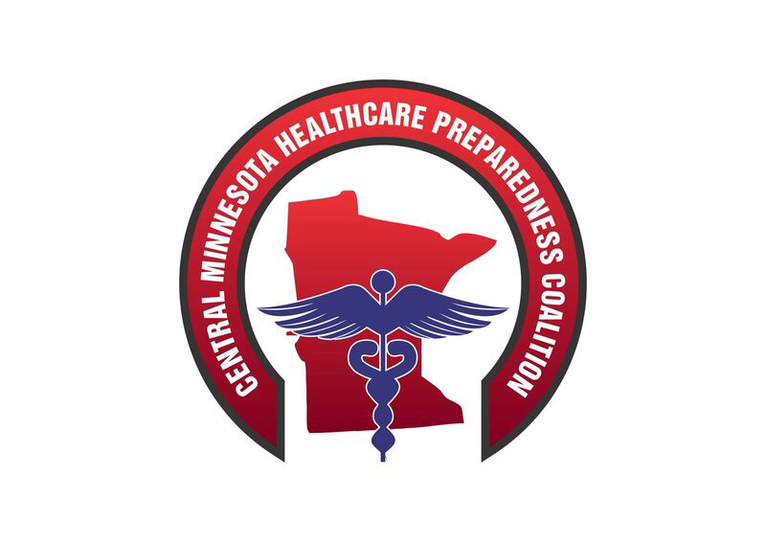
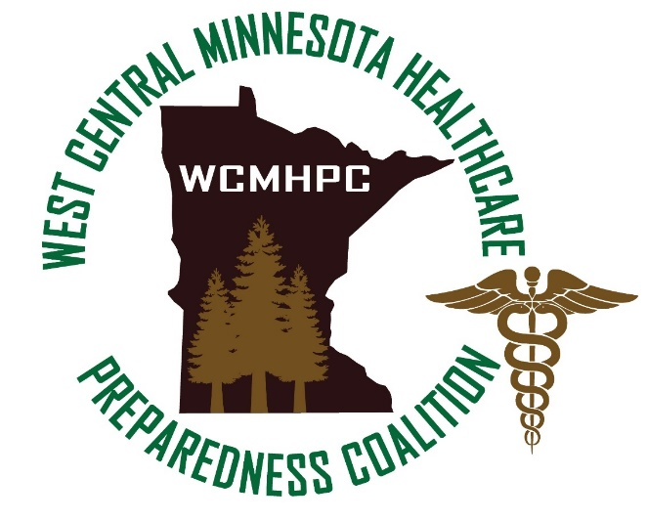

New Member Toolkit

October 2022

Table of Contents
Assumption: 3
FAQs 3
About this Document 3
Acronyms 4
I. The Central and West Central Minnesota Healthcare Preparedness Coalitions (CMHPC & WCMHPC) 5
A. Mission Statements 5
B. Relationships between our coalitions 5
C. Role of the Coalitions 6
D. Membership Requirements for the coalitions 7
E. Coalitions Response Plans 8
F. Resources and Resource Requests 8
II. Best Practices for New Facility Healthcare Emergency Management Coordinators 8
G. Introduction to the Role of Emergency Management Coordinator 8
H. Hazard Vulnerability Analysis (HVA) and Risk Assessments 11
I. Emergency Operations Plan (EOP) Writing 11
J. Communications With the Coalitions 12
K. Exercise Design 12
L. Training Opportunities 13
M. Professional Organizations and Certifications 13
III. Introduction to Healthcare Coalitions 13
A. History of the Hospital Preparedness Program (HPP) 13
B. The Development of Healthcare Coalitions 15
C. The Role of Healthcare Coalitions in Response 15
D. Healthcare Coalitions in Minnesota 16
Appendix A: COALITION WEBSITE USER GUIDE SHEET 17

Assumption:
In this document, the term “coalitions” refers only to CMHPC and WCMHPC, not other coalitions in Minnesota. This document provides basic information and a series of links and resources.

FAQs
Q: What does it cost to be a coalition member?
A: Membership is free and comes with a variety of free services. We also offer some fee-based services. See page 6 for details.
Q: How are coalitions funded?
A: Minnesota’s coalitions are funded through federal grants that are administered and distributed through the Minnesota Department of Health. CentraCare – St. Cloud Hospital is the fiscal agent for the Central and West Central Coalitions. They are responsible for management and accountability of funds, human resources functions, facilities, communications infrastructure and more. They receive a 10% fee for providing these products and services to the coalitions.
Q: How do I contact the coalitions?
A: For routine communication, email cwchealthcarecoalitions@centracare.com. For urgent needs, call 320-654-2720 (answered 24/7).

About this Document
The purpose of the Central Minnesota Healthcare Preparedness Coalition (CMHPC) and West Central Minnesota Healthcare Preparedness Coalition (WCMHPC) New Member Toolkit is to provide a standard resource for new coalition members. This document is broken into three sections:
  - Chapter I – The Central & West Central Minnesota Healthcare Preparedness Coalitions
This chapter describes the coalitions, their resources, and their role in response. New Coalition members can use this information to understand the mission of the coalition, membership requirements, and services that the coalitions can provide to an agency.
  - Chapter II - Best Practices for New Healthcare Emergency Management Coordinators
This chapter describes resources available to a newly appointed Healthcare Emergency Management Coordinator for an agency in the coalition(s). Resources included in this chapter provide information on the role of the coordinator, essential elements of an emergency management program, and additional training opportunities.
  - Chapter III - Introduction to Healthcare Coalitions
This chapter provides historical information about the development of the Hospital Preparedness Program (HPP) and Healthcare Coalitions (HCC) from the federal and state levels.

Acronyms

Acronyms | Definition
ASPR | Administration for Strategic Preparedness and Response
ASPR TRACIE | Administration for Strategic Preparedness and Response Technical Resources, Assistance Center, and Information Exchange
CDC | Centers for Disease Control and Prevention
CMHPC | Central Minnesota Healthcare Preparedness Coalition
CMS | Center for Medicare and Medicaid
DNV GL | Det Norske Veritas Germanischer Lloyd
EOC | Emergency Operations Center
EOP | Emergency Operations Plan
EMC | Emergency Management Coordinator
EMI | Emergency Management Institute
EMS | Emergency Medical Services
FEMA | Federal Emergency Management Association
HCC | Healthcare Coalition
HHS | US Department of Health and Human Services
HICS | Hospital Incident Command System
HPP | Hospital Preparedness Program
HSEEP | Homeland Security Exercise and Evaluation Program
HVA | Hazard Vulnerability Analysis
ICS | Incident Command System
MN-MMT | Minnesota Mobile Medical Team
MOU | Memorandum of Understanding
NDMS | National Disaster Medical System
NIMS | National Incident Management System
PHEP | Public Health Emergency Preparedness
PHPC | Public Health Preparedness Consultant
RHPC | Regional Healthcare Preparedness Coordinator
WCMHPC | West Central Minnesota Healthcare Preparedness Coalition
WC | West Central

The Central and West Central Minnesota Healthcare Preparedness Coalitions (CMHPC & WCMHPC)

The CMHPC serves Benton, Cass, Chisago, Crow Wing, Isanti, Kanabec, Mille Lacs, Morrison, Pine, Sherburne, Stearns, Todd, Wadena and Wright counties, and the Mille Lacs Band of Ojibwe tribal government.

The WCMHPC serves Clay, Douglas, Grant, Otter Tail, Pope, Stevens, Traverse, and Wilkin Counties.

New members will need to sign up for full website access and be approved by the coalition for access to protected documents. You can do so at: Register – Central and West Central Healthcare Preparedness Coalition (cwchealthcarecoalitions.org)

  - Mission Statements
The CMHPC serves our communities in collaboration with other partners to coordinate emergency preparedness, response, and recovery activities.
The WCMHPC is a multi-disciplinary partnership of healthcare and supporting and responding agencies; that collaborate to coordinate preparedness, response, and recovery activities as it pertains to routine and emergent events that could impact the region.

  - Relationships between our coalitions
The CMHPC and WCMHPC have a fiduciary and collaborative relationship with one another and with CentraCare - St. Cloud Hospital. CentraCare - St. Cloud Hospital is the fiduciary agent for both coalitions and therefore supports both coalitions. Natural transfer patterns from both regions to CentraCare - St. Cloud Hospital further underscore this relationship. The Central and West Central Coalition Coordinators and the Coalition Educator report to the Emergency Preparedness Program Manager.
This leadership structure provides for natural collaboration between the coalitions and shared resources (office space, storage space and communications infrastructure) and personnel that can support both regions in an event.

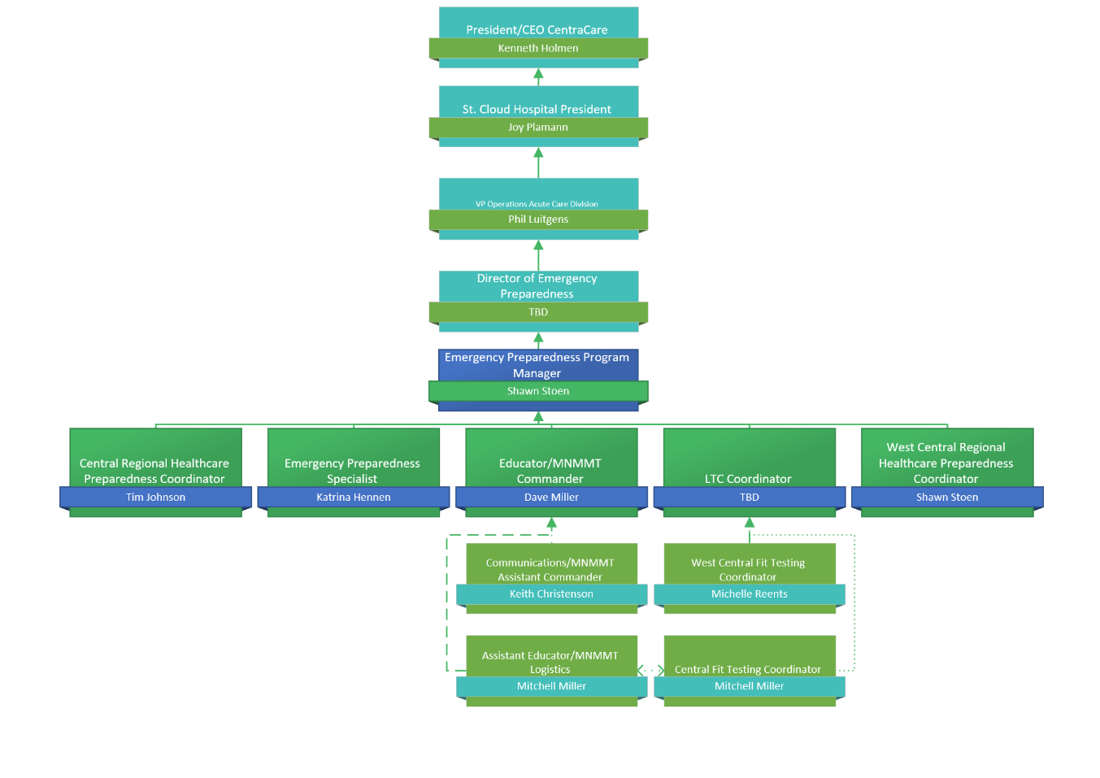
  - Role of the Coalitions
    - Services Provided by the Coalitions at no cost to membership:
The primary role of the coalitions is coordination, collaboration, and facilitation of programs that support the region. Using federal grant funds, the coalitions will arrange for trainings, tools, resources, and project management that all members can use. The coalitions provide:
      - Collaborative planning, preparedness, and response efforts
      - Standardized preparedness and integration efforts across the region
      - A centralized communication and information sharing system between local, regional, and state entities
      - Support for the regions’ coordinated response through training and exercises
      - Access to a cache of supplies that are deployable during and emergency
      - Contacts and relationships with other Healthcare entities in the region, state, and across the US
      - Support for MNTrac (an online database that provides real-time bed tracking as well as command center chat room for use during a response).
      - 24/7 access to emergency preparedness and response specialists for coalition members.
    - Fee-Based Services Provided by the Coalitions
In addition to the free services supported by the federal grant, the coalitions offer facility-specific emergency preparedness services to its members for a reasonable fee. These services can include:
      - Facility-based Hazard Vulnerability Analysis (HVA) / risk assessment review and development
      - Environmental safety and security risk assessments
      - Physical security and environmental design assessments
      - Plan and documentation review and development
      - Emergency communications consultation
      - Evacuation equipment training
      - First receiver decontamination training
      - Incident Command System (ICS) / Hospital Incident Command System (HICS) training
      - Psychological First Aid training
      - Respiratory protection training and fit testing train-the-trainer
      - Self-defense techniques and verbal de-escalation training
      - Facility-based exercise planning, facilitation, and support
      - Professional speaking on emergency preparedness topics

  - Membership Requirements for the coalitions
The coalitions’ bylaws outline the membership requirements. Active membership in the coalition is evidenced by a signed form (see table below).

Document to Complete | Location
Appendix 5.2.2 Healthcare Signature Form | Membership toolkit and documents – Central and West Central Healthcare Preparedness Coalition (cwchealthcarecoalitions.org) | Healthcare partners (LTC, Assisted Living, Hospitals, Clinics, EMS, Pharmacies) sign once and are members until they elect not to be.
Appendix 5.2.3 Partner Agency Acknowledgement | Membership toolkit and documents – Central and West Central Healthcare Preparedness Coalition (cwchealthcarecoalitions.org) | Emergency Management and Local Public Health sign once and are members until they elect not to be.

See coalition bylaws and memorandum of understating (MOU) in the appropriate preparedness plan, including bylaws, signatory process and memorandum of understanding – located on the coalition website.
  - Coalitions Response Plans
Each coalition has a comprehensive response plan approved by the coalition members. The response plan details the plan for regional coordination, communications, medical surge, mass fatality, and access and functional needs. See each regional response plan and appendixes for more details – located on the coalition website.

  - Resources and Resource Requests
The coalitions have a plan to accept resource requests and allocate resources. See the Response Plan – located on the coalition website:
    - Regional Cache
The coalitions maintain a regional cache of healthcare supplies that may be needed to supplement the resources available for Coalition members. The Coalition maintain, monitor, allocate, and distribute control the inventory items in the cache as well as the acquisition and disposal of equipment. Items in the cache can be requested through the Coalition.
    - Minnesota Mobile Medical Team (MN-MMT)The Minnesota Mobile Medical Team (MN-MMT) is a group of volunteer medical and support professionals who have received training and practice in providing acute medical care in a mobile field environment. The MN-MMT can be requested by a local jurisdiction through the local Emergency Manager via the Minnesota State Duty Officer (SDO).
See Mobile Medical Team for more details.
    - Resources and Supplies from the Minnesota Department of Health (MDH):
The Coalition may request resources from the MDH to aid in a response. Forms for resource requests are located on the Coalition website – within the Response Plan.

Best Practices for New Facility Healthcare Emergency Management Coordinators
Healthcare facilities and their staff play a key role in emergency preparedness and response efforts for all types of events. This section of the New Member Toolkit provides links and resources to assist a person new to the role of Facility Healthcare Emergency Management Coordinator (EMC).

  - Introduction to the Role of Emergency Management Coordinator
Emergency management is the organization and management of resources and responsibilities in response to an emergency. In healthcare, focusing on patient care, which differs from other response agencies, and can be driven by specific regulatory requirements (see below).
    - Emergency Management Basics
See the resources and training opportunities listed below for introductory material.
      - The Coalition website has a resource library that is available – it contains many helpful tools and resources. Central and West Central Healthcare Preparedness Coalition – Partnering to Plan, Prepare, and Respond (cwchealthcarecoalitions.org)
      - The US Department of Health and Human Services (HHS) Public Health Emergency (PHE) website offers a list of Technical Assistance and Tools for Health and Emergency Management Professionals.
      - One of the best links on this site is for the Administration for Strategic Preparedness and Response Technical Resources, Assistance Center, and Information Exchange (ASPR TRACIE).
      - Framework for Healthcare Emergency Management is a course offered by the Center for Domestic Preparedness for personnel who are responsible for the development, implementation, maintenance, and administration of emergency management programs and plans for healthcare facilities and/or systems.
      - Emergency Management Principles and Practices for Healthcare Systems is a program on the California Hospital Association’s website.
      - FEMA’s Emergency Management Institute (EMI) offers self-paced, online, Independent Study Courses designed for people who have emergency management responsibilities and the general public. All are offered free-of-charge to those who qualify for enrollment.
        - IS-100: Introduction to the Incident Command System
        - IS-230: Fundamentals of Emergency Management
        - IS-235.c: Emergency Planning
        - IS-700.b: Introduction to the National Incident Management System
        - IS-800.c: National Response Framework
      - The Long Term Care Preparedness Toolkit was put together by the eight healthcare coalitions around the State. Collaboration with the Leading Age and Care Providers allowed these tools to target the needs of the LTC facilities.
    - Regulatory Requirements
Depending on the type of healthcare agency you are, there may be different requirements for emergency management or emergency preparedness. Those listed here are the most common.
      - The Centers for Medicare and Medicaid (CMS)
On September 8, 2016, the Federal Register posted the final rule Emergency Preparedness Requirements for CMS Participating Providers and Suppliers. All 17 types of healthcare providers and suppliers affected by this rule were to comply and implement all regulations on November 15, 2017. See the CMS website for the complete list of requirements, interpretive guidance, and other resources. Additional resources for compliance with the CMS Rule:
        - ASPR TRACIE
        - Understanding the CMS Rule (CMS webinar)
        - Central and West Central Coalitions’ website
      - The Joint Commission
The Joint Commission accredits the full spectrum of healthcare providers – including hospitals, ambulatory care settings, home care, nursing homes, behavioral health programs and laboratories. For emergency management, many of the standards that apply to hospitals apply to other settings across the care continuum. As such, the Joint Commission’s emergency management standards provide a valuable foundation and guide for healthcare organizations to coordinate planning and response efforts and establish Healthcare coalitions. See the Joint Commission Emergency Management Portal for more information on the standards. Additional Resources for compliance with the Joint Commission:
        - The Joint Commission EM Standards
        - The Joint Commission Emergency Management Resources
      - DNV GL (Det Norske Veritas Germanischer Lloyd)
DNV GL was authorized by CMS to begin surveying hospitals in 2008. DNV GL surveys hospitals, critical access hospitals, and ancillary providers like home health, and hospice. Additional services include pharmacy, behavioral health, and convenience care clinics.
    - All Hazards Planning
An all-hazards approach focuses on capacities and capabilities that are critical to preparedness for a full spectrum of emergencies or disasters, including internal emergencies, anthropogenic emergencies (or both) and natural disaster. This approach is specific to the location of the provider or supplier and considers the hazards most likely to occur in their areas. Rather than managing planning initiatives for a multitude of threat scenarios, an all-hazards approach develops capacities and capabilities that are consistent across a full spectrum of events. Thus, All Hazards does not mean “every hazard” but ensures those hospitals and all other providers and suppliers will have the capacity to address a broad range of related emergencies. Additional Resources for Al Hazards Planning:
      - Ready.Gov Planning Reference
      - FEMA Guide for All Hazards Emergency Operations Planning
    - Incident Command System and Coordination
The Incident Command System (ICS) is a standardized approach to the command, control, and coordination of emergency response providing a common framework for responding agencies. ICS came out of the fire service and was initially developed to address problems of inter-agency responses to wildfires in California and Arizona. Since then, it has been added to the National Incident Management System (NIMS) and evolved into use in All-Hazards situations by multiple agencies.

Healthcare leaders recognized the value and importance of using an incident management system consistent with responders in emergency situations. The Hospital Incident Command System (HICS) was initially developed as the Hospital Emergency Incident Command System (HEICS) in California in the 1990s. HEICS became HICS in 2006 as the value and importance of using an incident management system to assist with daily operations, preplanned events, and non‐emergent situations as well as emergency incidents became apparent. The Fifth Edition of the Hospital Incident Command System (HICS) was released May of 2014.

Additional Resources for HICS:
      - IS-100.C: Introduction to the Incident Command System
      - IS-200.C: Basic Incident Command System for Initial Response
      - The Center for HICS Training and Education
      - HICS for Nursing Homes
      - HICS for Small Hospitals
The coalitions offer facility-specific training on the Hospital Incident Command System. Contact the regional coordinator to discuss any specific fee-based facility training/exercise needs.

  - Hazard Vulnerability Analysis (HVA) and Risk Assessments
The Hazard Vulnerability Analysis (HVA) and/or risk assessment is the cornerstone of an emergency management program. From this assessment, and EMC can determine the highest risks to their facility and guide planning efforts, training programs, and exercises based on the highest risk events. An HVA or risk assessment is required by regulatory bodies.

There is no required format or process for conducting an HVA / risk assessment. But it should be conducted with a multidisciplinary process with representatives from all services that could be involved in an emergency. The process includes assessing the probability of each type of event, the risk it would pose, and the organization’s current level of preparedness. This HVA should also consider nearby community resources likely to be affected or called upon for assistance.

Tools for HVAs / Risk Assessments:
    - American Society for Healthcare Engineering (ASHE) HVA Resources
    - ASPR TRACIE HVA Tools
    - California Association of Healthcare Facilities (CAHF) HVA Tools
    - California Hospital Association (CHA) Kaiser Permanente HVA Tool
    - Coalitions’ Resource Library – including the Kansas Model HVA Tools

Resources for How to Conduct an HVA / Risk Assessment:
    - ASPR TRACIE HVA Training Resources
    - ASPR PHE Hazard Vulnerability Analysis
    - Conducting a Hazard Vulnerability Analysis and Webinar
    - Northeast Florida Regional Council Outpatient Facility HVA Webinar
    - Northeast Florida Regional Council Inpatient Facility HVA Webinar
    - Metrolina Healthcare Coalition Overview and Integration of HVAs Webinar
    - Ready.Gov Risk Assessment

  - Emergency Operations Plan (EOP) Writing
A facility Emergency Operations Plan (EOP) outlines the management structure and processes that the organization utilizes to respond to and initially recover from an event. As mentioned above, an All-Hazards approach allows the organization the ability to respond to a range of emergencies varying in scale, duration, and cause. The EOP should also include:
    - Introduction to the organization (type, services provided, geographic coverage, patient types)
    - Activation authority and procedure
    - Termination authority and procedure
    - Use of the Incident Command System (or similar system) and position checklists
    - Communication plan and Emergency Communications
    - Contact list for emergency services
    - Hazard-specific response plans
    - Recovery strategies
    - Alternate sites for care, treatment, and services

Tools / Templates for an EOP
    - ASPR TRACIE EOP Resources
    - California Association of Healthcare Facilities EOP Resources
    - California Hospital Association EOP Resources
    - Coalitions’ Resource Library
    - Kansas Department of Health Hospital EOP Template
    - Minnesota Department of Health Long Term Care Toolkit
    - 10 Keys to Healthcare Emergency Planning

  - Communications With the Coalitions
During a response, emergency communication is vital for the coalition(s) to understand the impact at each of its member facilities and to be able to share vital information. Each coalition’s Communications Plan is contained within the Regional Response Plan. Also included is a plan that discusses how coalitions, the State and Cross Border partners can communicate.
    - Day-to-day communication with the coalitions happens through email and phone.
    - The coalitions are available 24/7 to support members. For routine communication, email cwchealthcarecoalitions@centracare.com. For urgent needs, call 320-654-2720 (answered 24/7).
    - MNTRAC is vital to the coalitions to gather and share information. See the MNTRAC resources and instructional cheat sheets in the coalitions’ Resource Library.

  - Exercise Design
An emergency management program is not complete without an exercise program. Exercises of all sizes provide a learning opportunity for staff and a way to evaluate response procedures ahead of an actual response.

FEMA has created the Homeland Security Exercise and Evaluation Program (HSEEP) to standardize the approach to the design, conduct, and evaluation of exercises. FEMA also offers exercise design training.
    - IS-120.C: An Introduction to Exercises

Additional Training and Resources for Exercise Design:
    - ASPR TRACIE Exercise Program Resources
    - CIDRAP Hospital and Health Facility Emergency Exercise Guide
    - Coalitions’ Resource Library
    - MDH Emergency Preparedness Training and Exercises
    - NETEC Highly Infectious Disease Exercises

  - Training Opportunities
For additional training on various Healthcare preparedness topics not already mentioned in this toolkit, see the links below.
    - CDC’s Learning Connection
    - Coalitions’ Training and Education
    - FEMA’s Center for Domestic Preparedness Resident Training Courses
    - FEMA’s Center for Domestic Preparedness Independent Study Programs
    - The Joint Commission Resources Learning Events

  - Professional Organizations and Certifications
This section contains a list of professional organizations, certifications, and opportunities for continuing education.
    - Professional Organizations
      - Association of Healthcare Emergency Preparedness Professionals (AHEPP)
      - Association of Minnesota Emergency Managers (AMEM)
      - The International Association for Preparedness and Response (DERA)
      - National Emergency Management Association (NEMA)

III. Introduction to Healthcare Coalitions
  - History of the Hospital Preparedness Program (HPP)
Public health and medical leaders became concerned about the preparedness level of the health and medical system after the attacks of September 11, 2001, and the subsequent anthrax letters. In 2002, the National Bioterrorism Hospital Preparedness Program was created. Approximately $125 million was spent to provide states with funding to address gaps in hospital preparedness and emphasize decontamination, maintaining pharmaceutical caches, identifying hospital bed surge capacity, and training providers in the diagnosis of diseases caused by bioterrorism.

In 2004, emphasis of the program shifted from a capacity-based, bioterrorism-focused program to an all hazards, capabilities-based approach. The change meant that hospitals could no longer meet requirements simply by purchasing equipment and/or supplies; they needed to demonstrate the capability to perform core functions common to all responses. In 2006, the Office of the Administration for Strategic Preparedness and Response (ASPR) was created to serve as the principal advisor to the Secretary of HHS on all matters related to public health and medical preparedness and response to public health emergencies. The HPP moved under ASPR in 2007, and ASPR became the single point of coordination and integration for all public health and medical preparedness programs with medical response programs and activities for the Federal government.

Within the National Response Framework, HHS uses the HPP to help address gaps in Healthcare preparedness and the National Disaster Medical System (NDMS) to augment damaged and/or overwhelmed local medical systems in health emergencies.

Hurricane Katrina in 2005 and the 2009 H1N1 influenza pandemic highlighted even more the importance of hospitals and Healthcare systems being prepared for potential threats and the consequences that occur when a community is ill-prepared. In 2012, ASPR released the National Guidance for Healthcare System Preparedness defined a set of Healthcare Preparedness Capabilities to assist Healthcare systems, Healthcare Coalitions (HCCs), and Healthcare organizations with preparedness and response. These capabilities aligned with the 15 Public Health Emergency Preparedness (PHEP) Capabilities released in March 2011 and were designed to facilitate and guide joint preparedness planning and ultimately assure safer, more resilient, and better-prepared communities. The following eight capabilities (shown with their aligned HPP/PHEP Capability numeric designation) were the basis for Healthcare system, Healthcare Coalition, and Healthcare organization preparedness:
    - Healthcare System Preparedness
    - Healthcare System Recovery
    - Emergency Operations Coordination
    - Fatality Management
    - Information Sharing
    - Medical Surge
    - Responder Safety and Health
    - Volunteer Management

Changes to the HPP came again in 2017 when ASPR released the 2017-2022 Healthcare System Preparedness and Response Capabilities to describe what the Healthcare delivery system has to do to effectively prepare for and respond to emergencies that impact the public’s health. The 2017-2022 Healthcare Preparedness and Response Capabilities document outlines the high-level objectives that the nation’s Healthcare delivery system (including HCCs and individual Healthcare organizations) should undertake to prepare for, respond to, and recover from emergencies. ASPR has provided expectations, priorities, and performance measures to assess progress toward building the capabilities. There are four capabilities defined within the HPP:
    - Foundations for Healthcare and Medical Response
    - Healthcare and Medical Response Coordination
    - Continuity of Healthcare Services Delivery
    - Medical Surge

  - The Development of Healthcare Coalitions
Based on the evolution of the HPP, the concept of the HCC emerged as the need for coordinated planning efforts across the entire Healthcare community and to engage the non-Healthcare community in preparedness activities became apparent. The evolution of HCCs can be broken into three phases.
    - 2002-2011: Individual facilities purchase equipment with HPP’s support. Hospitals use HPP funding to buy tangible resources like ventilators, mobile medical units, and pharmaceutical caches.
    - 2012-2016: HPP formalizes support for regional Healthcare coalitions. HPP funding is dispersed to HCCs to promote the development of healthcare capabilities as capabilities-based planning shifted from facility-level to community-level preparedness.
    - 2017 and beyond: HPP emphasizes the role of the HCCs as response entities. HCCs use HPP funding to operationalize for response by optimizing membership and geographic coverage.
According to the 2017-2022 Healthcare System Preparedness and Response Capabilities, HCCs are groups of individual Healthcare and response organizations in a defined geographic location that serve as multi-agency coordinating groups and support and integrate with public health and medical services activities. HCC member composition varies by jurisdiction but should include four core members: hospitals, emergency medical services (EMS), emergency management organizations, and public health agencies. Other partners may include behavioral health, long-term care, pharmacies, tribal entities, public safety, and multiple community-based and non-governmental organizations. HCCs have functions during both preparedness and response. HCCs serve as communication hub for participating entities and coordinate the sharing of resources, policy, and practices both prior to and during an event.
  - The Role of Healthcare Coalitions in Response
Although specific response roles vary by coalition, there are commonalities.
    - Sharing information between HCC members and with other jurisdictional partners.
    - Maintaining situational awareness.
    - Sharing and coordinating resources.
    - Analyzing public health and Healthcare data.
    - Coordinating patient movement and evacuation.
    - Conducting disease surveillance functions.
    - Assisting with coordination of mass shelter operations.
    - Tracking patients and supporting family reunification.
    - Coordinating assistance centers and call centers.
    - Coordinating psychological care services.
    - Providing staff to support emergency operations centers (EOC)

Though the HCC as an entity may conduct specific response functions, individual HCC members must also perform roles specific to their organizations to carry out an effective response. Individual response roles that support the overall HCC response can vary by organization but can include the following:
    - Provide organization-specific information to HCC leads.
    - Provide bed availability counts, disease surveillance information, and patient tracking information.
    - Conduct planning and training activities with agency staff.
    - Contribute and share agency resources to help support surge needs and alleviate resource shortages.
    - Host community response sites and/or points of dispensing.
    - Provide talking points, messaging templates, and clinical recommendations.
In addition, HCCs use a variety of strategies to organize and coordinate response operations, including the following:
    - Establishing an HCC leadership committee to make decisions and set priorities.
    - Providing representatives to sit in the local emergency operations centers (EOC).
    - Utilizing existing HCC communication channels to share and receive emergency information.

  - Healthcare Coalitions in Minnesota
Minnesota’s Center for Emergency Preparedness and Response is focused on supporting the regional coalitions as they assist in preparing Healthcare systems and their partners to prevent, respond to, and rapidly recover from a growing list of man-made and natural threats.

Each Healthcare Coalition in Minnesota has a Regional Healthcare Preparedness Coordinators (RHPC). These RHPCs work together on plans and projects that ensure the coordination across regions.

Appendix A: COALITION WEBSITE USER GUIDE SHEET

LINK TO THE WEBSITE: www.cwchealthcarecoalitions.org
- Access to the full site requires membership – click on Register to request access to the site. Once the request is made allow for 24 hours for the approval to go through.
COALITION RESOURCES:
- This page is open to the public
- Contains:
  - New Membership Toolkit
  - Resource Library
  - News
MEMBERS ONLY:
- Open to those that have registered on the site
- Contains:
  - Coalition Chat Room (note – this is used as a tool to communicate with coalition members during a response/exercise)
  - Threat Assessment tools
  - Continuity Planning tools
  - Incident Command Training videos
Each coalition and the MN Mobile Medical Team have their own pages. If you click on the plus sign by the logos, you will be taken directly to each specific page.
The coalition pages include:
- Membership list (updated to include all that are signed members in the coalition)
- Regional Plans (including preparedness and response plans and their attachments)
- Coalition and Facility Regional Resources
- News
- Exercise Documentation
- Empower Data

