MNTrac training

HOW TO UPDATE YOUR BED SURGE CAPACITY
Log into www.mntrac.org and enter your username and password
Bed Surge – defined:
When asked for your bed surge numbers, you are being asked to assess your current patient census and staffing levels to determine if you are able to exceed your current bed capacity within the designated number of hours. To do this, you could call in more staff, discharge patients to home or an alternate appropriate treating facility (i.e. nursing home), or rearrange your current bed assignments.
The bed – surge alert can be received by email, text message and/or phone.
To update your patient surge numbers you would log into MNTrac at www.mntrac.org.
On your facility summary page – you will see the Bed Surge widget……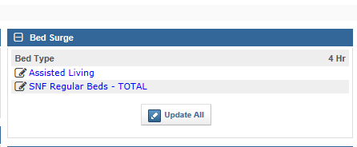
To update your numbers – simple click on the words Update All……….
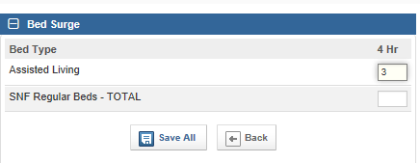
Put in the appropriate bed availability next to the appropriate bed type and click on Save All.
NOTE: If you do not see the Bed Surge widget, click Widget Preferences in the top right corner of your dashboard. Select the Bed Surge widget and click Save. Click Widget Preferences to close the drop down.
You will also need to acknowledge the alert by putting in your credentials and your password.

