Respiratory Protection & “The Flu”
As we progress through the winter season, the flu is in full swing. We are seeing a lot of Influenza A and an occasional Influenza B. The real question is, how are WE doing, the healthcare providers…
Influenza requires droplet precautions, or a simple procedure/surgical “mask”. The real problem occurs when WE provide the patient with nebulized medications for their respiratory distress or cough, the virus then becomes airborne. Once the virus becomes airborne, then we must switch from a simple mask to a respirator (N-95 or PAPR). Even after the procedure is completed, the virus can remain airborne for many minutes, even up to an hour.
With the use of a respirator, specifically an N-95, you must complete annual fit testing. Fit testing can be time consuming and expensive. Many healthcare institutions have now begun to use PAPRs rather than N-95 respirators. These devices do not require the annual fit testing and can be used by all staff with minimal “just in time” training. They can be worn with glasses, facial hair, and other situations where an N-95 respirator cannot.
There are many brands and types of N-95s on the market, I would recommend that you find one that is cost effective with a high fit test pass rate for your staff. The region does carry a small cache of N-95 respirators to deploy in the case of an emergency. The respirators that we carry are the 3M 1870+, we have approximately 35,000 in storage.
The N-95 respirator can be a very useful tool, but it has its limitations as described above. The PAPR is a much broader use tool, but it comes with a cost. As we as a regional coalition look to protect our staff with the best possible protection, there is always the dollar figure in the background that drives many of our decisions. In the next few paragraphs, I am hoping to go through the benefits of the PAPR and a few ways to keep PAPR costs down and staff safety up.
First let’s talk about safety, or better described as APF (approved protection factor). A simple procedure/surgical mask has a APF of 2. This means that it will filter at a rate of x/2 where x is the amount of “crap” in the air. An N-95 respirator has a APF of 10 when properly “fitted”. This means that it will filter at a rate if x/10 or 5 times better than a standard mask. As we move from a tight-fitting mask or respirator to a loose fitting PAPR, we greatly increase the level of protection. A PAPR with a headcover protects at a APF of 25, a PAPR with a hood (untucked) will provide a APF of 100, and a PAPR with a tucked hood will provide a APF of 1000.
The most important thing to remember is that all procedure/surgical masks, N-95 respirators, and the 3M Versaflo PAPRs (TR-300 or TR-600) are designed to be utilized for biological contaminants such as bacteria and viruses only. They are not for use with chemicals (exception is the TR-600 with applicable filters in place). Only the 3M BreathEasy with the CBRNE filters in place will protect against chemical contaminants, as well as biologic, radiologic, nuclear, and explosive. The BreathEasy can also be utilized for any application that an N-95 respirator or Versaflo PAPR is applicable.
Type of Respiratory Protection | Contaminate in the air | APF | Contaminate to the user
Procedure Mask (no splash protection) | 5,000 | 2 | 2500
Surgical Mask (splash protection) | 5,000 | 2 | 2500
N-95 Respirator | 5,000 | 10 | 500
PAPR w/headcover | 5,000 | 25 | 200
PAPR w/untucked hood | 5,000 | 100 | 50
PAPR w/tucked hood | 5,000 | 1,000 | 5

When it comes to PAPRs, the region also has a small cache for use by its members in an emergency. We currently have 36 PAPRs in St. Cloud and 10 PAPRs in Glenwood that could be deployed with short notice anywhere in the Central or West Central region for emergency use. These PAPRs are the 3M TR-300, like the PAPRs that each hospital received via the EBOLA grant in EBOLA year one. A few notes regarding the TR-300 and its use. First, the battery should always remain on the charger unless in use, it will be just fine on the charger and will then be ready when needed. There is no need to “cycle” the battery, they are “smart” batteries with “smart” chargers. (If you still have the 3M AirMate PAPR, you must charge and cycle the battery every 30-90 days) You may also notice that some of the regional EMS agencies are now carrying the 3M TR-600, this PAPR has a few other options that are suited for out of hospital settings.
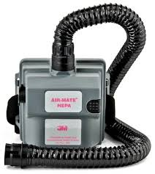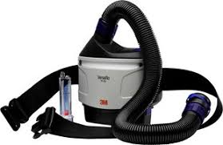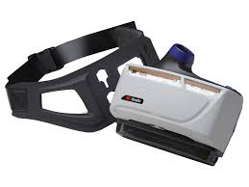
Above are pictures of the PAPRs that you may notice at your facility that were provided by the Regional Coalition. You may also recognize another PAPR that was provided by the Regional Coalition, the 3M Breathe Easy pictured below.
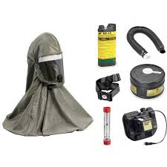This PAPR is primarily used for CBRNE incidents (Chemical, Biological, Radiological, Nuclear, or Explosive) and any other situation where one of the above PAPRs is utilized.
Now we will discuss how to save money but utilizing different breathing tubes and headcovers/hoods. The chart below will show what comes with the unit and what will work with the unit as well.
PAPR | Breathing Tube | Headcover | Hood
3M AirMate | BE-224 | BE-12 series | BE-10 series
3M Versaflo TR-300 & 3M Versaflo TR-600 | BT-20S | S-103S or S-103L | S-403S or S-403L
 | BT-20L
 | BT-30
 | BT-40
 | BE-224 | BE-12 series | BE-10 series
3M BreathEasy | 520-03-32R01 | BE-12 series | BE-10 series
 | 520-01-00R01
 | 520-02-94R01
 | BE-324 | S-103S or S-103L | S-403S or S-403L
Comes with the unit… Will work with the unit…
The coalition has a stock of the following for deployment during and emergency;
- Previous Version
  - BE-224 Breathing Tube
  - BE-12 Headcover
  - BE-10 Hood
- Current Version
  - S-103 Headcover
  - S-403 Hood
  - BT-30 Breathing Tube
I encourage all of you to see what you have at your facility and play/practice with it so that when the time comes, you are familiar with your equipment and feel good about using it. The most dangerous part of using this equipment is lack of knowledge and fear with use. Please feel free to contact any of the regional staff with further questions or concerns.
David R. Miller, NRP, Community Paramedic
CentraCare Health - Saint Cloud Hospital - Level II Emergency Trauma Center
Central & West Central MN Healthcare Preparedness Coalition EP Specialist
Minnesota Mobile Medical Team - Deputy Commander & Logistics Chief
1406 6th Avenue North (mailing)
1555 Northway Drive (office)
St. Cloud, MN 56303
(320)828-2511 (c)
(320)252-0340 (h)
(320)240-3196 (fax)
(320)251-2700x53045 (o)
millerdav@centracare.com

