Let’s Talk Respiratory Protection…
In this episode of “Regional Equipment”, we will discuss the differences between the levels of respiratory protection available to healthcare workers in the Central and West Central Coalitions. We will start with the basic and progress to the complex, start with the reasonable and proceed to the elite, start with the cheap and end with the expensive…
Let us first look at the options and definitions. A few key terms to understand are mask-vs-respirator and Assigned Protection Factor (APF). A mask can be worn by anyone, does not require a medical evaluation, and does not require an annual fit test. A respirator on the other hand requires the wearer to complete a medical evaluation, may require a fit test, and is only worn by healthcare staff (not for pt. use). Assigned Protection Factor is a rating of how much protection is granted by a properly worn mask or respirator. These ratings can go from 2-1,000 for practical healthcare settings.
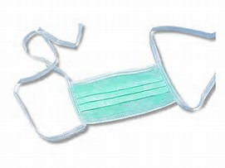
Surgical Mask
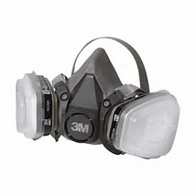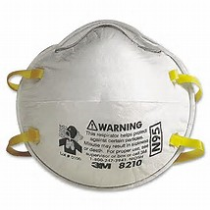
Respirators
Every day we communicate and breath without a filter. If we do need to filter what we breath we have many options. The most basic is the “procedure mask”. This item is designed to “cover your cough”. It is better at catching things that are exhaled than those that are inhaled. It is assigned a APF of 2; that is, if there are 10,000 particles in the air, it will allow up to 5,000 of them (10,000/2) to get past. A surgical mask has the same APF, however it has a fluid resistant membrane that prevents fluids from crossing over the membrane from either side. These are often available for pennies per procedure mask to a few dimes for a surgical mask.
Moving from “masks” to “respirators”, we now gain APF, but add additional requirements as well. A simple N-95 respirator protects us with an APF of 10; that is, if 10,000 particles are floating in the air, it will allow up to 1,000 (10,000/10) to sneak through. As you can see this is 5x better protection for the wearer, however we must add in the fact that this is a tight-fitting respirator and requires a fit test to meet this level of protection. The fit test must be renewed annually to be OSHA compliant. These are still reasonable at around $1.00 per N-95and have a shelf life of approximately 5 years.
As we progress up the respirator spectrum, we now enter the more elaborate and expensive options. With this come additional protection and maintenance. Staying with the non-powered respirators, there is one option that may of interest to EMS. The full-face respirator allows the user a APF of 50; that is, if 10,000 particles are in the air, 200 may pass through. It has the same OSHA requirements of an N-95 with the added protection. It also adds the ability to use specific filters for not only a Highly Infectious Disease (HID), but also for Chemical, Biological, Radiological, Nuclear, and Explosive ((CBRNE). We have now significantly gained in protection ability but as well in cost. The cost can be $100-$200 for the respirator and $10-$60 for each filter. The filters are a onetime use. The respirator is re-useable and may be repaired or maintained as needed. The filters have a shelf life of 5 years.
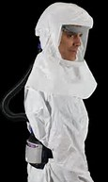
Powered Air Purified Respirator (PAPR)
Moving into the Powered Air Purified Respirator (PAPR), we eliminate the need for fit testing (which can be expensive) as well as sizing (on size fits all). A PAPR can be worn with two very different head ensembles and for two very different reasons. The first is known as a “headcover”. The headcover gives the user a APF of 25 (<400 get by), or 2.5 times better than that of a standard N-95. With this headcover, it is only authorized for use for HID. If you choose to utilize the “hood”, the APF now becomes 1,000. If 10,000 particles are in the air, only 10 will put you at risk. This is a huge level of protection, but they are very cumbersome to wear and function in. It is still recommended that the user complete a medical evaluation. The cost of the PAPR unit is around $1,000, headcovers are about $20 each, hoods are about $25, and the chemical hoods are over $600 (might be able to re-use). The HID PAPR (Versaflo TR-300 PAPR) is re-useable and the headcover can be cleaned and re-used up to 10 times using bleach wipes between pt. encounters for HID. After a chemical event, it will be determined the re-usability of all potentially contaminated equipment (3M Breathe Easy PAPR). The battery is rechargeable, which involves a bit of care and maintenance. On the chemical PAPR, the filters are good for 5 years or one use and are $200 per set. On the HID PAPR, the filter is changed out every 5 years and is about $75.
In both coalitions, the hospitals have a minimum of 2 3M Versaflo TR-300 HID PAPRs and at least 3 3M Breathe Easy CBRNE PAPRs. Regionally we do also have a small cache of the Versaflo PAPRs for use during an epidemic or pandemic. There are also a variety of PAPR accessories and N-95s available as well.
Stay tuned for the next instalment of Dave’s Equipment Corner

