WCMHPC Hospital To-do Checklist
☐ | 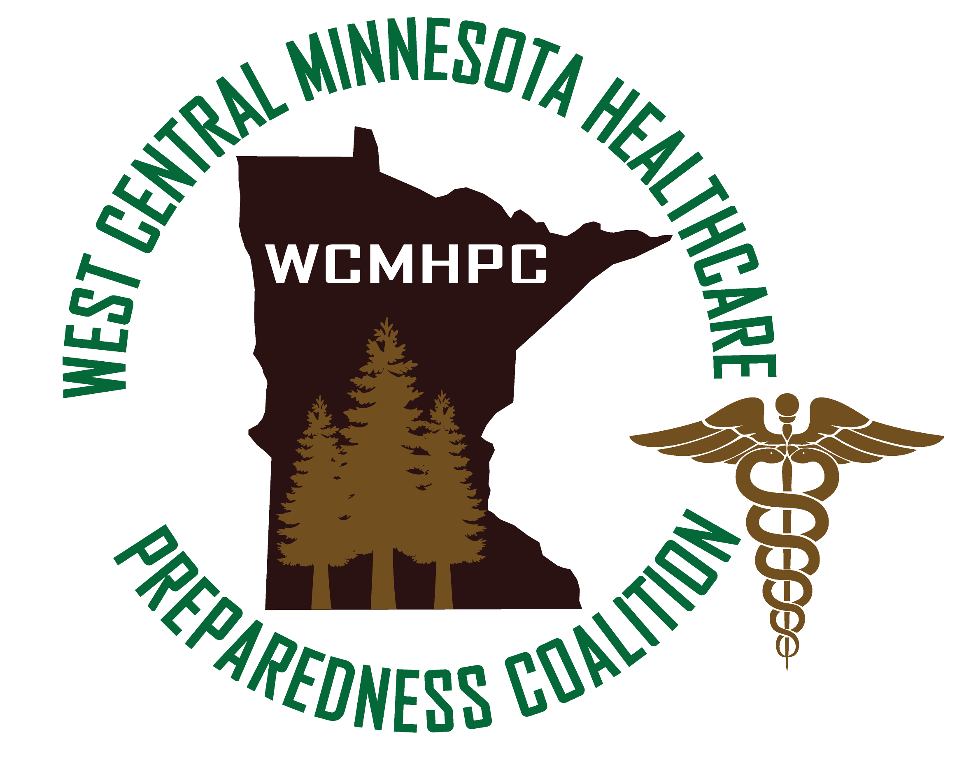  Schedule one on one MNTrac training with Shawn GOAL DATE: Feb 28, 2020
☐ | Submit In-kind report (July 2019 – Dec 2019) GOAL DATE: Jan 28, 2020
☐ | Submit Ebola Reimbursement form GOAL DATE: Jan 28, 2020
☐ | Full Scale Exercise – intent to participate notification GOAL DATE: Jan 28, 2020
☐ | Provide feed back on the regional HVA draft GOAL DATE: Jan 31, 2020
☐ | MNTrac Checklist:  ☐ Review staff list - inactivate/clean up list. Make sure have alert notifications and command center access. Make sure all have email and hopefully cell phone numbers to ensure multiple people get notifications of alerts.  ☐ Review facility set up – ensure bed numbers/typing are accurate  GOAL DATE: March 1, 2020
☐ | Review contact list on coalition website to verify accuracy GOAL DATE: June 30, 2020
☐ | Submit In-Kind Report (Jan 2020 – June 20, 2020) GOAL DATE: June 20, 2020
☐ | Submit End of Year Reimbursement form GOAL DATE: June 20, 2020

