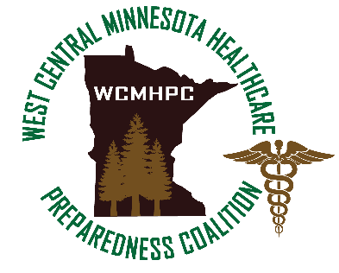

WC MN Healthcare Preparedness Coalition Minutes
6 February 2020
1000 - 1200
WebEx – Conference Call

Topic | Discussion/Findings  These columns are not to be bolded. | Actions/Follow Up  (include responsible person and due date)  These columns are not to be bolded.
Call to Order
Approval of Agenda | Approved changes
Approval of Minutes | No changes to January 2020 minutes
Regional HVA | - Regional HVA sent for review and recommendations for three weeks  - One minor change due to spelling error  - Voted – all approved
Anthrax training/tools for your facility | - Power point reviewed  - Website updated (Exercise WCMHPC)
2019 Novel Coronavirus | - Check in via email every two weeks  - Calendar invite sent out to all EP representatives with the questions that are to be answered  - Frequency may change – increase/decrease  - Questions may change – so watch the calendar invite
MDH Workplan review | - Scheduled for March 10 @ 1 p.m. | Calendar invite was sent to those that expressed interest in participating. Thank you
Regional MYTEP | - Looking for a couple of people willing to spend 2 hours working on the regional MYTEP which is due the end of March.  - Will meet one time to review the plan and make recommended additions/changes based upon our discussions at recent meetings  - Would like representation from LPH, EM, EMS, LTC and Hospital  - Will meet the end of February
MNTrac training reminder | - Would like to do facility specific training for all hospitals – please reach out to Shawn to schedule
Summer workshop with EM’s | - Good date/month  - Will be a 4 hour day
Education/training – reminders | - See attached flyer
Partner Updates | - Karen Moser – PH/MDH  - Shelley Svec – LPH  - Dona Greiner/Lynn Seigel – EM  - Lynn Seigel – WCEMS
Website update | - Included on the resources page:  - Coronavirus  - Cybersecurity
Next Meeting: March 5th at 1000
Minutes Taken By: Shawn
Attendance:
A/P | Name | Facility
P | Jim Harkins/Mary Steidl/Edward Reiff/Brad Brejha | Alomere Health
P | Dena Siemieniewski | CHI St. Francis – Breckenridge
P | Greg Meyers | Glacial Ridge Health
P | Beth Kraft | Lake Region Health
P | Karen Meyer | Perham Health
P | Judy Haley | Prairie Ridge
P | Jeff Olson | Sanford Wheaton
P | Bev Larson | SCMC
P | Karen Moser | MDH PHPC
 | Jeanna Hayes | HSEM
P | Dona Greiner | EM – Stevens County
P | Lynn Seigel | EM – Traverse County & WCEMS
 | Rick Cameron/Chad Mickelson | EMS – FM Ambulance
 | Nathan Roy | EMS - Morris EMS
 | Scott Johnson | EMS – North Memorial
 | Jakki Sjobeck | LTC – Bethany on the Lake
 | Bob Ottesen | LTC – Moorhead Rehab
P | Shelley Svec | LPH – Horizon PH
A | Rachel Mockros | Regional Staff
A | Dave Miller | Regional Staff
 | Josh Ebert | Clay County PH

