MNTrac training

COMMAND CENTER – HOW TO’S
Log into www.mntrac.org and enter your username and password
The Command Center allows multiple partners to log in and communicate as well as share documents within a secure platform.
Command Center invitations are received via text message and email.
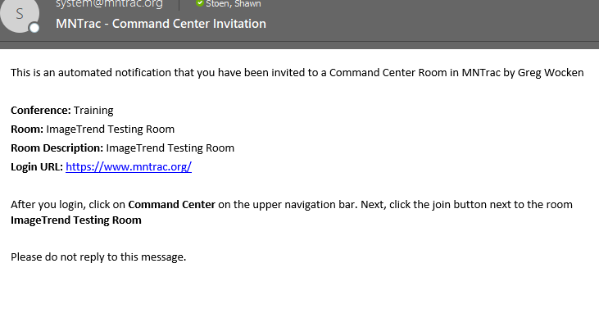
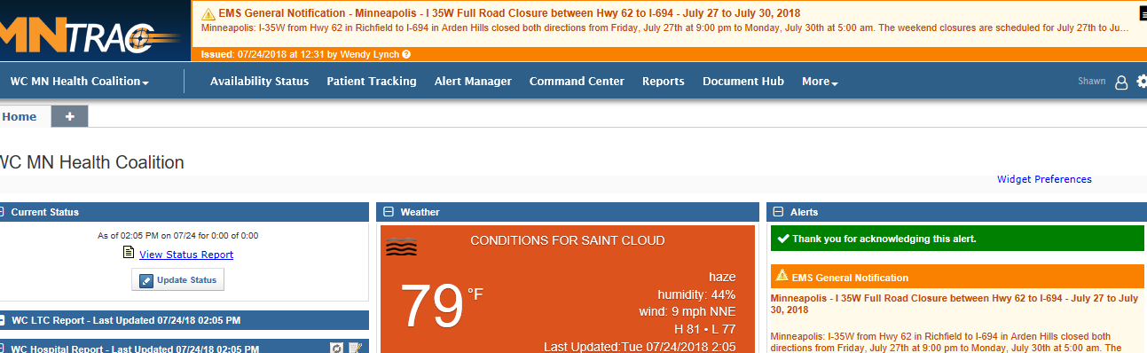
To go to Command Center, log into MNTrac and click on Command Center.

Click on the Join Chat button next to the name of the Command Center room that you have been invited to……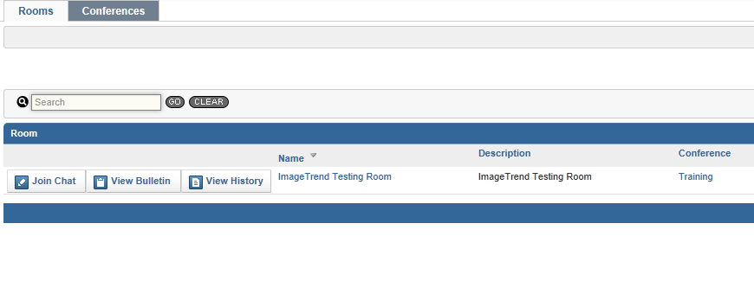
When you get into the room you will see five sections:
- Chat
- Room Note
- Users
- Bulletin Board
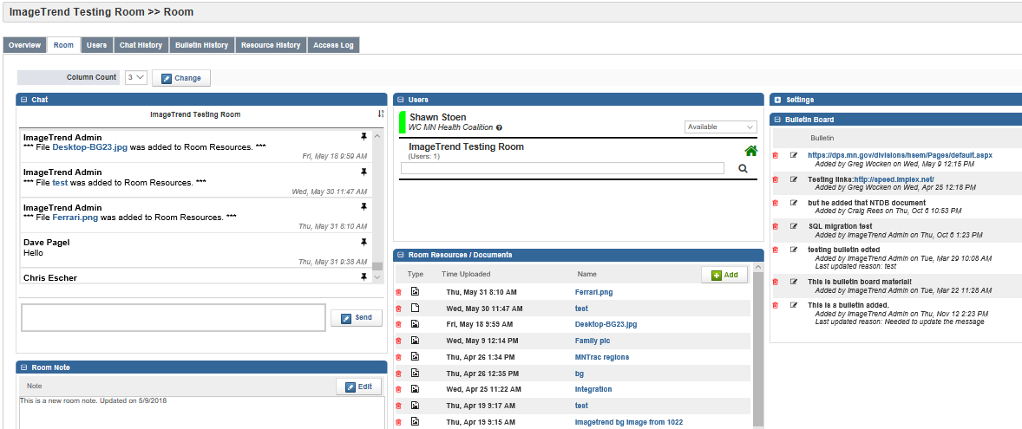
- Room Resources

- The layout of this room is unique to each user; no one else sees the room in your configuration.
- You can move, expand and collapse widgets to view the information most important to you.
- The Room tab is where all activity such as chats, uploading resources or for this room actually takes place.

Chat
- All users in the room can participate in the room Chat.
- Please introduce yourself and the facility/agency that you are representing
- To make it easier to monitor, there is a toggle in the top right-hand corner of the chat widget that looks like an arrow – make sure that the numbers next to the large arrow listed as 1 then 9 – this will ensure that the most recent chat post is at the top. 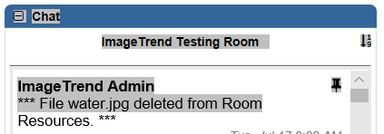

users
- This area lists all the active users currently in the room.
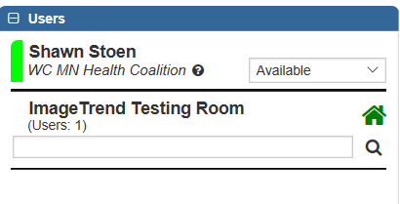
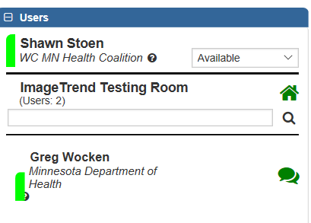
- You can privately chat with any user in the room. This chat is not seen by the other users. To access the private chat – click on the green bubbles next to the name of the individual that you want to chat with…..

- A new tab will open in the Chat box with the name of the individual that you are chatting with.
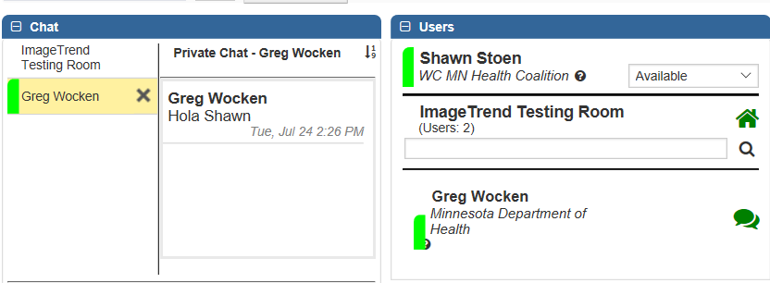
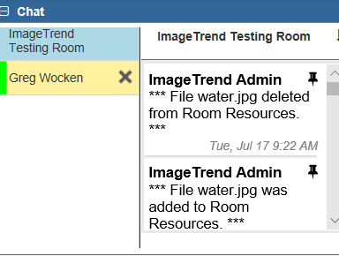
- To toggle back and forth between the private chat and the room chat simply highlight the name of the chat that you wish to follow.

- During private chat – there may be a message that states #unread count…..this means that while you are in private chat – there have been additional comments made in the main Chat room that you have missed. Simply click on the Read button to be returned back to the main Chat.
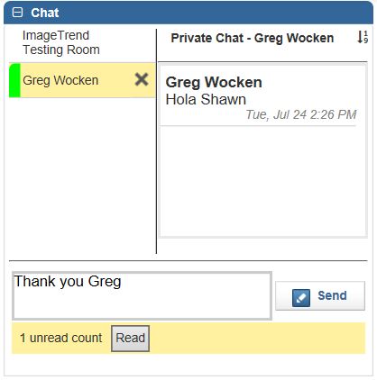

Room note
- The room note is used to provide specific information about the room or the situation.
  - May include contact information for the room organizers
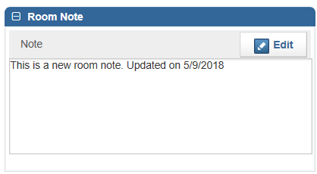
  - Description of why the room is open

room resources/documents
- Room resources are viewed, added and deleted in the Room Resources widget for all users in the room.
- Since every room is configurable to every user, your Room Resources widget might appear anywhere on the Room page.
- Most common types of files are allowed as room resources, including PDF, JPEG, PNG, and Word or Excel documents. However, .jar, .cfm, .cfc, .exe and .bat files cannot be uploaded.
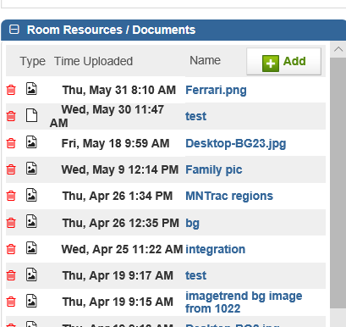
- Deleting a resource requires users to enter a reason for its removal. The reason for removal can be found in the Resource History tab. The only person that can delete a resource/document in this section is the person that uploaded the document.

bulletin board
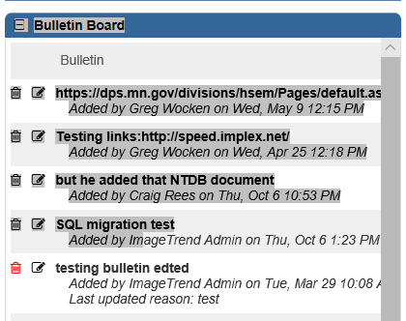
- Bulletin board items are items that are placed by the room organizers or designees and can include documents and/or links to other sources.

