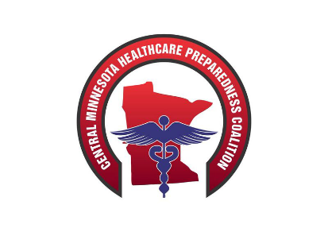
Central MN Regional Healthcare Advisory / Coalition Agenda
January 20th, 2020
Time Change 0900 - 1200

Time | Topic | Discussion/Findings  These columns are not to be bolded. | Actions/Follow Up  (include responsible person and due date)  These columns are not to be bolded.
Due to the weather and ALL Clear being here we will get through these details and let everyone before the major snow hits
0900 | Call to Order
 | Approval of Agenda
0900 | Introductions
 | All Clear Sustainment Planning Meeting | Sustainment Workshop | - All Clear will have a report of today’s results completed by the March meeting.  - Will discuss a smaller advisory committee formation next at months advisory call
1200 | Lunch | The lunch will be paired back to sandwiches so folks can “grab and go” if they wish
**** Reminders
Paperwork:
- In Kind – Mid Year Paperwork – on website
- If you haven’t turned in your EEG’s from the December HCID exercise, please send to Dave Miller - MillerDav@centracare.com In order to create the regional AAR he needs those.
Upcoming Education –
  - Medical Countermeasures: PODS MGT-319 March 3rd & 4th, 2020
    - St. Cloud, MN
      - On Website
  - Senior Officials Workshop - April 14th, 2020
    - St. Cloud, MN
      - On Website
    - April 16th, 2020 - Fergus Falls, MN
      - On Website
  - HCL or HERT T-t-T - April 26th – May 2nd, 2020
    - Anniston, AL
      - Email Dave Miller @ millerdav@centracare.com
  - PIO
    - May 5th-6th, 2020 - Fergus Falls, MN
      - On Website

JUNE 19TH – Threat Assessment Team education – Details coming soon
August 18th, 19th Camp Ripley Exercise – Additional Details coming soon

