August 2021

Appendix 3.5.8 MN Responds volunteer workforce plan

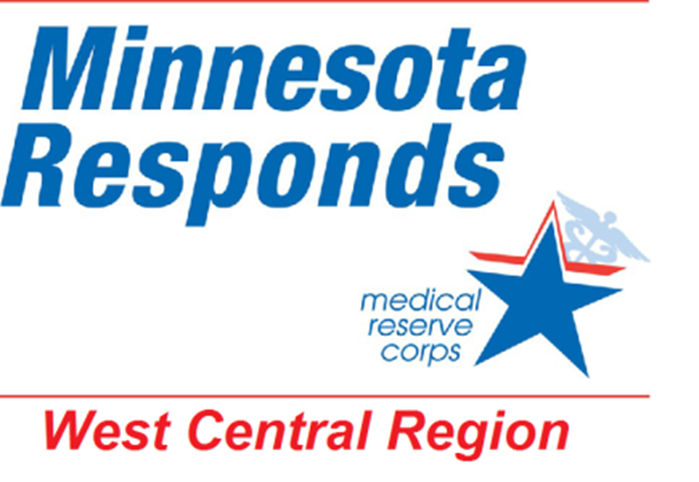

Administrator/Coordinator
Handbook

This handbook outlines the working structure of the West Central Region Minnesota Responds/Medical Reserve Corps unit. It functions as the MN Responds/MRC handbook and plan for the counties within the West Central Region: Clay, Douglas, Otter Tail, Pope, Stevens Traverse Grant, and Wilkin.

Table of Contents
Program Overview
Mission Statement
Goals and Objectives
Organizational Structure
Roles and Responsibilities
Legal Authority
Activation Authority

Volunteer Relations
Guiding Principles
Recruitment
Orientation
Training and Exercises
Newsletters
Profiles and credentialing

Utilization of Volunteers
Deployment

Administrative Responsibilities

Attachments

Record of Changes
June 2012 – Approval of plan and attachments
January 2014 – Edit demobilization
Program Overview
Mission
The West Central Region MN Responds MRC is a partnership that integrates local, regional and statewide volunteer programs to assist our public health and healthcare systems during a disaster. It is part of a national initiative to coordinator and mobilize health volunteers to respond to emergent incidents, ongoing public and community health events, and exercises.

The Unit will recruit, organize, train, deploy and debrief these vetted volunteers. Volunteers may be of medical or non-medical backgrounds who agree to contribute their skills and expertise in response to emergent incidents and events. Local and regional administrator and coordinators will be able to assist in achieving a prepared volunteer base.

Goals and Objectives
The goals and objectives of the Unit are as follows:
- To foster a culture of acceptance and recognition of the value of volunteers.
- To train, exercise and evaluate a volunteer unit able to provide a coordinated public health response.
- To assist in strengthening the public health infrastructure.
- To provide volunteers with a wide base of skills and experiences.
- To provide opportunities to assist with non-emergency public health or community initiatives.

Roles and Responsibilities
The West Central MN Responds MRC Unit (herein referred to as Unit) is facilitated as joint unit directors by each of the 3 Community Health Boards within the region: Clay – Wilkin, Horizon (Douglas, Pope, Stevens Traverse Grant), and Otter Tail. The fiscal host for the Unit is Centracare based St. Cloud, with monies divided between the CHBs with the understanding that utilization is done collaboratively.
- Each county entity will maintain a local administrator/coordinator to facilitate the county’s MN Responds unit.
- Each CHB will have a designee to the regional work group and request input from all county programs within the CHB.
- Specific roles and responsibilities for each level are listed in the attachments.
- Contact information is listed in the attachments.

MN Responds is the statewide initiative to pre-register, credential and train volunteers. The Minnesota Department of Health maintains the website www.mnresponds.org . It provides support, guidance and training for county and regional programs administrators. It provides the credential check for medically licensed volunteers.

The Unit is registered with both the Minnesota Department of Health and the United States Office of the Surgeon General as the West Central MN Responds MRC.

Legal Authority
Attachments address some of the legal protection issues in more detail.
- Each county accepts responsibility for the volunteers deployed within their county.
- The state assumes responsibility for those requested at the state’s behalf.

Activation Authority
Volunteer notification and activation will occur when the county identifies the need for volunteers to respond. This will occur by:
- Following National Incident Management System (NIMS) and Incident Command Structure (ICS).
- Being consistent with the county’s public health and emergency plans.
- Deployment to be done by the local administrator/coordinator or designee.
- Following deployment procedures.
- Healthcare entities accessing volunteers much coordinate through appropriate ICS.

Volunteers may also be requested by other counties within the Unit. These would be requested through the Multi Agency Coordination Center. West Central coordinators do have access to each other’s county units to serve as redundant coordinators. Requests for volunteers at the state level may come through either the MACC or directly to the local county to request for interested volunteers.

Volunteer Relations
Guiding Principles
The WC Region MN Responds/MRC follows these guiding principles in regard to volunteers:
- We treat all people, volunteers, clients, and co-workers with respect and dignity in all situations.
- We honor the commitment of our volunteers who contribute their time and skills to the MR while staying prepared through ongoing trainings.
- We will communicate clearly and consistently with MRC volunteers.
- We value and encourage input from volunteers.
- No volunteer will be asked to perform beyond the scope of his or her licensure, credentials, training, or comfort level.
- We work to ensure that no member will knowingly be placed at risk during training or deployment.
- We provide volunteers with the option of refusing an assignment for any reason.
- We believe that a response to disasters outside of their community and region are voluntary.
- We ask that no member will self-deploy. The Unit Coordinator will activate its volunteers.
- We consistently seek inclusion of residents across all demographics in order to ensure balanced representation of all the citizens in the county.
- Roles and responsibilities depend on the member’s physical ability, interest, training, and expertise. All service is voluntary.

Recruitment
The Unit strives to recruit individuals who have a vested interest in assisting with emergencies. Volunteers are not limited to those with health care backgrounds. Some ideas may be as follows:
- Placing materials in health care facilities.
- Educational sessions.
- Recruitment during training and exercises.
- Media relations: papers, radio, social networking, web-based information.
- Displays at health fair, community events, etc.

Orientation
- Accepted volunteers will receive either a letter or email acknowledging acceptance. A sample letter is found in the attachments.
- Online orientation will be encouraged. If unable to access by volunteer, county will make arrangement for orientation to be viewed at the county setting.
- Orientation materials will include online training suggestions, personal preparedness materials, MRC Core Competency materials and others.
- New volunteers will be encouraged to make self and family ready for deployment by making personal emergency plan, go kit and gather more information.
- Materials are also found in the attachments.

Training and Exercising
- Unit volunteer training plan is shared with all volunteers.
- Volunteers are encouraged to track trainings within the MN Responds system as well as MN Train.
- Classroom trainings will occur at a minimum of twice a year. They may include topics other than a basic orientation.
- Volunteers will be notified of local Psychological First Aid trainings.
- Volunteers will be encouraged to keep CPR/First Aid certification up to date.
- Volunteer will be notified when there is a role to participate in exercises.
- Attachments identify materials supporting training.

Newsletters
- Quarterly newsletters will be sent to volunteers.

Profiles and credentialing
- Volunteers will be encouraged to update their profiles routinely.
- Badging procedures will follow the MDH guidelines.
- Photo badging of volunteers will take place by the local county. Attached is a draft photo consent.

Utilization of Volunteers
The WC MN Responds/MRC volunteers are to be used predominately to deepen the infrastructure of local public health activities. These may or may not be of an emergent nature.
- Non emergent activation may include:
- Vaccination clinics
- Public Health promotions and education events
- Health screenings
- Exercises

Deployment
- Deployment requests will be recorded in detail on the Volunteer Mission Request Form.
- Activation authority will be followed.
- Just In Time Training will be clarified.
- Communications with volunteers will be clear, concise, accurate and contain contact information.
- Demobilization will be addressed shortly after activation.
- Debriefing and follow up resources or referrals will be offered for volunteers.

Scheduling, tracking other administrative tools are located in the attachment sections.

Administrative Duties
Counties involved will maintain accountability for the local and regional WC MN Responds/MRC program. These duties include the roles and responsibilities outlined in the attachments.

