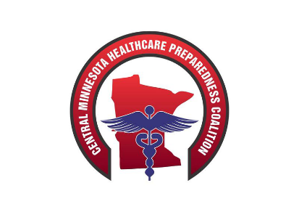

Central MN Regional Healthcare Coalition LTC Minutes
January 17th, 2020
CentraCare Plaza Windfeldt Room
1900 CentraCare Circle, St. Cloud 56303
0800 - 0900

Topic  0800-0900 | Discussion/Findings  These columns are not to be bolded. | Actions/Follow Up  (include responsible person and due date)  These columns are not to be bolded.
Call to Order
Introductions | Reviewed upcoming winter weather conditions
Approval of Agenda
Updates from the Healthcare Coalition  Acronyms  Resource Assessment  Possible re-org | Discussed the use of acronyms and the how their overuse becomes confusing, especially for new members.  Discussed homecare homes in the area. We are unaware of any in the area. | If there are any homecare agencies that operate actual facilities please let Don know of them so he can have them added to MNtrac and as well the coalition.
MNTrac Updates  If Possible – please also be logged into MNTrac as we would like to show you how to update Assisted Living beds as they have not typically been added and could be crucial in an event | Discussed a new tool that Don learned about that would track LTC Resources. Essentially space, staff and stuff. Don was impressed by it and thinks it would be a good thing to use.  Don showed everyone how to add assisted living beds to MnTrac. Discussed that MNTrac would be getting rid of male/female beds on MnTrac. This will be done by the person that runs MNTrac at MDH. | All agencies please to go onto MnTrac and add assisted beds living to their MnTrac.  To do this go to MnTrac > agency setup > beds > assisted living. Also add any AL Memory Care as well.
0900 Adjourn | The full coalition stats at 0930 and this is a workshop regarding sustainment based on the survey that was sent out. I anticipate some restructuring coming of this and strongly encourage attendance by the LTC community. Your voices need to be in the mix
Jamie Nyberg
Dake Henderson
Collin Baska
Jason Nelson
Jeff Meyer
Jen Peifer
Jennifer Smolen
Andrea Jung
Agnes Bearson
Brian Bernander
Rod Opheim
Dave Miller
Mandy Dudding
Rhonda Vedder

Upcoming Education –
  - Medical Countermeasures: PODS MGT-319 March 3rd & 4th, 2020
    - St. Cloud, MN
      - On Website
  - Senior Officials Workshop - April 14th, 2020
    - St. Cloud, MN
      - On Website
    - April 16th, 2020 - Fergus Falls, MN
      - On Website
  - HCL or HERT T-t-T - April 26th – May 2nd, 2020
    - Anniston, AL
      - Email Dave Miller @ millerdav@centracare.com
  - PIO
    - May 5th-6th, 2020 - Fergus Falls, MN
      - On Website

JUNE 19TH – Threat Assessment Team education – Details coming soon

