MNTrac training

staff
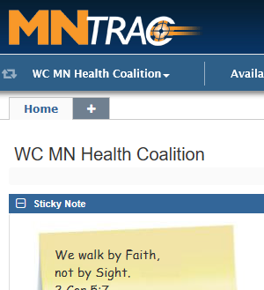
Log into www.mntrac.org and enter your username and password
1. Click on the down arrow next to your facility page:
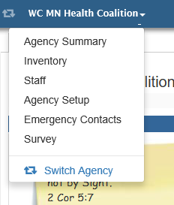
2. Click on Staff

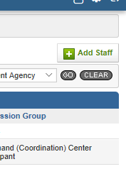
3. Click on Add Staff in the top right-hand corner.

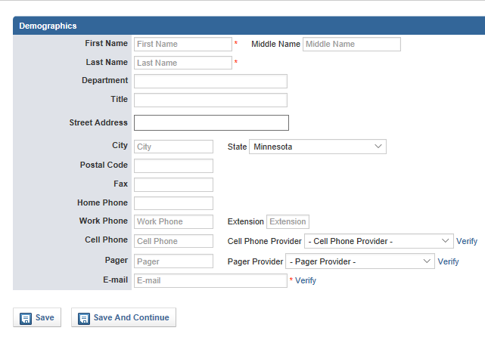
4. Demographics tab:
Must Have:
- First/Last Name
- Please put in employee’s title
- Work phone number
- Cell phone and provider
- Email Address

Hit Save and Continue……………

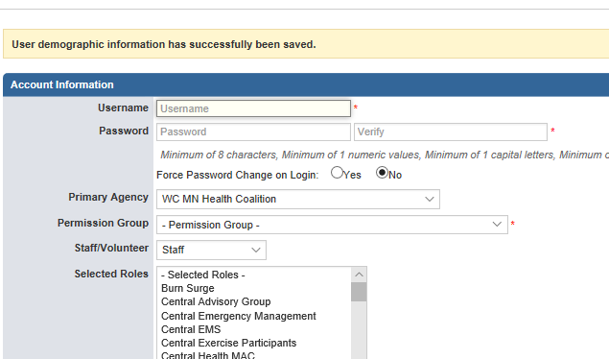
5. Permissions tab:
- Create a username
- Password (minimum of
8 characters and must have
one number and one capital)
Optional: have them change
their password the first time
they log in.
- Primary agency is your facility
name
- Permission group (select either):
  - Facility Administrator (have ability to change/add staff and change facility settings)
  - Facility User (able to participate in Command Center and do diversions and bed updates)
- Selected roles – scroll down and select either:
  - West Central Hospital staff
  - West Central LTC
  - West Central Public Health
  - West Central Emergency Management
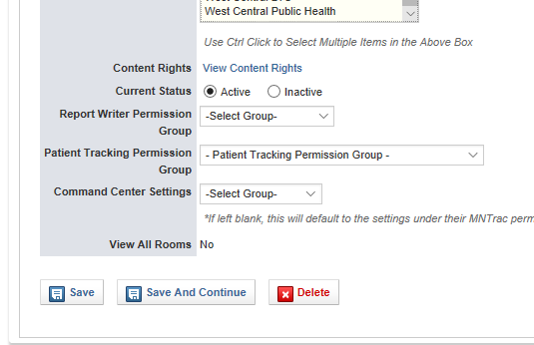
  - West Central EMS

- Current Status – should be ACTIVE
- Report writer permission group should be
REPORT USERS
- Skip Patient tracking at this time
- Skip Command Center Settings – it will
default automatically.

CLICK SAVE AND CONTINUE

NOTE: This is where you would inactivate an employee that is listed in your facility and is no longer employed or no longer needing access to your MNTrac account. (Change the Active to Inactive)

It is very important that Facility administrators monitor who is assigned as staff in their MNTrac account to ensure that only active employees have access.

6. OPTIONS/NOTIFICATIONS:

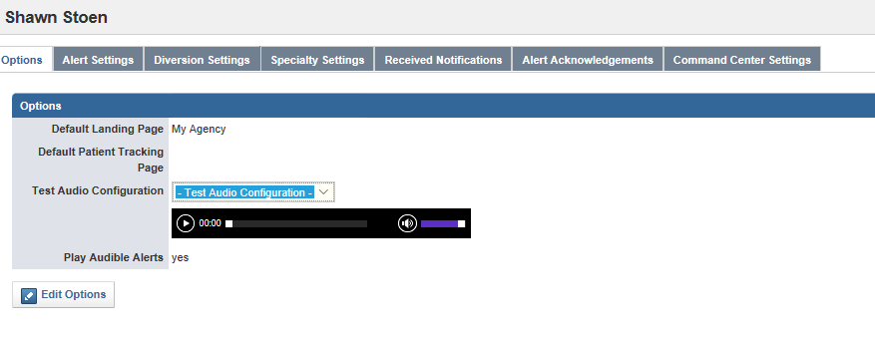
The only tabs that you will be going to are:
Alert Settings
Diversion Settings
Command Center Settings

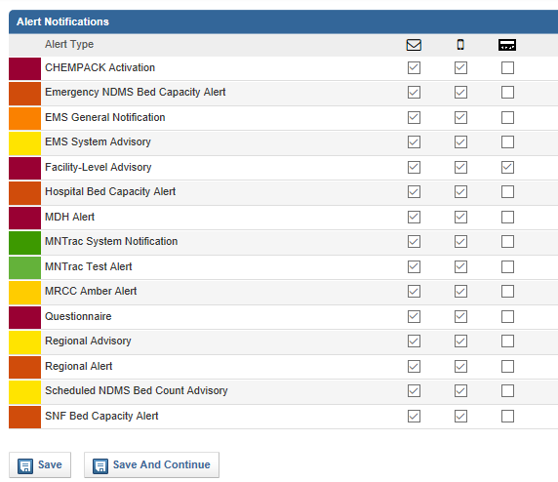
- Alert Settings:
  - First column is Email
  - Second column is text message
(which only works if there is a
cell phone on the account)

Recommended Alerts to receive:
    - Facility Level Advisory
    - Hospital bed capacity
alert (Hospitals only)
    - MDH Alert
    - Regional Advisory
    - Regional Alert
    - SNF Bed capacity alert
(SNF, LTC, Assisted Living
centers only)

CLICK ON SAVE AND CONTINUE

- Diversion Settings:
  - This is the optional section. You choose which agencies and what types of diversions that you would be notified from. Typically, it is facilities that would have a direct impact on yours if they were to divert. (i.e neighboring hospital)
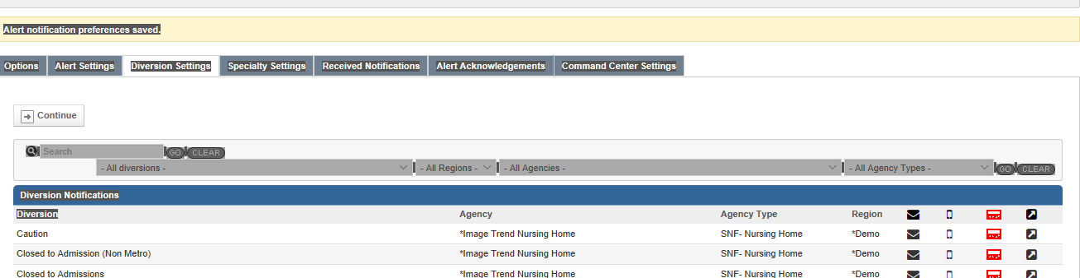
  - EMS agencies should have any of the hospitals that they typically transport too/from checked (consider including any Metro or specialty hospital that you may transfer too).

  - Need to ensure that you select the regions/agencies and/or agency types that you want to receive notifications from.
  - When you check on the envelope and turn it to green you will receive the notification via email.
  - When you check on the cell phone and turn it to green you will receive the notification via text message.
  - Hit continue to go to the next area
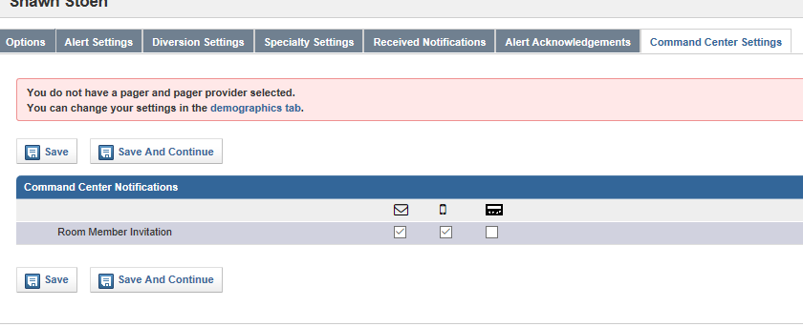
- Command Center

  - Click on the envelope and the cell phone to ensure all users have access to command center.
CLICK ON SAVE – AND YOU ARE DONE SETTING UP THE STAFF

