MNTrac training

HOW TO UPDATE YOUR CURRENT BED STATUS
Log into www.mntrac.org and enter your username and password
This training is divided into two sections:
1. Day to Day operations
2. Responding to a request from MNTrac

Day to day operations
Maintaining your current bed availability census within MNTrac allows your regional coordinators the ability to quickly access the availability within their region. All hospitals are asked to update their current bed availability at least once a day.
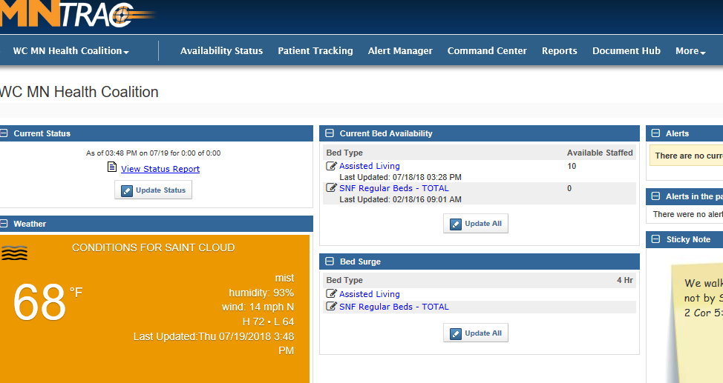
To update your daily bed census, simply log into MNTrac to get to your facilities summary page……..

- In the Current Bed Availability
widget – click on the Update All
button.

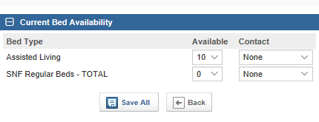
- Change the bed available counts
based on your current available
staffed beds. You can not select
a number that is more that what
your facility is licensed for (in the
facility set up section). Make sure
to select your name in the Contact
drop down area.
- Click Save All

responding to a bed update alert
When a regional or state bed update request is activated – you will receive an email, text message or phone call.
To acknowledge and update your beds you can either:
Click on the “click here” link in the email
or
Log into MNTrac

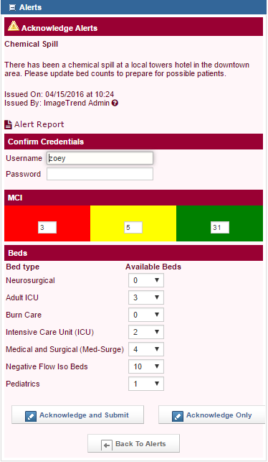
When you log into MNTrac or click on the link within the email, a pop-up box will appear that will request you to put in your credentials and update the bed availability…….
- When you put in the updated bed
availability numbers click on
Acknowledge and Submit.

- If you are having someone else put
In the bed availability numbers,
please acknowledge the alert by
putting in your credentials and
clicking on the Acknowledge
Only box.

