MNTrac training

HOW TO ACKNOWLEDGE AN ALERT OR ADVISORY
Log into www.mntrac.org and enter your username and password
Alerts and Advisories are sent to facilities to:
- Advise of a situation impacting another facility within the region that may have an impact on other facilities
  - Surge event
  - Closure/Evacuation of another facility
  - System/equipment failure requiring services to be limited or changed
    - CT or other radiological equipment down
    - Phone system down – providing alternative phone numbers to use
    - Power failure causing changes to service availability
  - Activation of a command center
- Alerts/advisories from other partners in the state…..
  - Changes to access to Emergency rooms due to building construction or road construction
  - Service disruption at facilities outside the region

To ensure that the messages have been received, it is important that the alert and advisories be acknowledged.
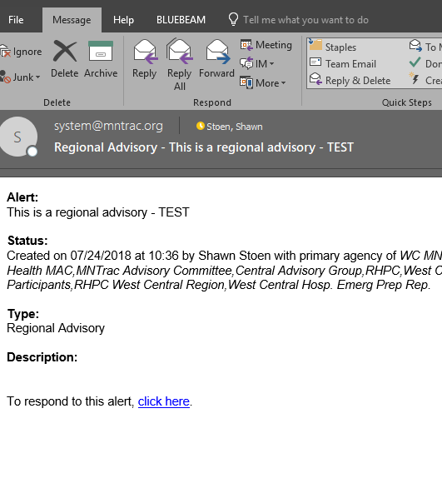
Alerts/advisories may be received by email, text message, or phone call.
EMAIL:
- To acknowledge an alert/advisory received via
email simply click on the highlighted “click here”
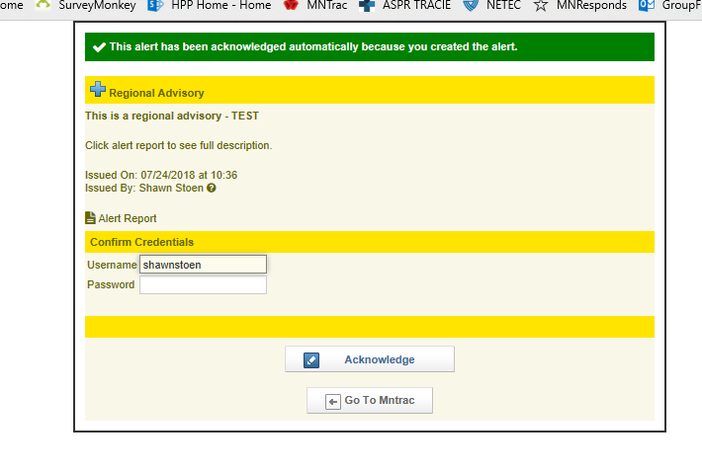
button contained within the email.
- A new box will pop – up………..
Simply insert your username
and password and click on
acknowledge

TEXT MESSAGE/PHONE CALL:
- When an alert is received by a text message….you simply log into MNTrac at www.MNTrac.org
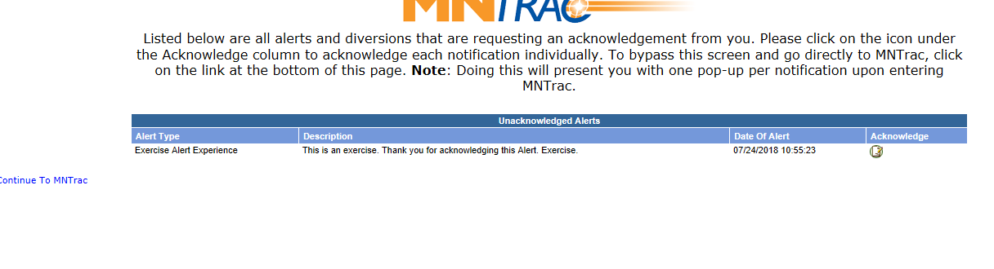
- Once you log in you will see the alert:

- To acknowledge the alert you can click on the piece of paper below acknowledge….a new box will pop up where you will be asked to provide your password and click on the word acknowledge.
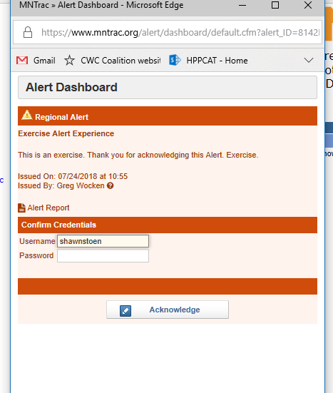

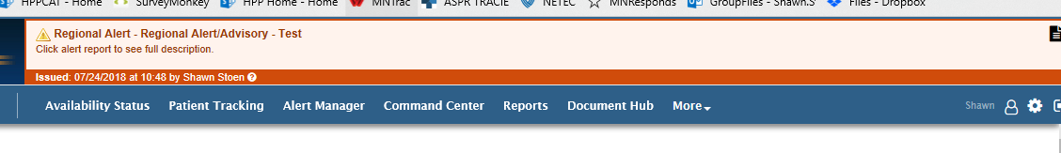
- You will then be taken to your main MNTrac page and you will see a banner across the top of the MNTrac page with the alert:

- Within the Alert widget box you will see the Alert and the fact that you acknowledged it:
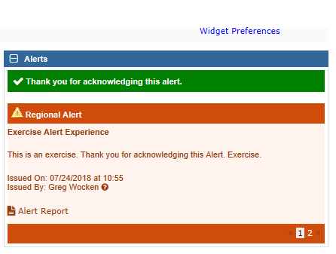

- You will also see in the “Alert in the Past 24 hours” widget any alerts that you have acknowledged. In the example below:
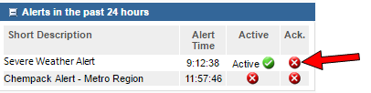
  - The Severe Weather Alert is active and has not been acknowledged because there is a red x below the acknowledged tab.

  - If you see that the alert has not been acknowledged (as in the example above), you can click on the red x and the alert box will pop up and allow you to acknowledge it.

