MNTrac training

FACILITY SUMMARY PAGE
Log into www.mntrac.org and enter your username and password
Your summary page is customized to each individuals preferences. Customization is accomplished via the widget preferences.
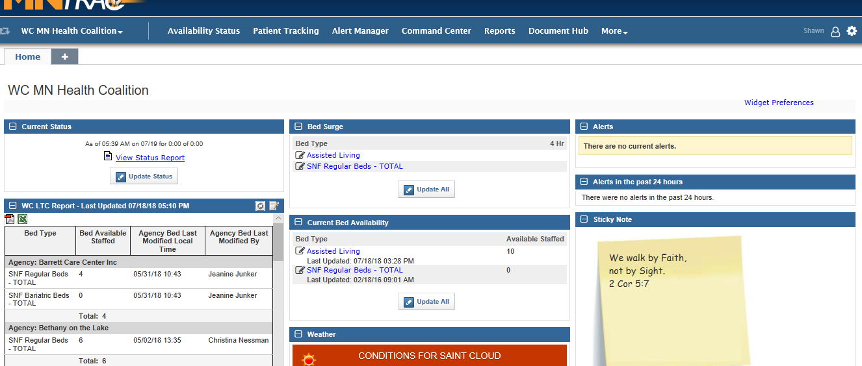
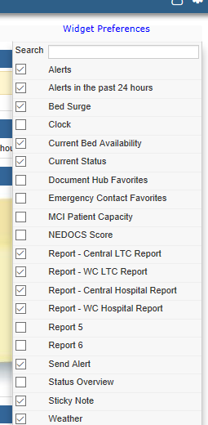
You have several options to choose within the widget preferences:
The list of available widgets is based upon the user’s access/role
within MNTrac however the recommended widgets are as follows:
Long Term Care: Hospitals:
Alerts Alerts
Alerts in the past 24 hours Alerts in the past 24 hours
Bed Surge Bed Surge
Current Bed availability Current Bed availability
Current Status Current Status
MCI Patient Capacity

Optional Widgets:
Clock
Weather
Sticky Note

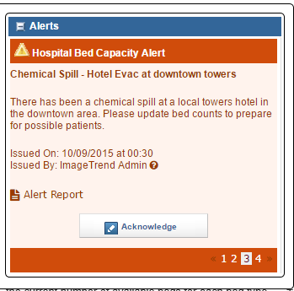
To choose your widget preferences place a check mark in the box preceding the widgets and then hit Save.

Widgets defined:

Alerts:
The Alert widget displays all of the active
alerts sent to you or the agency.

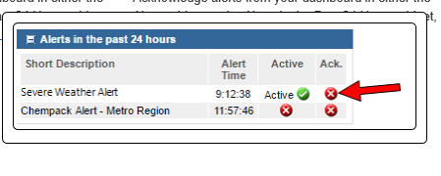

Alerts in past 24 hours:
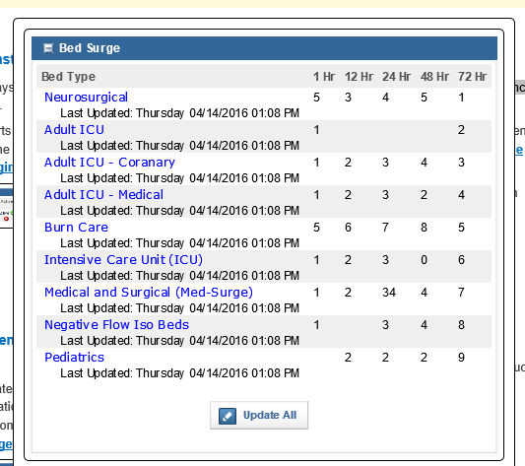
This widget displays alerts
sent to you or the agency in the past 24 hours. It
identifies if the alert was Active (green check
mark indicates that the alert is still active) and if
your facility has acknowledged the alert (if the
alert has been acknowledged then the green
check box is there – if not acknowledged then
there will be a red x).

Bed Surge:
The Bed Surge widget allows you to enter
your agency's surge capacity for each bed type.
This is information that would be requested
by an alert. Typically, this box would have ‘0’ for
bed numbers.
Bed surge is defined as – the number of beds that
could be made available after the facility assesses
the current census and:
- calls in more staff
- discharges patients to home/another facility
- rearranges rooms/areas to accommodate more
patients
The Bed Types listed are only the types listed as
available at your facility.

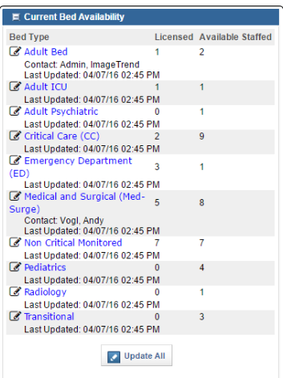
Current Bed Availability:
The Current Bed Availability widget allows you
to update the current number of available
beds for each bed type at your facility.

The numbers posted are obtained by reviewing your facilities
current patient census and identifying how many more patients
you can accept based upon the current staffing and the number of
empty beds.

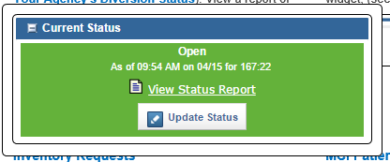
Current Status:
The Current Status widget allows you to keep other
agencies up-to-date with your
agency's / hospital's status, such as Closed.
This is also known as the Diversion Status.
Setting or changing the status is based upon your
own facilities policies and procedures.

Other agencies (that opt to receive notifications) will
receive notification that your facilities status has changed.
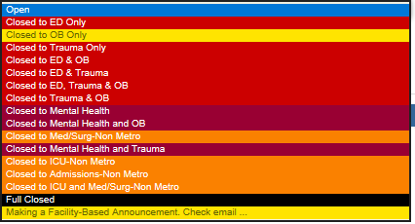

Current Status options available to chose from
are based upon the type of facility and types
of beds.

It is important that users know the facilities
specific policies about changing diversion
settings.

MCI Patient Capacity:
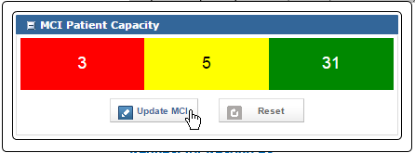
This widget allows you to quickly update
the number of patients you are able to
receive from an MCI, based on triage severity
rating of Green, Yellow, Red and Black.

This option is available for hospitals.

An alert would be sent out asking facilities to
update their MCI Patient capacity.

Optional Widgets:

Clock and Weather: Information displayed is based upon the location of the user.

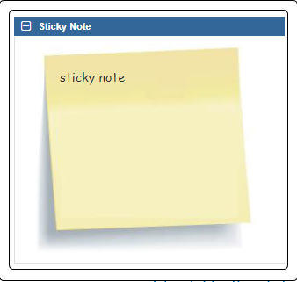
Sticky Note:
The Sticky Note widget allows you to write a note to yourself.
Notes are only visible to you.

