MNTrac training

Facility set up
Log into www.mntrac.org and enter your username and password
To have your facility added to MNTrac – contact your Regional Health Care Preparedness Coordinator
You will need to provide the following information:
- Official name of facility
- Address
- Phone number
- Type of Facility
- List of services provided
- Types of beds licensed for and total number of beds licensed for each type
Once your facility is set up in MNTrac – you can make some basic changes to your facility set-up. The changes include:
- Address or contact information change
- Bed licensure counts and types
To access your Facility Set Up – click on the drop down menu next to your agency/facility name:
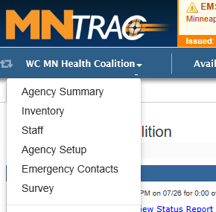
Then click on Agency Set up……….

update location
Click on the Locations tab….
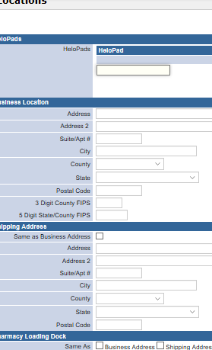
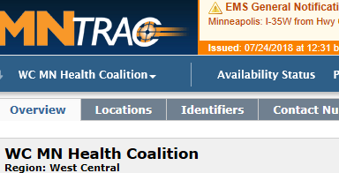
Update the appropriate information and click SAVE at the bottom.

update beds
The bed counts are the total number of licensed beds – not your daily census availability.
To update your licensed bed numbers click on Beds…….
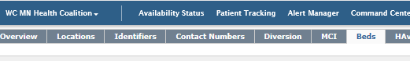
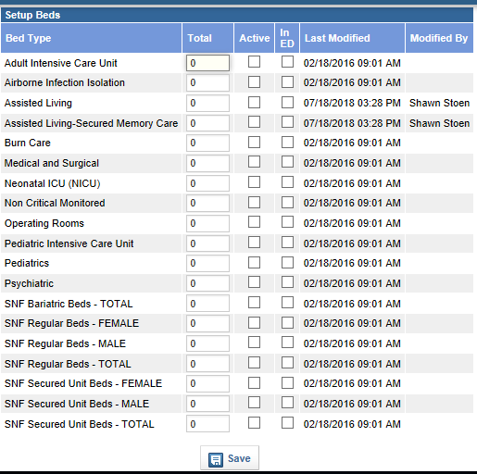
- Enter the number of
Licensed beds next to the
appropriate bed type.
- Place a check mark in the
box in the Active column
- Click on Save at the
bottom

NOTE:
- It is not necessary to
define if the SNF beds
are for Male or Female.
You can simply do the
Total numbers.

