MNTrac training

DIVERSION SETTINGS AND FACILITY BASED ANNOUNCEMENT
Log into www.mntrac.org and enter your username and password

changing a facilities diversion settings

- In the Current Status widget, click Update Status.

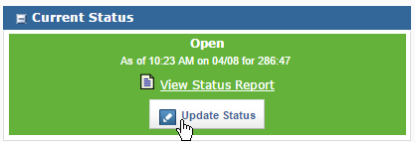
- Click the drop down to select a new status.

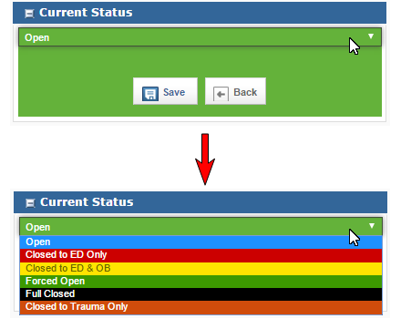
- There are several options or diversion status’s available. Make sure to select the appropriate diversion for your facility.
- Ensure that you are following your facilities protocol for diversions.
- It is extremely important that the diversion status be reviewed and that it is removed as soon as the situation is resolved or returns to normal.
- See below for facility based announcement instructions.
- Click Save.

- Enter your MNTrac credentials (log in username and password).
- Click Submit.

making a facility based announcement
This is not an actual diversion. This allows you to make a customized announcement to your partners. Facility based announcements can be used to:
- CT down for maintenance
- Phone lines down – please use alternate number….(123)456-7890
- MRI unit down
- Road construction – please use XYZ road to access hospital
These announcements are temporary and are only sent to the facilities that have opted in to receive these types of announcements.
To do a facility based announcement – simply click on that option in the diversion status changing area. You will be asked to input your credentials and then you can create the announcement in the comment section.
To read the entire announcement the individuals would need to log into MNTrac to read your comments.

