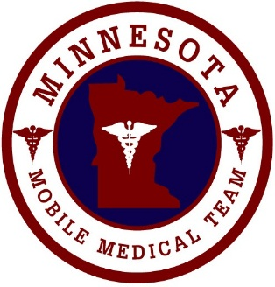
Agenda
MINNESOTA MOBILE MEDICAL TEAM

Tuesday, June 20th, 2018
MNMMT All Team Call
WebEx call in information in the body of the email
1000-1100

Welcome All
Budget Updates Don
- Still waiting approval
- Looking into doing a presentation at the MESH conference
July Meeting location – St. Cloud / Lunch decisions Don
- Location will be St. Cloud – we will be doing a team building bar-b-que/Bring your own lawn chairs
New (donated vehicle) trailer update Dave
- New vehicle has been trimmed with names/logo of the team
April Exercise – AAR Review (Brief) Don / Others
- Discussed the IT specifics during the lessons learned
- Reviewed the recommended corrective actions
Patient Tracking Jason
Training and Exercise Plan update (Ideas) Don
- MN Responds testing – quarterly (please go in and make sure your MN Responds profile is up to date) to correspond with our face to face meeting
- Team organization structure
- Training on specific illnesses i.e. chemical exposures/lab testing needed s/sx and potential supplies needed
- Exercise preparation (looking at developing an exercise in conjunction with the tribe for an exercise where the team supplements the operations of a hospital)
- Role specific trainings (we need to be a team of cross-trained individuals)
  - Logistics
  - HUC
  - Planning
  - Lab (I-Stat training) – 2 hours (July)
  - Pharmacy
  - Respiratory therapy
- Mankato Airshow Exercise/Activation (will need to talk with MDH)
Other?
Shawn is looking for some additional individuals to support Minnesota Responds activation (decided Command Staff to be trained) – Shawn will create a training schedule and cheat sheet.
ALL TEAM MEMBERS – PLEASE GO INTO YOUR MINNESOTA RESPONDS PROFILE AND MAKE SURE THAT IT IS UPDATED – AS SOON AS YOU DO – PLEASE SEND SHAWN AN EMAIL TO SAY THAT YOU HAVE IT DONE.

Adjournment

On the Call:
Peggy Eric W
Karen W Rhonda V
Jason F Randy S
Dave M Marion L
Keith C Jason S
Don S Chris C
Chris S Shawn S
Pedro Pat H

